
What is an ankle sprain?
A sprained ankle occurs when the ligaments of the ankle are injured. Ligaments are strong bands of tissue that connect one bone to another and help hold joints together.

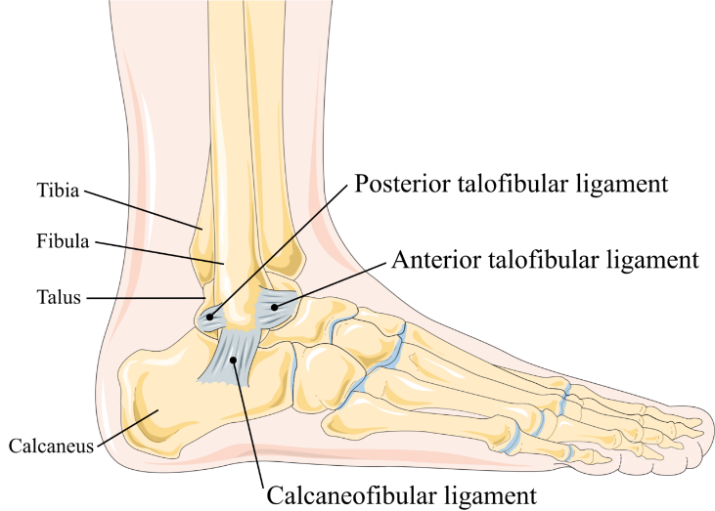

https://en.wikipedia.org/wiki/Lateral_collateral_ligament_of_ankle_joint

How is it caused?
A sprained ankle occurs when a ligament is forced into an abnormal position, causing it to overstretch.

The most common type of ankle sprain is when the sole of your foot turns inwards, overstretching the ligaments on the outside of your ankle and squeezing those on the inside.

Ankle sprains are more likely to occur:
- If you are female.
- If you are under or over weight.
- If you have limited ankle range of motion
- If you have poor balance/coordination.
- During activities involving jumping
- Wearing high heeled shoes.

How is it diagnosed?
Ankle sprains occur in different severities. The 3 grades of ankle sprain are:
Grade 1 – a mild strain (typically involving less than 10% the fibres).
Grade 2 – a partial ligament tear (typically involving between 11-49% of the fibres)
Grade 3 – a complete ligament tear (typically involving more than 50% of the fibres)

Diagnosis is generally made clinically following a history taking and physical examination.

You may be referred for an X-Ray if an ankle fracture is suspected. If your ankle is not recovering as expected with rehabilitation you may be referred for further investigations such as an Ultrasound or MRI scan.

What are the symptoms?
Signs and symptoms of a sprained ankle vary depending on the severity of the injury. They may include:
- Pain, especially when you bear weight on the affected foot
- Tenderness when you touch the ankle
- Swelling
- Bruising
- Restricted range of motion
- Instability in the ankle
- Popping sensation or sound at the time of injury

What can I do?
In the early stages (48-72 hours)

Protect the injury with relative rest (keeping moving but resting often).
Optimal loading by gradually increasing the weight through your leg and trying to walk as normally as possible early on. Evidence suggests this aids quicker recovery. If you are struggling with your walking or weight bearing, you may be provided with crutches to help.
Ice applied wrapped in a damp towel to the area for between 10-20 minutes every few hours
Compression bandage such as a tubigrip or neoprene support can be applied to limit bleeding and swelling in the injured area.
Elevating the leg above your heart level on pillows will help with pain and may reduce swelling. Both compression and elevation can be completed in-between periods of icing.

Over-the-counter analgesia, such as paracetamol or anti inflammatories such as ibuprofen may also help to reduce your symptoms. If you require further information on pain relief, speak to your GP or pharmacist.

Progressive Exercise
Exercise is an essential part of your recovery following an ankle sprain. Coordination and balance training have been shown to prevent recurrent ankle sprains. They should be done as pain allows, with some discomfort being acceptable. If a sharp shooting pain is provoked then ease off. As your pain reduces and your movement improves consider progressing to the more difficult exercises.

Factors influencing pain and recovery
During your recovery a number of other factors can influence your pain levels. Keep the following factors in mind to help move the healing process along:

Look after yourself
Pain is not usually simply a physical problem. Your general well-being can make you vulnerable to pain and your wellbeing can also be made worse by pain. Looking after your general health and well-being will help recovery. There is helpful advice on this website: https://www.nhs.uk/oneyou

Reduce stress and anxiety
It is normal for people with pain to have stress, anxiety and change in mood. This may affect your ability to cope with the pain and may influence your pain levels. Help is available if you are being affected by stress, anxiety or low mood – see the links below or discuss with your practitioner.

It is important that your whole nervous system is in a healthy state to aid recovery. If your brain is stressed or overworked this may slow recovery. Relaxation is an important part of your recovery. Simple relaxation techniques may help manage pain and stress. Try to set aside some time each day to relax – you can use relaxation techniques as linked below, or simply an activity you enjoy – reading, deep breathing, sitting in the garden, singing – whatever relaxes you.

Find help and support here: https://www.nhs.uk/oneyou/every-mind-matters/
https://www.northessexiapt.nhs.uk/west-essex

Physical Activity
Exercise improves fitness, confidence with movement and strength. It can also help reduce your stress and tension and improve your mood and quality of sleep, helping support you to return to normal activities. Perhaps you could simply start by trying to walk for 10 minutes per day.

Alcohol
Avoid alcohol in the early stages of healing (first three days). Evidence has shown this can slow down recovery and increase the chances of re-injury. https://www.drinkaware.co.uk/

Sleep
Sleep is very important for your wellbeing. Poor sleep quality, and lack of sleep can make managing pain more difficult. Consistently getting 6-9 hours is recommended. Get help and tips here:
https://www.nhs.uk/live-well/sleep-and-tiredness/

Smoking
Smoking can also impact how quickly tissues can heal and affect pain levels. For help with stopping smoking https://www.essexlifestyleservice.org.uk/stop-smoking/ https://www.nhs.uk/better-health/quit-smoking/

How long will it last?
In the first few weeks you will weight bear as pain allows using the support from elbow crutches and an ankle support if necessary.
Mild sprains would be expected to recover within 3-4 weeks.
Moderate or severe sprains treated conservatively would be expected to recover within 6-8 weeks.

You may need the guidance of a physiotherapist to help you return to normal activity:
- If your injury is more severe;
- If you wish to return to sports involving jumping activities or high speed movement; or
- If your symptoms have persisted despite following the advice and exercise provided in this leaflet.

If you require 1:1 physiotherapy treatment please fill out a self-referral form which can found at https://eput.nhs.uk/our-services/essex/west-essex-community-health-services/adults/rehabilitation/musculo-skeletal-physiotherapy and send to epunft.mskphysio@nhs.net

Is there anything I should avoid?
- Overstretching within the first few weeks can put too much strain on the healing tissue.
- Returning too quickly to activity involving high speed movement within the first 30-50 days has the potential to cause further injury. A gradual re introduction to running is advised.

What other options are there?
Bracing:
In more severe cases an ankle brace may be worn for 4-6 weeks after your injury to help with your recovery.

Physiotherapy:
Manual mobilisation of joints combined with exercise therapy has been shown to result in short term increases in ankle range of motion and reductions in pain.

Surgery:
Surgery is mainly reserved for patients who have chronic instability after an ankle sprain and who have not responded to a comprehensive exercise-based physiotherapy programme.

