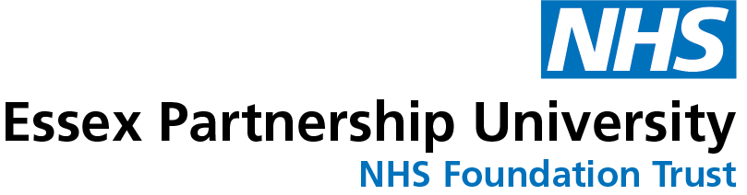
What is Golfer’s Elbow (medial elbow tendinopathy)?
Golfer’s elbow is a common musculoskeletal condition that affects as much as 1 in 3 people in their lifetime, usually affecting those between 40 and 60 years of age. It is a condition that causes pain pain where the tendons of your forearm muscles attach to the bony bump on the inside of your elbow. It is also known as medial elbow tendinopathy, and previously as medial epicondylitis.
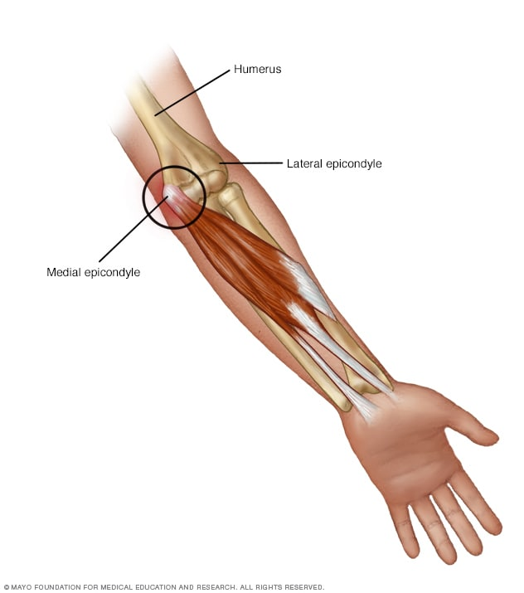

https://www.mayoclinic.org/diseases-conditions/golfers-elbow/symptoms-causes/syc-20372868

How is it caused?
It mostly occurs due to overuse of the muscles and tendons of the forearm, which attach to bony bump on the inside of your elbow, which are responsible for flexing the wrist, turning and gripping objects.

It is not limited to golf and can occur in sports involving repeated wrist movements, or everyday activities, which involve a lot of gripping. If the muscles and tendons are strained, tiny tears and inflammation can develop, causing pain. It is not commonly caused by a specific injury or event.

What are the symptoms?
- Pain around the bony bump on the inside of your elbow that can spread into the forearm and wrist.
- Pain during activities involving gripping or twisting your forearm, such as turning a door handle or opening a jar and typing.

How is it diagnosed?
Golfer’s elbow is generally diagnosed based on you tell us and a physical examination of your elbow and wrist. You will only be referred for tests such as ultrasound scan or other imaging if nerve damage or other problems are suspected.

What can I do?
Activity modification:
You should still be able to continue most activities but you may need to make some changes. Avoid heavy activities or positions that aggravate your symptoms such as holding heavy shopping in the one hand, use your other arm whenever possible and take regular breaks from activities such as typing.

Exercise:
This has been shown to be an essential part of helping improve symptoms in the medium to long term. Exercise can help to gradually build up the load that the tendon can tolerate over time. It can take several months before benefit from exercise is noted so you need to stick with it.

A small increase in pain while exercising is ok as long as it goes away within 30 minutes and is not worse the next day. If this happens, do less repetitions or reduce the weight/tension next times and gradually build up again.

Ice:
Apply ice wrapped in a tea towel to the area a few times a day for approx. 8-10 minutes. This can help to reduce swelling and pain.

Support strap/clasp:
These may assist in reducing load through the tendons helping to reduce symptoms. Ask your health professional for further information.

Medication:
Over-the-counter analgesia, such as paracetamol or anti inflammatories such as ibuprofen may also help to reduce your symptoms. If you require further information on pain relief, speak to your GP or pharmacist. Take any medication as prescribed at regular intervals to reduce symptoms, not just when it is particularly bad.

Factors influencing pain and recovery
During your recovery a number of other factors can influence your pain levels. Keep the following factors in mind to help move the healing process along:

Look after yourself
Pain is not usually simply a physical problem. Your general well-being can make you vulnerable to pain and your wellbeing can also be made worse by pain. Looking after your general health and well-being will help recovery. There is helpful advice on this website: https://www.nhs.uk/oneyou

Reduce stress and anxiety
It is normal for people with pain to have stress, anxiety and change in mood. This may affect your ability to cope with the pain and may influence your pain levels. Help is available if you are being affected by stress, anxiety or low mood – see the links below or discuss with your practitioner.

It is important that your whole nervous system is in a healthy state to aid recovery. If your brain is stressed or overworked this may slow recovery. Relaxation is an important part of your recovery. Simple relaxation techniques may help manage pain and stress. Try to set aside some time each day to relax – you can use relaxation techniques as linked below, or simply an activity you enjoy – reading, deep breathing, sitting in the garden, singing – whatever relaxes you.

Find help and support here: https://www.nhs.uk/oneyou/every-mind-matters/
https://www.northessexiapt.nhs.uk/west-essex

Physical Activity
Exercise improves fitness, confidence with movement and strength. It can also help reduce your stress and tension and improve your mood and quality of sleep, helping support you to return to normal activities. Perhaps you could simply start by trying to walk for 10 minutes per day.

Alcohol
Avoid alcohol in the early stages of healing (first three days). Evidence has shown this can slow down recovery and increase the chances of re-injury. https://www.drinkaware.co.uk/

Sleep
Sleep is very important for your wellbeing. Poor sleep quality, and lack of sleep can make managing pain more difficult. Consistently getting 6-9 hours is recommended. Get help and tips here:
https://www.nhs.uk/live-well/sleep-and-tiredness/

Smoking
Smoking can also impact how quickly tissues can heal and affect pain levels. For help with stopping smoking https://www.essexlifestyleservice.org.uk/stop-smoking/ https://www.nhs.uk/better-health/quit-smoking/

How long will it last?
Golfer’s elbow can last on average between 6 months to 2 years.

It is important to remain patient during your rehabilitation as it can take up to 12 weeks for elbow symptoms to respond to treatment.

If your symptoms have persisted or worsen despite following the advice and exercise provided in this leaflet you will need to visit your GP surgery again.

What other options are there?
If you haven’t responded to self-management strategies over a course of a few months you may be referred for:

Physiotherapy:
They can advise you further about exercises to complete, and may consider other management strategies to help reduce your symptoms.

Shockwave therapy
Shockwave therapy is a non-invasive treatment, where high-energy shockwaves are passed through the skin to help relieve pain and promote movement in the affected area. However, these treatments may not be available on the NHS in your local area.

Steroid injection
This is considered when all other measures have been unsuccessful. The injection is completed directly into the painful area and provides short term benefit. There is growing evidence that the tendon itself can be damaged further by completing this procedure, and therefore should only be considered as a last resort.

Surgery
This is also reserved for particularly stubborn, severe cases, and is completed rarely. It involves removing part of the damaged tendon.

