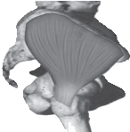
Gluteal Tendinopathy

What is a Gluteal Tendinopathy?
Up until recently hip bursitis was diagnosed as the main cause of lateral hip pain but recent studies suggest that an irritation of the gluteus muscle tendon is the likeliest cause.
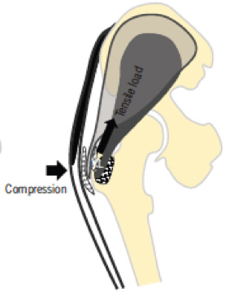
The tendon attaches onto a bony prominence (greater trochanter) and
In lying

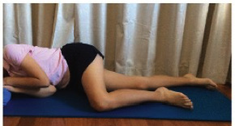
Either on your bad hip or with bad hip hanging across body like so

it is here that the tendon is subject to compressive forces leading to irritation. This can result in pain over the lateral hip which can refer down the outside of the thigh and into the knee.

How common is it?
Gluteal tendinopathy is relatively common affecting 10-25% of the population. It is 3 times more prevalent in women than men and is most common in women between the ages of 40 and 60. One of the reasons for this is women tend to have a greater angle at their hip joint increasing compressive forces on the tendon.

Signs and Symptoms
- Pain on the outside of your hip, can refer down outside of the thigh to the knee
- Worse when going up and/or down stairs
- Worse lying on affected side (and sometimes on the other side)
- Worse when crossing legs

How is it diagnosed?
Clinical tests as performed by your physiotherapist or doctor should be good enough to diagnose a gluteal tendinopathy.
All these positions lead to increase friction of the tendon, can cause pain and slow the healing process.

For sleeping you might like to try these positions:

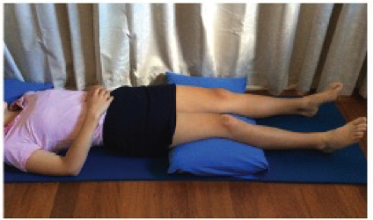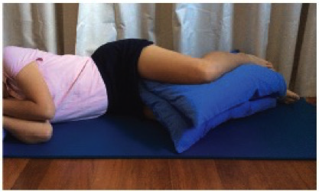
It is also important to modify your activity. Avoid or reduce things that flare up your pain, this could be climbing stairs or hills or those longer walks/runs.

Exercise Therapy

This is best administered by a Physiotherapist to suit the individual but below is a rough guide to exercises which can help a gluteal tendinopathy.

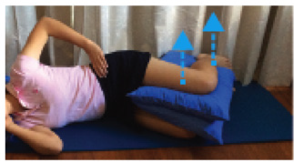
Isometric (static) contraction of the gluteus muscles which abduct the hip are effective in strengthening and pain relief in an inflamed tendon.

Treatment Advice
Positions to Avoid:
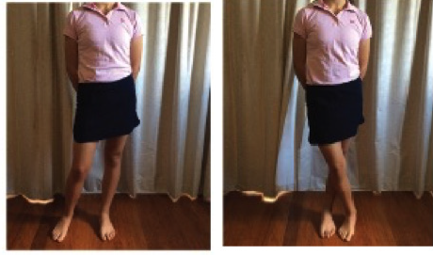

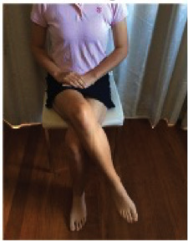
In Sitting

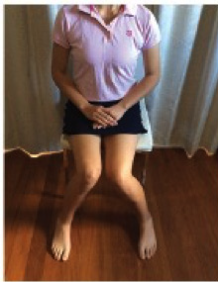
In standing
Place two pillows between legs, bad leg on top. Raise leg off pillow keeping shin level. Hold position for up to 45s. Repeat 5 times.


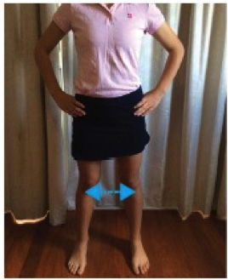
In standing with feet slightly wider than hip width, push legs apart as if going to do the splits, friction will prevent feet from moving. Feel muscles at hips working; hold position for up to 45s. Repeat 5 times.

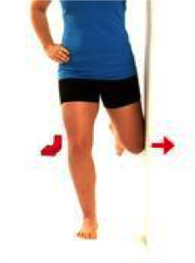
Standing leg is working in this exercise. Ensure good posture and push bent knee into wall to feel standing hip muscles work. Keep standing knee pointing forward. Hold for up to 45s.
Repeat 5 times.

Eventually exercises will be progressed to strengthen during functional activities such as walking or stair climbing.

Medication
A gluteal tendinopathy responds best to Non-Steroidal Anti-Inflammatories such as Ibuprofen which can be obtained without prescription. Follow recommended doses and always discuss with your GP or Pharmacist if you are unsure.

Other
If conservative management is unsuccessful a corticosteroid injection may be considered to settle down the inflammation, but this should be done in conjunction with your strengthening programme.

If your symptoms have persisted despite following the advice and exercise provided in this leaflet you may need the guidance of a physiotherapist to help you return to normal activity.
If you require 1:1 physiotherapy treatment please fill out a self-referral form which can found at https://www.eput.nhs.uk/resources/msk-physiotherapy-self-referral-form/
and send to epunft.mskphysio@nhs.net

EP0468
Published October 2017

