
What is neck pain?
Neck pain is common and can be very painful, but serious or permanent damage is rare. Almost everyone will have neck pain at some stage in their life. Most neck pain is caused by simple muscular strain and clears up within a few days. You can often treat those spells of neck pain yourself with over-the- counter painkillers and some gentle exercise. You not need to see your
doctor. It’s important not to rest for too long as lack of movement can cause the muscles to weaken, which makes it more likely to strain your neck in future. Simple neck exercises overleaf can help to reduce the risk of future problems.

What causes neck pain?

Non-specific neck pain: This is the most common type of neck pain. Many people develop a stiff and painful neck for no obvious reason. This is likely due to spasm in the muscles that support the neck. This doesn’t mean your neck is damaged. This usually disappears after a few days, provided you keep your neck moving.

Cervical spondylosis: happens when the discs and facet joints in your neck become worn. It’s caused by everyday use over many years and is quite normal as you get older. Spondylosis doesn’t always cause neck pain, but it may increase the risk of having spells of neck pain.

Whiplash: This happens most commonly in road traffic collisions and sports injuries. This occurs due to the rapid change in direction and speed your head moves in relation to your body. There is often a delay before you feel any pain. Most of these injuries improve within a few weeks or months. Seat belts and correctly adjusted headrests can reduce the risk, and gentle exercise to keep your neck moving will help with recovery and prevent any linger-term problems.

Tension: being worries or stressed can results in the muscles at the back of the neck tightening. This can cause neck pain and even tension type headaches.

Discs: Sometimes a disc can bulge slightly and irritate a nerve. This is associated with pain radiating down the arm, numbness, pins and needles or weakness. This will often settle by itself or following physiotherapy.

What can I do to help myself?

Painkillers: Simple over-the-counter painkillers such as paracetamol or ibuprofen will often help. It’s best to take them before the pain becomes very bad, but you shouldn’t take them more often than every four hours. Please speak to a pharmacist before taking any new medication, or if you are pregnant, have asthma, indigestion, stomach ulcer or are taking blood thinners.

Heat and cold: Heat and ice packs can be used for short term relief of pain and to relax muscle tension. You can use a reusable heat pack, a hot water bottle, an ice pack or a bag of frozen peas. Make sure you don’t put heat or ice packs directly onto your skin, wrap them in a towel first.

Relaxation: Stress can make neck pain worse. Relaxation, meditation or mindfulness video or audio guides are available online or in shops.
Posture: Staying in the same posture/position for too long can aggravate neck pain. Make sure to regularly change your posture/position, or regularly exercise your neck with the
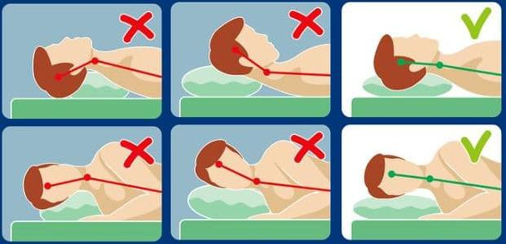
exercises below.

Sleep: If your pillow is too thick, or you use too many, it may increase your neck pain. Changing the position or number of pillows can be helpful. Your head and neck should be supported so that your head is level with your body in a neutral position.

Exercise: Exercise is the most important way that you can help
yourself if you have neck pain. If you stop being active for a long time, the muscles in your neck become weak and this can make your neck pain worse. Research shows that regular exercise leads to shorter and less frequent episodes of neck pain. Simple exercises can promote strength, ease stiffness, restore movement and get your neck back to normal. Start with these exercises. Start off slowly and gradually increase the amount of exercise you do. Try taking some painkillers beforehand too. Over time, your neck will get stronger and more flexible and this should reduce the pain. You should use the suggested exercises for at least 6–8 weeks to help prevent symptoms returning. Exercise might make your neck feel a bit sore at first but it doesn’t cause any harm-so don’t let it put you
off! If you require 1:1 physiotherapy treatment please fill out a self-referral form which can found at https://www.eput.nhs.uk/resources/msk-physiotherapy-self-referral-form/ and send to
epunft.mskphysio@nhs.net

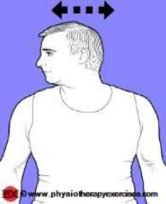  Head Turn: Turn your head towards one side, keeping your chin at the same height and moving within comfortable limits. Hold this position for 5 seconds. Return your head to the centre and  repeat on the opposite side. Repeat 5 times on each side. | 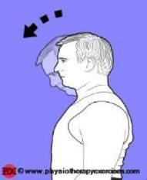  Head Down: Sit or stand, keeping good posture. It’s best to sit down if you have trouble balancing. Slowly tilt your head down to rest your chin on your chest. Hold this position for five seconds.  Repeat five times
  Head Tilt: Tilt your head down towards your shoulder, leading with your ear. Hold this position for 5 seconds.  Return your head to centre and repeat on the opposite side. Repeat 5 times on each  side. | 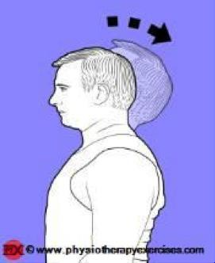  Head up: Sit or stand, keeping good posture. It’s best to sit down if you have trouble balancing. Slowly look up towards the ceiling. Hold this position for five seconds. Repeat five times.
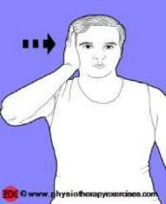  Side Head Push:  Place your hand on the side of your head and push your head into your hand. Hold the pressure for 5 seconds. Repeat 5 times to each side. | Forward Head Push:  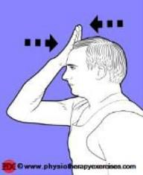  Place your hand on your forehead and push your head into your hand. Try not to let your chin poke forward. Hold the pressure for 5 seconds.  Repeat 5 times.
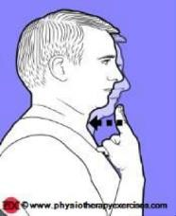
Chin Tuck:
Gently tuck your chin into your throat, while keeping your eyes forward. Hold the position for 5 seconds. Repeat 5 times.

