How to manage an asthma attack in children
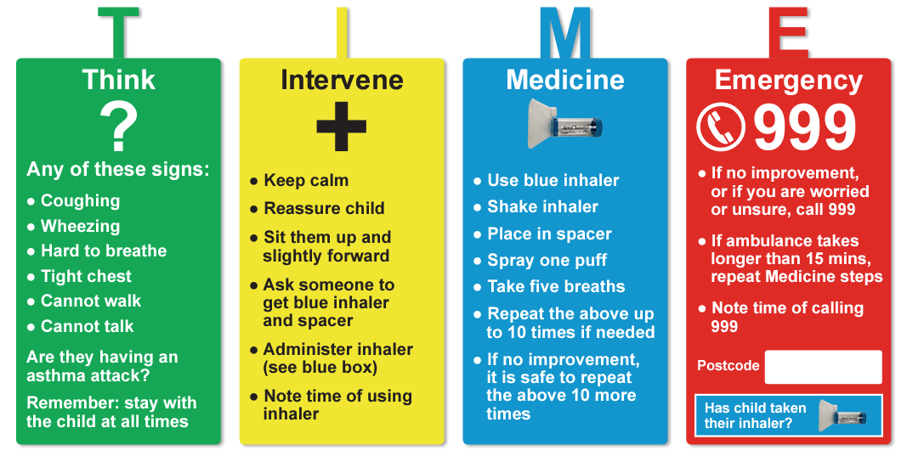
When asthma strikes, it’s TIME to act

