
What is Femoral Acetabular Impingement (FAI)?
FAI is a condition where there is a variation in the hip joint structure. It can affect the head of the thigh bone (femur), the socket (acetabulum) or both. Variations are considered to be normal, but unfortunately it can be painful to some people.

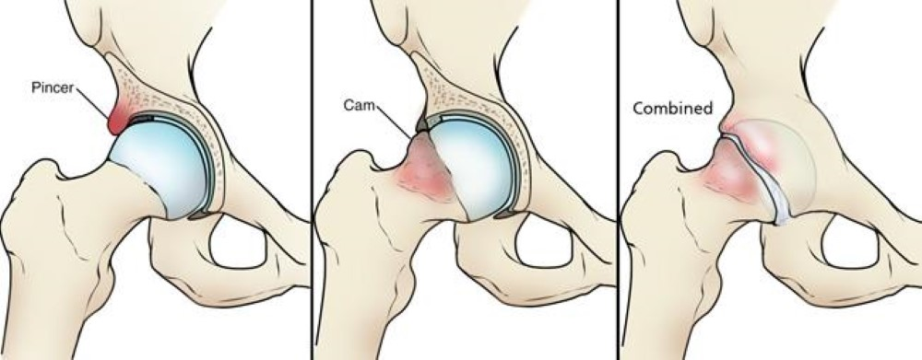

https://orthoinfo.aaos.org/en/diseases--conditions/femoroacetabular-impingement/

How is it caused?
- Having very deep hip sockets or a hip that is angled a little further back than normal.
- Childhood conditions called Perthes disease (where the blood supply to this hip is affected, and can affect the ball part of the joint), and slipped capital femoral epiphysis (where the growth plate moves during childhood).
- Trauma or fracture which fails to heal or after a fracture where it heals with the hip facing backwards.

In general FAI is more commonly caused by a developmental cause rather than trauma.

What are the symptoms?
- Pain and discomfort in the groin or outer aspect of the hip/thigh or buttock.
- Clicking or catching sensations
- Difficulty with certain movements or are position-related eg- when the knee is brought towards the chest such as squatting or during long car journeys

How is it diagnosed?
Diagnosis is generally made clinically following a history taking and physical examination. If FAI is suspected further imaging in the form of an X ray or MRI scan may be requested.

What can I do?
Stay Active: Exercise is recommended as a first line of treatment for FAI. It is important to patient and consistent as it may take up 3 months for symptoms to improve.

These exercises may make your muscles ache initially. Stop if the exercises severely aggravate your symptoms.

Medication: Over-the-counter analgesia, such as paracetamol or anti inflammatories such as ibuprofen may also help to reduce your symptoms. If you require further information on pain relief, speak to your GP or pharmacist.

Pacing your activities: Try to find the right balance between activity and rest to avoid overstraining your joint.

Factors influencing pain and recovery
During your recovery a number of other factors can influence your pain levels. Keep the following factors in mind to help move the healing process along:

Look after yourself
Pain is not usually simply a physical problem. Your general well-being can make you vulnerable to pain and your wellbeing can also be made worse by pain. Looking after your general health and well-being will help recovery. There is helpful advice on this website: https://www.nhs.uk/oneyou

Reduce stress and anxiety
It is normal for people with pain to have stress, anxiety and change in mood. This may affect your ability to cope with the pain and may influence your pain levels. Help is available if you are being affected by stress, anxiety or low mood – see the links below or discuss with your practitioner.

It is important that your whole nervous system is in a healthy state to aid recovery. If your brain is stressed or overworked this may slow recovery. Relaxation is an important part of your recovery. Simple relaxation techniques may help manage pain and stress. Try to set aside some time each day to relax – you can use relaxation techniques as linked below, or simply an activity you enjoy – reading, deep breathing, sitting in the garden, singing – whatever relaxes you.

Find help and support here: https://www.nhs.uk/oneyou/every-mind-matters/
https://www.northessexiapt.nhs.uk/west-essex

Physical Activity
Exercise improves fitness, confidence with movement and strength. It can also help reduce your stress and tension and improve your mood and quality of sleep, helping support you to return to normal activities. Perhaps you could simply start by trying to walk for 10 minutes per day.

Alcohol
Avoid alcohol in the early stages of healing (first three days). Evidence has shown this can slow down recovery and increase the chances of re-injury. https://www.drinkaware.co.uk/

Sleep
Sleep is very important for your wellbeing. Poor sleep quality, and lack of sleep can make managing pain more difficult. Consistently getting 6-9 hours is recommended. Get help and tips here:
https://www.nhs.uk/live-well/sleep-and-tiredness/

Smoking
Smoking can also impact how quickly tissues can heal and affect pain levels. For help with stopping smoking https://www.essexlifestyleservice.org.uk/stop-smoking/ https://www.nhs.uk/better-health/quit-smoking/

Nutrition and weight: Being overweight can increase the physical strain on the body and also contribute to inflammation in your body. Some studies have shown that reducing bodyweight by 5% resulted in a 32.6% improvement in physical function after 8 months.

Make sure you eat a balanced diet. Adult weight management services are available free to Essex residents here: https://acelifestyle.org/weight-management

How long will it last?
It is important to patient and consistent as it may take up 3 months for symptoms to improve.

If your symptoms have worsened despite the advice given we would recommended you see a healthcare professional for review as you may require more guidance specific to your individual needs.

Is there anything I should avoid?
Take care with activities which may have a greater chance of aggravating your symptoms such as prolonged sitting, deep squatting or rowing.

What other options are there?
Physiotherapy
A physiotherapist can help provide advice and guidance on exercise which is specific to your individual needs.

If you require 1:1 physiotherapy treatment please fill out a self-referral form which can found at https://eput.nhs.uk/our-services/essex/west-essex-community-health-services/adults/rehabilitation/musculo-skeletal-physiotherapy and send to epunft.mskphysio@nhs.net

Surgery
If a patients symptoms persist after a course of treatment, a referral to an orthopaedic surgeon may be recommended for a surgical opinion. Surgery would aim to reshape either the ball or socket of the hip joint. This can be done either through keyhole (arthroscopy) or open surgery. This would be followed by a course of physiotherapy rehabilitation. For further information on surgery visit https://orthoinfo.aaos.org/en/treatment/hip-arthroscopy/

