
What is knee cap joint related pain?
Knee cap pain is described as pain around or behind the knee cap that starts without any traumatic injury. It can occur during or shortly after performing an exercise or activity. It is sometimes called anterior knee pain, runner’s knee or patella mal-tracking. It is the most common condition effecting the knee.

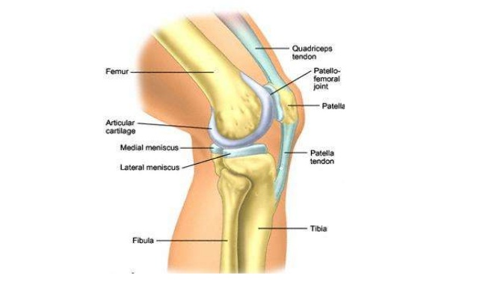
The knee cap sits in a groove on the end of the thigh bone. This joint is known as the patellofemoral joint. The knee cap acts as a lever for muscles controlling movement of the knee. These movements are controlled by a number of muscles that connect to the knee cap. Together, these muscles help to stabilise the knee cap and keep it running smoothly within the groove.

https://www.physio-pedia.com/images/1/16/PFJ-1-4-20-638.jpg

How is it caused?
There is no specific cause for knee cap pain but many possible factors that might contribute to it:
- A change in activity load, frequency or duration eg- Running more often, on more challenging terrain or for longer periods than you are used to.
- Weakness of the hip and thigh muscles that support the knee function
- Tightness of the thigh and calf muscles reducing the loading efficiency of the joint
- Movement biomechanics (How well your muscles control your movement)
- Foot biomechanics (flat feet or over pronation changing the loading force through the joint)
- Natural body shape (the position of your hip, knees and feet)

Very rarely is the structure of your knee joint the problem.

What are the symptoms?
Pain around or behind the knee cap during or following activities such as running, squatting, jumping, going downstairs or sitting for long periods of time.

A ‘noisy’ knee that produces a crackling sound is often the result of healthy fluid within the joint moving around. It does not necessarily mean the knee cap is damaged or even going to be painful.

How is it diagnosed?
A physiotherapist is well placed to diagnose this condition by listening to your symptoms and asking specific questions to rule out other causes for the knee pain.

Imaging is not normally needed to confirm a diagnosis of knee cap pain. Wear and tear changes to the cartilage on scans are very common and have not been shown to predict pain levels. These changes should not prove to limit recovery and return to full function.

What can I do?
Activity adjustment
Finding the right level of activity within level a pain that is tolerable for you is an essential part of making a good recovery.

Consider adjusting the activity that triggers the pain in the first instance, this may mean completely stopping or just a reduction in frequency and intensity to let the pain settle. You can take pain killers if you need to.

Exercise
- Start regular and specific exercises to help strengthen the hip and thigh muscles that support the knee. Exercises need to be progressed so that these muscles can withstand increased loads and demands.
- You should focus on exercise that is not too painful. Challenging your muscles to a tolerable discomfort is ok, as is lower impact exercise such as swimming, cycling and walking.
- Gradually build up to a return to your sport or activity in combination with your strengthening exercises. This is especially important if too much training was highlighted as contributing to the onset of your symptoms.
The exercises below build up in difficulty, progress gradually through them as you feel able.

A comprehensive exercise programme and guidance for returning to running can be found here: https://www.youtube.com/watch?v=asCslcRRu9k
https://www.youtube.com/watch?v=gW1RdkwsWOw

Medication:
Over-the-counter analgesia, such as paracetamol or anti inflammatories such as ibuprofen may also help to reduce your symptoms. If you require further information on pain relief, speak to your GP or pharmacist.

Factors influencing pain and recovery
During your recovery a number of other factors can influence your pain levels. Keep the following factors in mind to help move the healing process along:

Look after yourself
Pain is not usually simply a physical problem. Your general well-being can make you vulnerable to pain and your wellbeing can also be made worse by pain. Looking after your general health and well-being will help recovery. There is helpful advice on this website: https://www.nhs.uk/oneyou

Reduce stress and anxiety
It is normal for people with pain to have stress, anxiety and change in mood. This may affect your ability to cope with the pain and may influence your pain levels. Help is available if you are being affected by stress, anxiety or low mood – see the links below or discuss with your practitioner.

It is important that your whole nervous system is in a healthy state to aid recovery. If your brain is stressed or overworked this may slow recovery. Relaxation is an important part of your recovery. Simple relaxation techniques may help manage pain and stress. Try to set aside some time each day to relax – you can use relaxation techniques as linked below, or simply an activity you enjoy – reading, deep breathing, sitting in the garden, singing – whatever relaxes you.

Find help and support here: https://www.nhs.uk/oneyou/every-mind-matters/
https://www.northessexiapt.nhs.uk/west-essex

Physical Activity
Exercise improves fitness, confidence with movement and strength. It can also help reduce your stress and tension and improve your mood and quality of sleep, helping support you to return to normal activities. Perhaps you could simply start by trying to walk for 10 minutes per day.

Alcohol
Avoid alcohol in the early stages of healing (first three days). Evidence has shown this can slow down recovery and increase the chances of re-injury. https://www.drinkaware.co.uk/

Sleep
Sleep is very important for your wellbeing. Poor sleep quality, and lack of sleep can make managing pain more difficult. Consistently getting 6-9 hours is recommended. Get help and tips here:
https://www.nhs.uk/live-well/sleep-and-tiredness/

Smoking
Smoking can also impact how quickly tissues can heal and affect pain levels. For help with stopping smoking https://www.essexlifestyleservice.org.uk/stop-smoking/ https://www.nhs.uk/better-health/quit-smoking/

How long will it last?
There is no quick fix for knee cap pain and it requires consistency to maintain your rehabilitation. Improvements should be seen over a 3-6 month period.

If your symptoms have persisted despite following the advice and exercise provided in this leaflet you may need the guidance of a physiotherapist to help you return to normal activity.

If you require 1:1 physiotherapy treatment please fill out a self-referral form which can found at https://eput.nhs.uk/our-services/essex/west-essex-community-health-services/adults/rehabilitation/musculo-skeletal-physiotherapy and send to epunft.mskphysio@nhs.net

Is there anything I avoid?
Increasing your activity levels too quickly may make it more difficult to control your symptoms and lead to symptom flare up. If you do experience a flare up try to manage it early by reducing your activity levels and regressing your exercises back to a manageable level. Then gradually build back up your progressions and activity levels.
Ice, Heat or pain killers may be helpful to reduce the pain and allow you to build back up sooner.

What other options are there?
Occasionally shoe inserts (guided by a podiatrist), taping techniques (guided by a physiotherapist) or an injection are required to help settle the pain and allow you to start the rehabilitation process. These may be required in the short term over approximately 4-6 weeks.

A referral for surgery is rarely required as nearly all knee cap pain can be managed through education and exercise.

