
What is the osteoarthritis of the knee?
Osteoarthritis is a condition that affects the joints, causing pain and stiffness. The knee is a ‘hinge joint’ which is covered in a layer of cartilage. When the knee develops osteoarthritis, some of the cartilage roughens and becomes thin and the joint doesn’t move as smoothly as it should. In severe cases the cartilage can become so thin that it no longer covers the bone resulting reduced joint space.

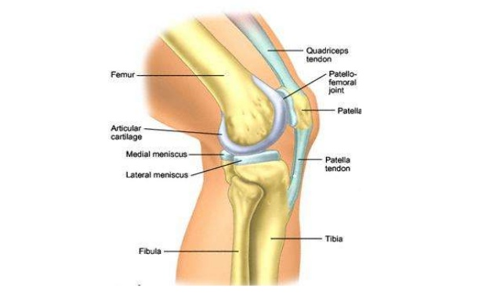

https://www.physio-pedia.com/images/1/16/PFJ-1-4-20-638.jpg

How is it caused?
- Knee osteoarthritis can be caused by a combination of factors:
- Age: osteoarthritis occurs mostly in those aged over 40
- Gender: osteoarthritis is twice as common in women
- Previous joint injury: normal activity and exercise does not cause osteoarthritis, but previous injuries/surgery can increase the risk
- Obesity: Being overweight increases the strain on your joints which can contribute to osteoarthritis
- Genetic factors: if a close family member has osteoarthritis, you are more likely to develop the condition

What are the symptoms?
Knee osteoarthritis can present differently in everyone. The most common symptoms include:
- Pain
- Early morning stiffness less than 30 minutes
- Reduced movement
- Hard or soft swellings
- Crepitus (grating/grinding)
- Giving way
- Locking
- Difficulty climbing stairs
- Knees can become bowed
- Muscle wasting

How is it diagnosed?
Knee osteoarthritis is normally diagnosed based on the signs and symptoms identified during a physical examination. X-rays can be useful but are not always required. There are no blood test for osteoarthritis but can be used to rule out other conditions.

What can I do?
Stay Active: Exercise has proven to ease pain and improve function. Gentle exercise in the form of specific exercises for your joint (see below), or more generalised activity such as swimming or walking, can help you can strengthen the muscles and protect the joint.

Warmth: can help reduce symptoms, use for 10 minutes twice daily.

Medication: Over-the-counter analgesia, such as paracetamol or anti inflammatories such as ibuprofen may also help to reduce your symptoms. If you require further information on pain relief, speak to your GP or pharmacist.

Weight management: studies tell us that losing 10-19.9% of your baseline body weight can significantly improve pain and function.

Aids: walking aids can help to reduce some of the load through your joint. Knee supports and braces can be used to reduce instability in severe cases.

Pacing your activities: try to find the right balance between activity and rest to avoid overstraining your joints

A range of excellent resources for helping manage osteoarthritis can be found at https://escape-pain.org/

Factors influencing pain and recovery
During your recovery a number of other factors can influence your pain levels. Keep the following factors in mind to help move the healing process along:

Look after yourself
Pain is not usually simply a physical problem. Your general well-being can make you vulnerable to pain and your wellbeing can also be made worse by pain. Looking after your general health and well-being will help recovery. There is helpful advice on this website: https://www.nhs.uk/oneyou

Reduce stress and anxiety
It is normal for people with pain to have stress, anxiety and change in mood. This may affect your ability to cope with the pain and may influence your pain levels. Help is available if you are being affected by stress, anxiety or low mood – see the links below or discuss with your practitioner.

It is important that your whole nervous system is in a healthy state to aid recovery. If your brain is stressed or overworked this may slow recovery. Relaxation is an important part of your recovery. Simple relaxation techniques may help manage pain and stress. Try to set aside some time each day to relax – you can use relaxation techniques as linked below, or simply an activity you enjoy – reading, deep breathing, sitting in the garden, singing – whatever relaxes you.

Find help and support here: https://www.nhs.uk/oneyou/every-mind-matters/
https://www.northessexiapt.nhs.uk/west-essex

Physical Activity
Exercise improves fitness, confidence with movement and strength. It can also help reduce your stress and tension and improve your mood and quality of sleep, helping support you to return to normal activities. Perhaps you could simply start by trying to walk for 10 minutes per day.

Alcohol
Avoid alcohol in the early stages of healing (first three days). Evidence has shown this can slow down recovery and increase the chances of re-injury. https://www.drinkaware.co.uk/

Sleep
Sleep is very important for your wellbeing. Poor sleep quality, and lack of sleep can make managing pain more difficult. Consistently getting 6-9 hours is recommended. Get help and tips here:
https://www.nhs.uk/live-well/sleep-and-tiredness/

Smoking
Smoking can also impact how quickly tissues can heal and affect pain levels. For help with stopping smoking https://www.essexlifestyleservice.org.uk/stop-smoking/ https://www.nhs.uk/better-health/quit-smoking/

How long will it last?
You can expect a flare up in your symptoms to last anywhere between a few weeks to a couple of months. If your knee joint has significant degenerative changes you may experience some ongoing symptoms. If your symptoms have persisted despite following the advice and exercise provided in this leaflet you may need the guidance of a physiotherapist to help you return to normal activity.

If you require 1:1 physiotherapy treatment please fill out a self-referral form which can found at https://eput.nhs.uk/our-services/essex/west-essex-community-health-services/adults/rehabilitation/musculo-skeletal-physiotherapy and send to epunft.mskphysio@nhs.net

If your symptoms have worsened despite the advice given we would recommended you see a healthcare professional for review.

Is there anything I should avoid?
Over rest: your symptoms are more likely to get worse if you sit and do nothing; too much rest is likely to increase stiffness and can result in muscle weakness

What other options are there?
Injections:
Research has shown a steroid injection into the knee joint can provide short (6 weeks) to medium term (3 months) pain relief. However, studies have also shown that when patients who have had a steroid injection are compared to patients who underwent physiotherapy, pain levels and disability were lower in those who had received physiotherapy at 1 year follow up. Recent research has also shown that steroid injections may speed up the process of osteoarthritis over a 2-4 year period.

Surgery: In severe cases, keyhole or a knee replacement surgery may be recommended. Suitability for surgery depends on several factors including general health and fitness and severity of OA.

If you are considering a joint replacement and would like more information to help you discuss your situation with your health professional please visit https://jointcalc.shef.ac.uk/.

