
What is a large rotator cuff injury?
A large rotator cuff injury involves the group of muscles known as the rotator cuff which arise from the shoulder blade and attach to the top of your humerus (arm bone).

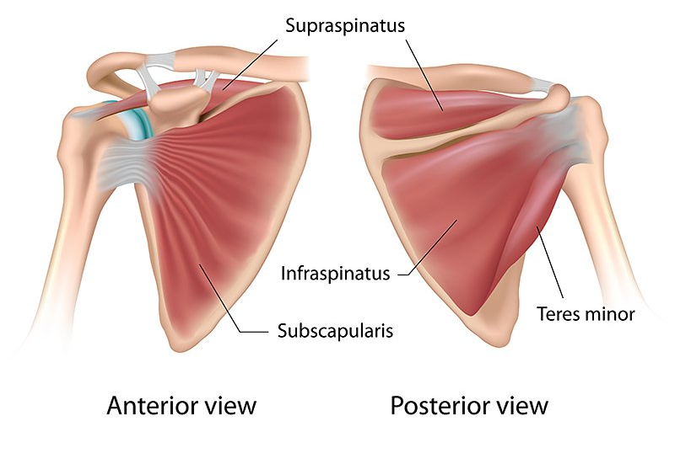
https://www.joionline.net/trending/content/rotator-cuff-tears

How is it caused?
Prolonged overuse or injury.

What are the symptoms?
- Limited active shoulder range of motion (often unable to lift the arm above shoulder height)
- Muscle weakness causing difficulty with lifting.
- Pain during activity and possibly at night when lying on your side.

How is it diagnosed?
A large rotator cuff injury is generally diagnosed from your clinical history and physical examination.

If you have had a trauma to the shoulder and a bony or muscle injury is suspected, you may also be referred for investigations such as an X-ray or Ultrasound scan.

What can I do?
Exercise therapy
There is a powerful muscle on the outside of your arm – the deltoid muscle – that may be re-educated to compensate for the torn rotator cuff muscle.

The following exercises help to train the deltoid muscle gradually so that your shoulder should be done 10 times each or until tired, 2-3 times a day over a period of 12 weeks to strengthen your deltoid muscle. It will aim to reduce your pain and improve both the range of movement and your arm function.

When an exercise becomes too easy, progress to the next stage.

Factors influencing pain and recovery
During your recovery a number of other factors can influence your pain levels. Keep the following factors in mind to help move the healing process along:

Look after yourself
Pain is not usually simply a physical problem. Your general well-being can make you vulnerable to pain and your wellbeing can also be made worse by pain. Looking after your general health and well-being will help recovery. There is helpful advice on this website: https://www.nhs.uk/oneyou

Reduce stress and anxiety
It is normal for people with pain to have stress, anxiety and change in mood. This may affect your ability to cope with the pain and may influence your pain levels. Help is available if you are being affected by stress, anxiety or low mood – see the links below or discuss with your practitioner.

It is important that your whole nervous system is in a healthy state to aid recovery. If your brain is stressed or overworked this may slow recovery. Relaxation is an important part of your recovery. Simple relaxation techniques may help manage pain and stress. Try to set aside some time each day to relax – you can use relaxation techniques as linked below, or simply an activity you enjoy – reading, deep breathing, sitting in the garden, singing – whatever relaxes you.

Find help and support here: https://www.nhs.uk/oneyou/every-mind-matters/
https://www.northessexiapt.nhs.uk/west-essex

Physical Activity
Exercise improves fitness, confidence with movement and strength. It can also help reduce your stress and tension and improve your mood and quality of sleep, helping support you to return to normal activities. Perhaps you could simply start by trying to walk for 10 minutes per day.

Alcohol
Avoid alcohol in the early stages of healing (first three days). Evidence has shown this can slow down recovery and increase the chances of re-injury. https://www.drinkaware.co.uk/

Sleep
Sleep is very important for your wellbeing. Poor sleep quality, and lack of sleep can make managing pain more difficult. Consistently getting 6-9 hours is recommended. Get help and tips here:
https://www.nhs.uk/live-well/sleep-and-tiredness/

Smoking
Smoking can also impact how quickly tissues can heal and affect pain levels. For help with stopping smoking https://www.essexlifestyleservice.org.uk/stop-smoking/ https://www.nhs.uk/better-health/quit-smoking/

How long will it last?
It may take up to 12 weeks (3 months) for your symptoms to improve with exercise so it is important to be consistent and stick with it.

If your symptoms persist or worsen despite the advice given we would recommended you see a healthcare professional for review.

Is there anything I should avoid?
- Progressing before an exercise becomes too easy may aggravate your pain.
- Avoid lifting heavy objects especially when they are not held close the body such as lifting shopping bags into the boot of your car or onto a worktop.

What other options are there?
Physiotherapy
Physiotherapists can provide expert guidance with exercise to help you return to normal activity.

If you wish for your progress to be monitored more closely and require 1:1 physiotherapy treatment please fill out a self-referral form which can found at https://eput.nhs.uk/our-services/essex/west-essex-community-health-services/adults/rehabilitation/musculo-skeletal-physiotherapy and send to epunft.mskphysio@nhs.net

Steroid Injection
This may be useful if pain is limiting your ability to exercise or disturbing your sleep.

Surgery
In certain circumstances, it may be possible to repair a large rotator cuff tear. A referral to an orthopaedic surgeon would be recommended to discuss your options.

