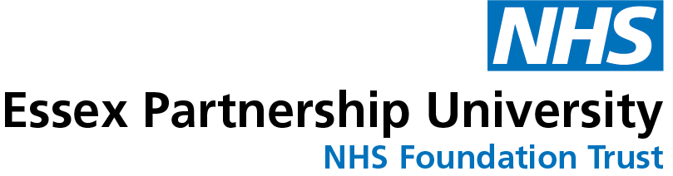
What is Musculoskeletal Low Back Pain?
Musculoskeletal back pain is often referred to as ‘mechanical back pain’ or ‘non-specific mechanical back pain’ and is very common, affecting most of us at some point (or points) during our lives.

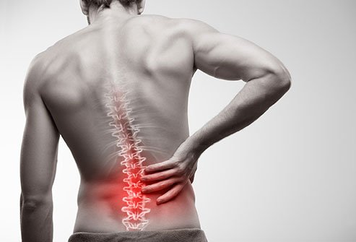

https://www.emedicinehealth.com/back_pain_health/article_em.htm

How is it caused?
Fortunately, low back pain it is not usually caused by a serious problem.

However in most cases, it remains difficult to identify the exact structure causing pain. Many structures in your back including joints, muscles and other soft tissues can be a source of pain often at the same time. Scans such as X-rays and MRI will commonly reveal structural changes which are poorly linked to pain levels. Whether the structure involved is a muscle, a ligament, or any other soft tissue, the treatment is largely the same.

Pain is often caused by a change in activity that has not been tolerated well, such as using working at a computer for longer than normal or lifting heavier objects more than normal. Sometimes this may cause pain to start suddenly and other times it may develop gradually.

There may also be other factors involved. You may recognise some from this list:
- Avoiding movements and protecting your back.
- Fear of damage or not improving
- Feeling down or being stressed.
- Smoking, being overweight, poor sleep, inactivity.
- Difficult relationships at work or at home
- Being unhappy at work
- Stressful life events such as bereavement or illness

Sedentary occupations are more at risk than those involving activity. Being very overweight is another risk factor. Heavy manual work and repetitive lifting do not seem to be risk factors.

What are the symptoms?
- Dull ache or a sharp pain usually localised to the lower back region but can be felt into the buttocks, hips or back of the thigh.
- Pain is noticed when performing certain movements
- The pain fluctuates and is not always constantly at one level
- Difficulty getting in a comfortable position at night or when turning over in bed

Should I be worried?
Only 1% of people with back pain have a rare or serious condition. One rare but serious condition called Cauda Equina Syndrome. This requires emergency treatment. If you experience any of these symptoms you should visit A+E.
- New, significant pain, pins and needles or numbness in both legs
- Loss of feeling or pins and needles between your inner thighs or around genitals
- Numbness around your back passage or buttocks
- Difficulty trying to start, stop or control flow of urine
- Loss of sensation passing urine
- Leaking of urine or not knowing your bladder is empty or full.
- Inability to stop a bowel motion or leaking
- Loss of sensation passing a bowel motion
- Change in ability to achieve an erection or ejaculate
- Loss of sensation in genitals during sexual intercourse

If you would like to read this information in another language please follow this link: https://www.eoemskservice.nhs.uk/advice-and-leaflets/lower-back/cauda-equina

You should also seek advice from your GP if you experience any of the following:
- Severe night pain or night sweats
- Rapid, unexplained weight loss
- Weakness in your legs causing you to trip and fall
- A fever or feeling unwell

You should tell your practitioner if you have a history of cancer or have had a fall, injury or accident.

How is it diagnosed?
Musculoskeletal back pain is normally diagnosed based on you tell us and a physical examination. Scans such as X-ray or MRI are not routinely required unless diagnosis is unclear. This is because they will often show structural change seen with aging which is commonly found in those without pain and is now known not to be a good predictor of pain levels.

What can I do?
Activity adjustment:
In the majority of cases mechanical back pain will settle if you temporarily reduce your activity to a level which does not significantly aggravate your pain. This will allow you to control your symptoms more easily.

For example, it is still completely safe to bend and lift when you have back pain. However, you may have to adjust how often or how heavy you lift for a short time. Try different ways of lifting, like bending your knees. Try to keep the load close to you and do not lift more than you are able to.

Research tells us that avoiding normal activities like lifting will prolong your recovery.

Exercise
Exercise is an essential towards helping your get back to normal activity as soon as possible as well as promoting healing. It can also be helpful in reducing the likelihood of the problem coming back again in the future. For example, research tells us that regular lifting practice is likely to improve your tolerance to lifting.

Movement will help to reduce muscle tension, reduce pain and increase range of movement. Avoiding movement could lead to higher levels of pain and poorer recovery resulting in longer periods off work.

Exercises may cause discomfort but should not increase your pain or symptoms. If a sharp shooting pain is provoked then ease off. As your pain reduces and your movement improves consider progressing to the more difficult exercises.

Remember, although movement may initially be painful but this does not mean that you are causing more damage or making anything worse.

If your back feels tight and stiff, start with some regular stretches. Stretches increase your flexibility but strengthening will enable you to bend, lift and do daily activities for longer with less pain.

Medication:
If you require medication to relieve your pain, you can liaise with your GP or pharmacist to determine the most appropriate medication. It can be difficult to move your neck if you are in too much pain, therefore it is useful to take pain medication, to relieve the pain, enable you to carry out exercise effectively and allow a faster recovery.

Heat therapy:
Heat and ice packs can be used for short term relief of pain and to relax muscle tension. In the first
48 – 72 hours you can try a cold pack on the affected area for 5-10 minutes – this can be a bag of frozen peas wrapped in a damp tea towel. Others may prefer heat – a hot water bottle, a bath or a shower to relax muscular tension.

Factors influencing pain and recovery
During your recovery a number of other factors can influence your pain levels. Keep the following factors in mind to help move the healing process along:

Work
You may be worried about continuing with work, or other responsibilities. It is important to discuss these fears with your practitioner. Remaining at work usually leads to a quicker recovery even if you have to work with modified activities.

Having poor posture does not cause back pain. There is no perfect posture. Staying in one position for long periods can be a factor in your pain. It is important to plan regular breaks and change posture regularly.

Your relationship with your boss and colleagues, job enjoyment, feeling supported at work and returning to work are all very important in helping your recovery. Speak to your employer if you need support at work.

Look after yourself
Pain is not usually simply a physical problem. Your general well-being can make you vulnerable to pain and your wellbeing can also be made worse by pain. Looking after your general health and well-being will help recovery. There is helpful advice on this website: https://www.nhs.uk/oneyou

Reduce stress and anxiety
It is normal for people with pain to have stress, anxiety and change in mood. This may affect your ability to cope with the pain and may influence your pain levels. Help is available if you are being affected by stress, anxiety or low mood – see the links below or discuss with your practitioner.

It is important that your whole nervous system is in a healthy state to aid recovery. If your brain is stressed or overworked this may slow recovery. Relaxation is an important part of your recovery. Simple relaxation techniques may help manage pain and stress. Try to set aside some time each day to relax – you can use relaxation techniques as linked below, or simply an activity you enjoy – reading, deep breathing, sitting in the garden, singing – whatever relaxes you.

Find help and support here: https://www.nhs.uk/oneyou/every-mind-matters/
https://www.northessexiapt.nhs.uk/west-essex

Physical Activity
Exercise improves fitness, confidence with movement and strength. It can also help reduce your stress and tension and improve your mood and quality of sleep, helping support you to return to normal activities. Perhaps you could simply start by trying to walk for 10 minutes per day.

Alcohol
Avoid alcohol in the early stages of healing (first three days). Evidence has shown this can slow down recovery and increase the chances of re-injury. https://www.drinkaware.co.uk/

Sleep
Sleep is very important for your wellbeing. Poor sleep quality, and lack of sleep can make managing pain more difficult and can affect your recovery. Consistently getting 6-9 hours is recommended. There is no evidence different mattresses improve night time pain. Try hot packs or pain killers before you go to bed if needed. Get help and tips here:
https://www.nhs.uk/live-well/sleep-and-tiredness/

Nutrition and weight
Being overweight can increase the physical strain on the body and also contribute to inflammation in your body. Make sure you eat a balanced diet. Adult weight management services are available free to Essex residents here: https://acelifestyle.org/weight-management

Smoking
Smoking is also linked with an increased susceptibility to back pain and slower healing. For help with stopping smoking https://www.essexlifestyleservice.org.uk/stop-smoking/ https://www.nhs.uk/better-health/quit-smoking/

How long will it last?
Most cases of low back pain feel better within 6 weeks although it may take longer for it to resolve. Pain can fluctuate during this time with some days being better than others. Returning to work and progressing your fitness levels will help you led a normal life whilst the pain resolves over time.

If your symptoms have not improved or worsen despite following the advice and exercise provided in this leaflet you will need to visit your GP surgery again.

Is there anything I should avoid?
Bed Rest Is Bad For Backs
We now know that bed rest for more than a day or two can cause you to feel stiff, lose muscle strength, lose physical fitness, lead to higher pain levels, delay your return to work and affect your psychological health.

What other options are there?
Physiotherapy:
Physiotherapists can provide expert guidance with exercise and other supportive treatments to help you return to normal activity.

If you require 1:1 physiotherapy treatment please fill out a self-referral form which can found at https://eput.nhs.uk/our-services/essex/west-essex-community-health-services/adults/rehabilitation/musculo-skeletal-physiotherapy and send to epunft.mskphysio@nhs.net

Community Pain Management Programme:
If you've been in pain for a long time, referral to a specialist programme that involves a combination of group therapy, exercises, relaxation, and education about pain and the psychology of pain may be offered. Speak to your health professional for more information.

Surgery and minimally invasive intervention:
Surgery including disc replacement is not recommended for managing low back pain. Spinal injections are also not recommended for managing low back pain.

Long term back pain which has failed to respond to specialist advice, exercise, and lifestyle improvements may be considered for minimally invasive treatment. A successful response to a medial branch block (a procedure that temporarily affects the function of the nerves supplying some of the spinal joints) would be followed by radiofrequency denervation (burning of the nerves which supply the facet joints of the spine). These procedures have been shown to work up to 50% of the time with nerve regrowth occurring over 6-12 months.

Other useful links

Chartered Society of Physiotherapy advice on managing back pain:
https://www.youtube.com/watch?v=24P7cTQjsVM

Understanding pain in less than 5 minutes- Live Active
https://www.youtube.com/watch?v=C_3phB93rvI

Low back pain – Dr Mike Evans
https://www.youtube.com/watch?v=BOjTegn9RuY

