
What are knee meniscus injuries?
Each knee joint contains an inner and outer meniscus (medial and lateral meniscus). These are thick rubber-like pads of cartilage tissue. They are C-shaped and become thinner towards the middle of the joint. The menisci act like shock absorbers to absorb the impact of the upper leg on the lower leg. They also help to improve smooth movement and stability of the knee.

When people talk about a cartilage injury to a knee, they usually mean an injury to one of the menisci.

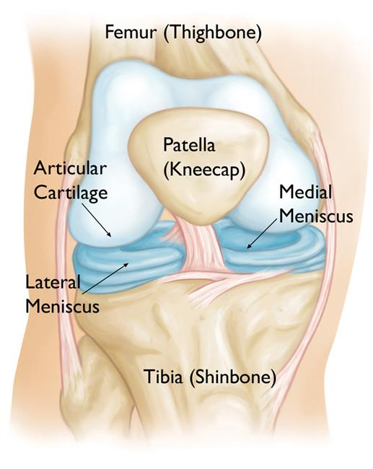

https://orthoinfo.aaos.org/en/diseases--conditions/discoid-meniscus

How is it caused?
- Traumatic meniscus tear: this is usually caused by forceful knee movement whilst you are weight bearing on the same leg.
- Non-traumatic (degenerative) meniscus tear: In some cases a tear develops due to repeated small injuries to the cartilage or due to wear and tear (degeneration) of the meniscal cartilage. This type of tear is commonly found in patients without symptoms and is very common in patients with knee osteoarthritis.

What are the symptoms?
- Pain
- Swelling
- Reduced knee movement, especially when trying to straighten the leg.
- Locking, clicking or giving way (mechanical symptoms)

How is it diagnosed?
Diagnosis is generally made clinically following a history taking and physical examination.

You may be referred for an X-Ray if you have had a trauma and a fracture is suspected or to rule out signs of osteoarthritis. If your knee is not recovering as expected with rehabilitation or diagnosis is unclear you may be referred for further investigations such as an MRI scan.

What can I do?
the early stages (48-72 hours)

Protect the injury with relative rest (keeping moving but resting often).
Optimal loading by gradually increasing the weight through your leg and trying to walk as normally as possible early on. Evidence suggests this aids quicker recovery. If you are struggling with your walking or weight bearing, you may be provided with crutches to help.
Ice applied wrapped in a damp towel to the area for between 10-20 minutes every few hours
Compression bandage such as a tubigrip or neoprene support can be applied to limit and swelling in the injured area.
Elevating the leg above your heart level on pillows will help with pain and may reduce swelling. Both compression and elevation can be completed in-between periods of icing.

Over-the-counter analgesia, such as paracetamol or anti inflammatories such as ibuprofen may also help to reduce your symptoms. If you require further information on pain relief, speak to your GP or pharmacist.

Progressive Exercise
Exercise is an essential part of your recovery following a knee meniscus injury. Strength training has been shown to prevent recurrent knee injuries. They should be done as pain allows, with some discomfort being acceptable. If a sharp shooting pain is provoked then ease off. As your pain reduces and your movement improves consider progressing to the more difficult exercises.

Graded return to running: start with walking and jogging intervals. Increase your distance and speed gradually.

Factors influencing pain and recovery
Whilst you are experiencing pain a number of other factors can influence your pain levels. Keep the following factors in mind to help move the healing process along:

Look after yourself
Pain is not usually simply a physical problem. Your general well-being can make you vulnerable to pain and your wellbeing can also be made worse by pain. Looking after your general health and well-being will help recovery. There is helpful advice on this website: https://www.nhs.uk/oneyou

Reduce stress and anxiety
It is normal for people with pain to have stress, anxiety and change in mood. This may affect your ability to cope with the pain and may influence your pain levels. Help is available if you are being affected by stress, anxiety or low mood – see the links below or discuss with your practitioner.

It is important that your whole nervous system is in a healthy state to aid recovery. If your brain is stressed or overworked this may slow recovery. Relaxation is an important part of your recovery. Simple relaxation techniques may help manage pain and stress. Try to set aside some time each day to relax – you can use relaxation techniques as linked below, or simply an activity you enjoy – reading, deep breathing, sitting in the garden, singing – whatever relaxes you.

Find help and support here: https://www.nhs.uk/oneyou/every-mind-matters/
https://www.northessexiapt.nhs.uk/west-essex

Physical Activity
Exercise improves fitness, confidence with movement and strength. It can also help reduce your stress and tension and improve your mood and quality of sleep, helping support you to return to normal activities. Perhaps you could simply start by trying to walk for 10 minutes per day.

Alcohol
Avoid alcohol in the early stages of healing (first three days). Evidence has shown this can slow down recovery and increase the chances of re-injury. https://www.drinkaware.co.uk/

Sleep
Sleep is very important for your wellbeing. Poor sleep quality, and lack of sleep can make managing pain more difficult. Consistently getting 6-9 hours is recommended. Get help and tips here:
https://www.nhs.uk/live-well/sleep-and-tiredness/

Smoking
Smoking can also impact how quickly tissues can heal and affect pain levels. For help with stopping smoking https://www.essexlifestyleservice.org.uk/stop-smoking/ https://www.nhs.uk/better-health/quit-smoking/

How long will it last?
The majority of meniscus injuries can improve on their own with time and correct management.
If your knee pain is being treated conservatively would be expected to show signs of recovery within 6-8 weeks, although full recovery may take as long as 12-16 weeks.

If your symptoms have persisted or worsen despite following the advice and exercise provided in this leaflet you will need to visit your GP surgery again.

Is there anything I should avoid?
- Overstretching within the first few weeks can put too much strain on the healing tissue.
- You should avoid pushing through pain and work within your pain limits. As your injury starts to heal your pain will reduce and you will be able to do more. You should aim not to increase your pain above a 4-5/10. Your exercises may feel challenging and make the muscles feel achy and fatigued but they should not be increasing your pain excessively for a prolonged period of time. If this is the case then discontinue and contact your physiotherapist.
- Complete rest or prolonged periods of reduced activity are likely to delay your recovery and return to normal function.

What other options are there?
Physiotherapy:
Physiotherapists can provide expert guidance with exercise, gait retraining and where necessary manual therapy to help you return to normal activity.

If you require 1:1 physiotherapy treatment please fill out a self-referral form which can found at https://eput.nhs.uk/our-services/essex/west-essex-community-health-services/adults/rehabilitation/musculo-skeletal-physiotherapy and send to epunft.mskphysio@nhs.net

Surgery:
A referral to an orthopaedic surgeon may be recommended if your meniscus tear was associated with a specific injury and is causing persistent mechanical symptoms such as locking and giving way.

Most operations are done by arthroscopy (keyhole). The types of operations which may be considered include the following:
- The torn meniscus may be able to be repaired and stitched back into place. However, in many cases this is not possible.
- In some cases where repair is not possible, a small portion of the meniscus may be trimmed.

Surgery is generally not recommended for non traumatic meniscus tears. Studies have shown no long term difference in outcomes between placebo surgery and meniscectomy (trimming of the meniscus)

Injection therapy
Steroid injections may be considered in situations where pain and/or swelling has persisted. Non traumatic meniscus tears may often not be the cause of ongoing symptoms. They often exist alongside other conditions such as osteoarthritis.

Steroid injections are generally used sparingly as some studies have shown they can cause potential damage to the joint when compared to those who don’t receive injections when monitored over a period of 2-4 years. Possible benefits may be seen for 4 -6 weeks.

