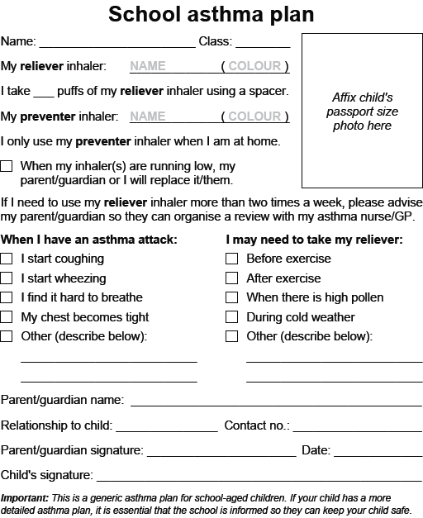

In an emergency see School Asthma Poster

