Larkwood Ward

Young Person
Information Pack

Name:

Welcome to The St Aubyn Centre (SAC)
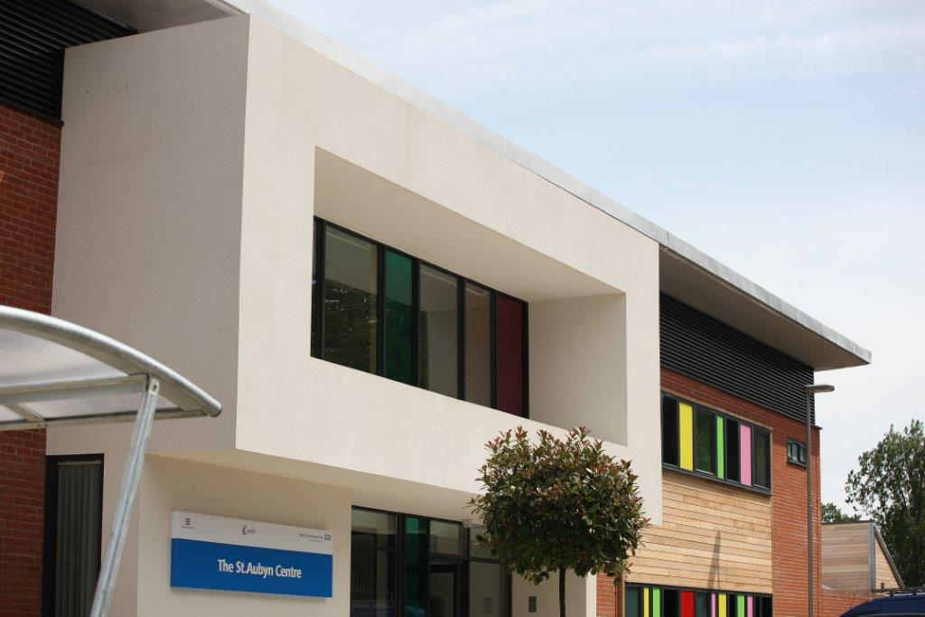

The St Aubyn Centre is a child and adolescent inpatient service provided for people under the age of 18 who require specialist mental health services.
SAC’s team of highly qualified mental health professionals provide top quality assessments, treatments, educational resources and short-term rehabilitation for young people. The unit is a safe place, where staff aim to help each young person feel cared for, secure, and protected.

Table of Contents
Welcome to your care team……………………………………………………………………………………………………..…. 5
Introduction to the Unit……………………………………………………………………………………………………………. 6-8
About the St Aubyn Centre 6
Facilities 7-8
Bedrooms 9
SAC Education 9
How will I begin to recover? 10
Care Pathways………………………………………………………………………………………………………………….…….11-12
How do staff keep me safe on Larkwood 13-14
Helping me feel safe on the ward 13
Observation levels 13
Searches 14
Restraints 14
Debriefs 14
Ward boundaries 15
What is not allowed to bring onto the ward 15
What is allowed to bring onto the ward 16
Non-smoking policy 17
Code of conduct 17
Zero Tolerance statement 17
Use of mobile phones and associated rules 18
Confidentiality……………………………………………………………………………………………...18
Important meetings on Larwood ward 20-22
Ward reviews 20
MDT Assessment 21
CPM 21
CPA 21
CETR 22
Social care 23
Larkwood Therapeutic Group Programme 24
Morning meeting 24
Education 24
Community meeting 24
Therapy groups 25
DBT groups 25
OT group 25
Creative Therapy group 25
Activity co-ordinator 25
Sample Larkwood Group Timetable 26
Other appointments 27-28
Positive Behavioural Support plan 28
Legal Framework 29
Treatment under the Mental Health Act…………………………………………………………………………..…………29
Treatment with consent………………………………………………………………………………………………..……….29
Contacting and Visiting 30
Contacting 30
Visiting 30
Leave 31
Advocacy…………………………………………………………………………………………………………………………………….32
What it is like to be away from home………………………………………………………………………………………….33
Sleep Hygiene……………………………………………………………………………………………………………………………..34
App and Resource Bank for Young People 35

Welcome to your Care Team

When admitted, every young person is assigned a core care team. These are the people who will work most closely with you during your stay.

Consultant Psychiatrist/ Responsible Clinician
Key Nurse
Key Teacher
Ward Social Worker
Key Team
Ward Manager
Modern Matron
Community Care Coordinator

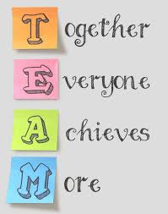

Introduction to the Unit
About the St Aubyn Centre

The St Aubyn Centre was opened in June 2012. It was designed specifically for the needs of young people with mental health difficulties aged between 13 and 18 years old.

Larkwood ward:
Larkwood ward is a regional secure ward providing a Psychiatric Intensive Care Unit (PICU) service. Larkwood caters for young people with severe mental health difficulties that cannot be safely managed on a generic ward. The primary role of Larkwood is to stabilise patients and establish if they need longer term care in a secure environment or can be treated on a general adolescent unit. All of Larkwood’s patients are detained under the Mental Health act at point of admission.
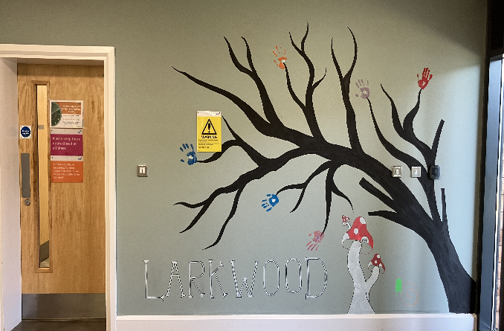
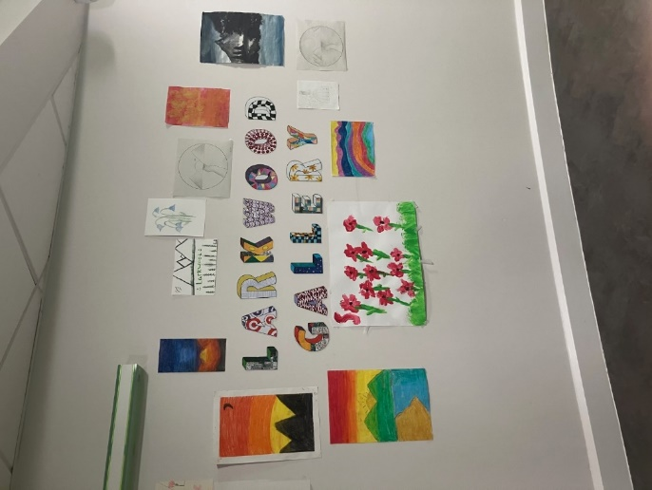

Longview ward:
Longview is a general adolescent unit for young people with a range of mental health difficulties including depression, self-harm, severe anxiety problems, and psychosis. Young people are admitted to Longview because their difficulties have become so severe that they are unable to manage everyday life appropriately and safely in the community.

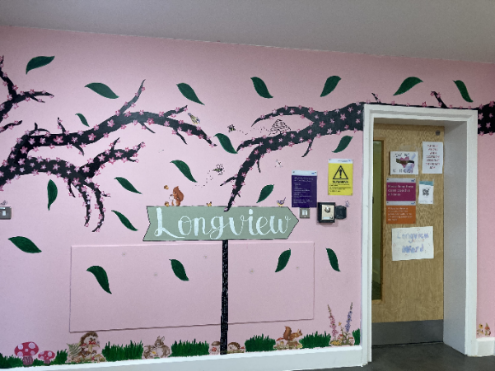

Facilities
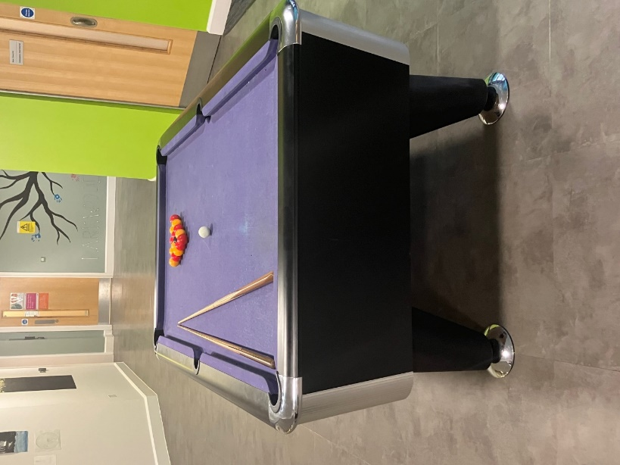
At SAC, we have many area for sports and leisure activites including an outdoor courtyard on each ward, a multi-purpose sports court, a gym, pool table, ping pong table, cinema space, sensory room, music room, art room, and a large social area on each ward.
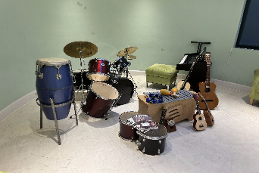
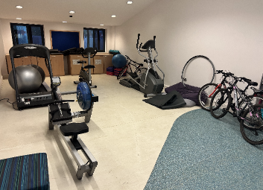

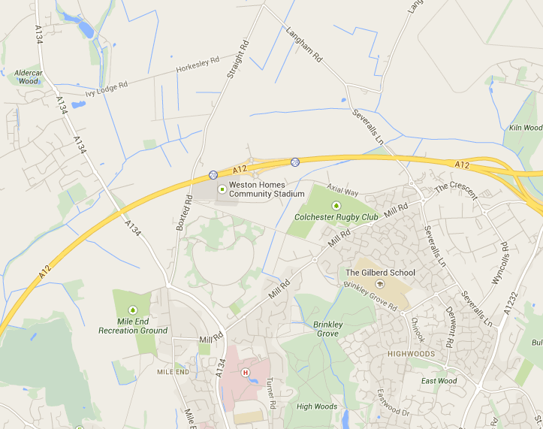

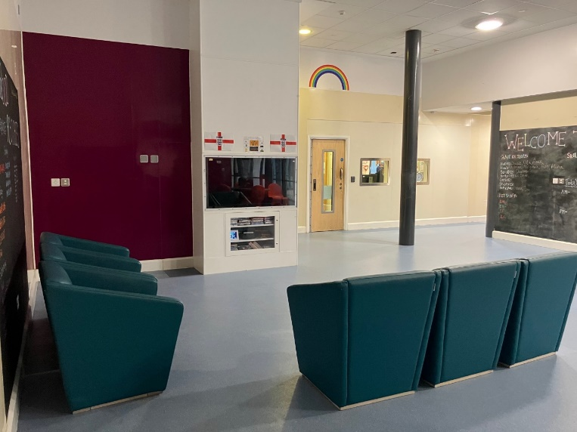
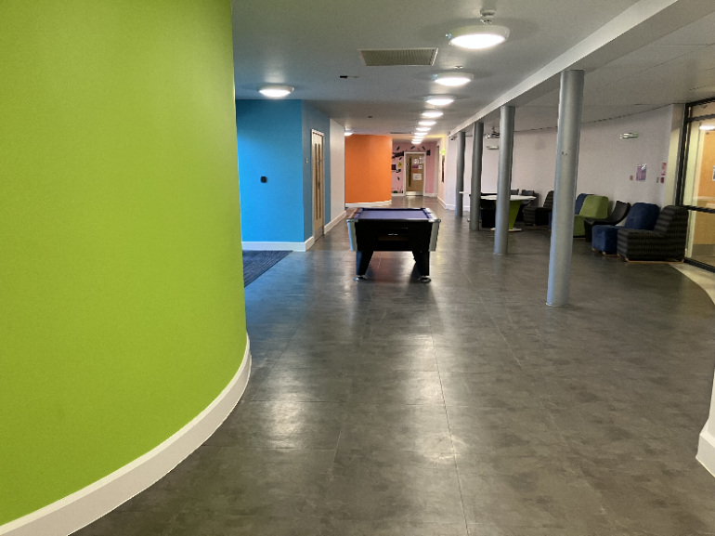
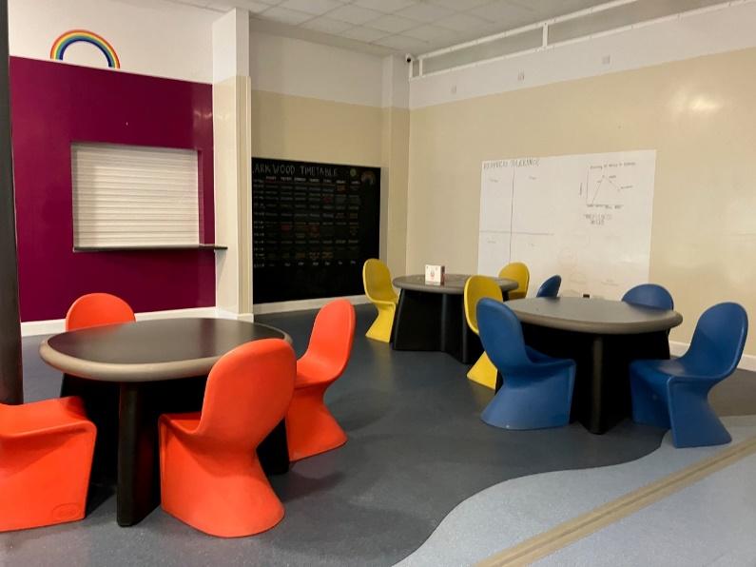
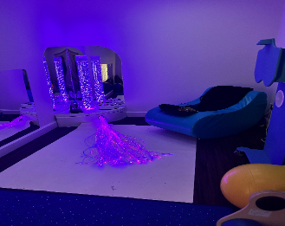
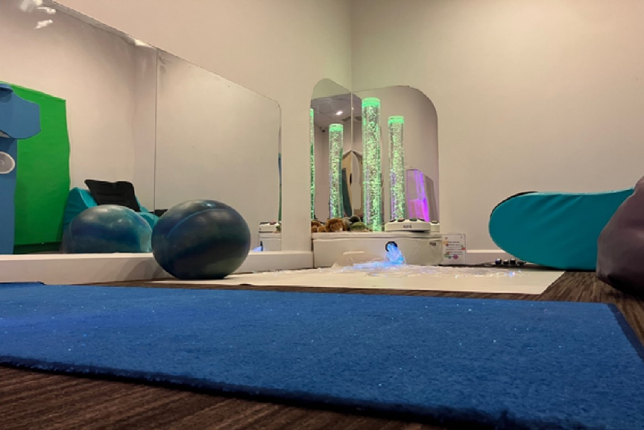

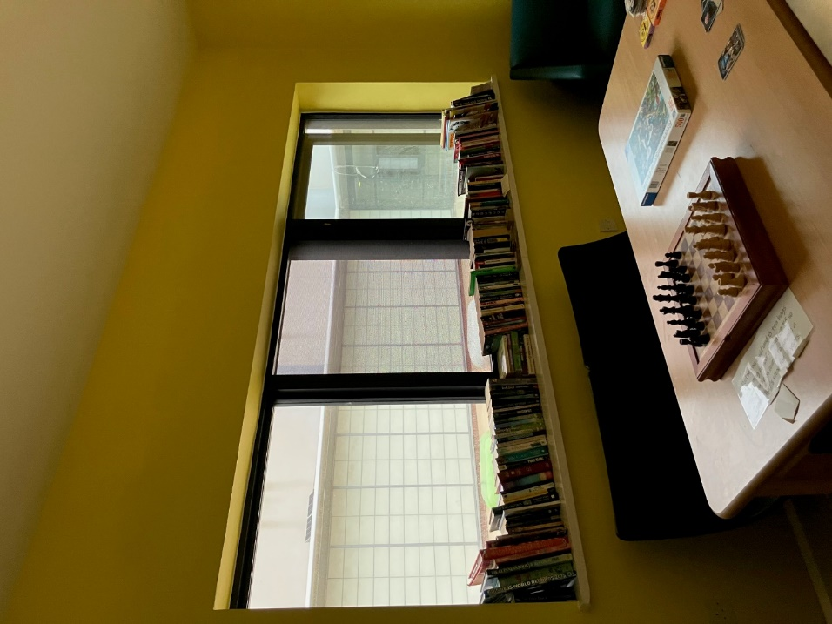
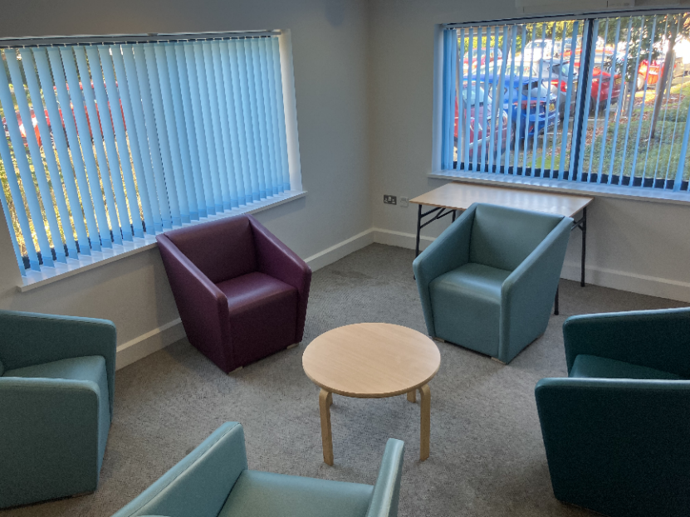
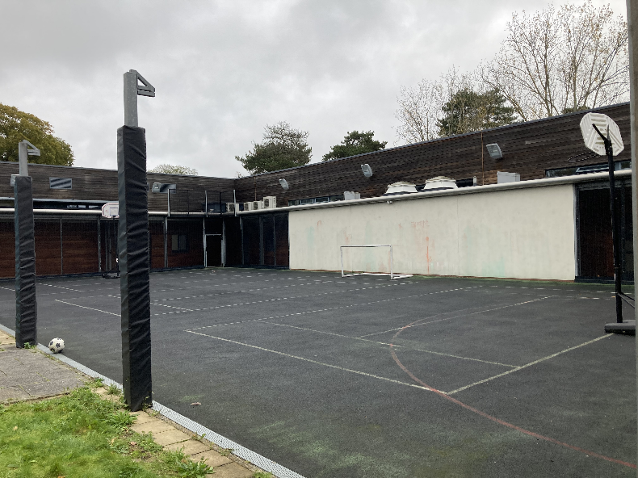
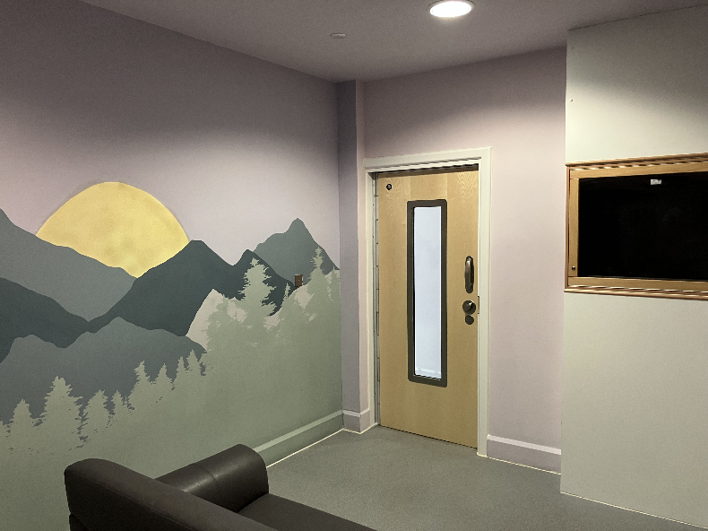
Pictures – left to right:
Music room; pool table; Larkwood’s dining area; The Street; gym; Larkwood’s social area; sensory room (lights on); sensory room (lights off); The Zen Den (Quiet Lounge); sports court; art room; family therapy room.

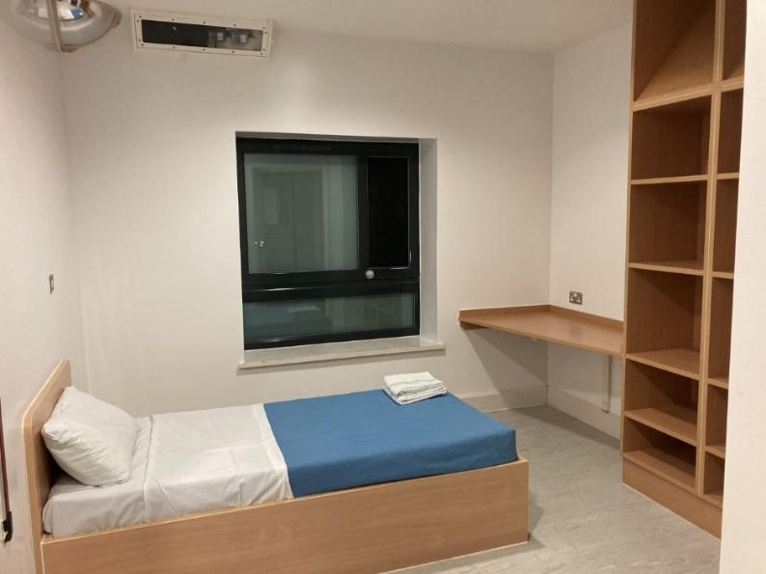
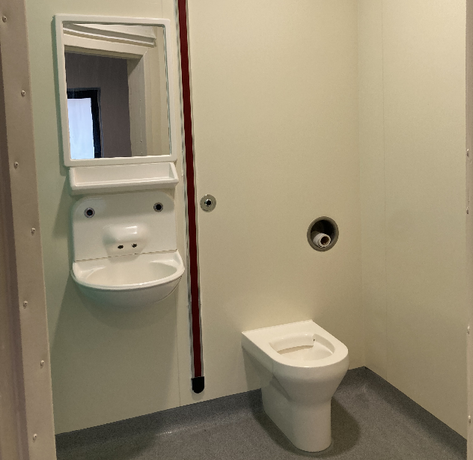
Bedrooms
Each bed space has space for the young person’s belongings, an en-suite and can be customised with posters, drawings and artwork.

SAC Education Department
SAC also has a Therapeutic Educational Department where young people can continue their studies whilst they are in hospital

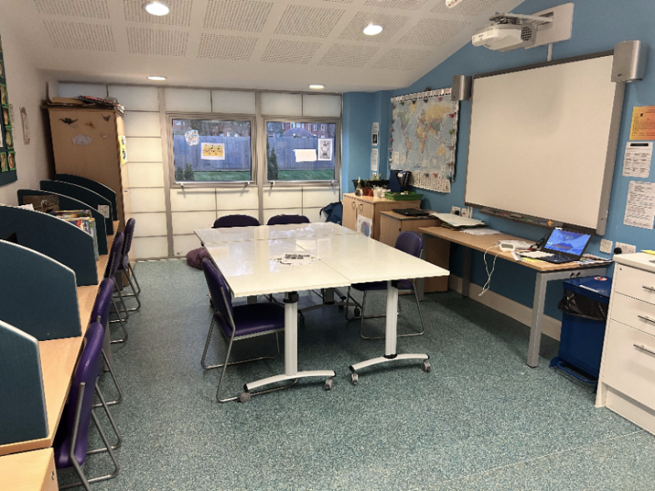
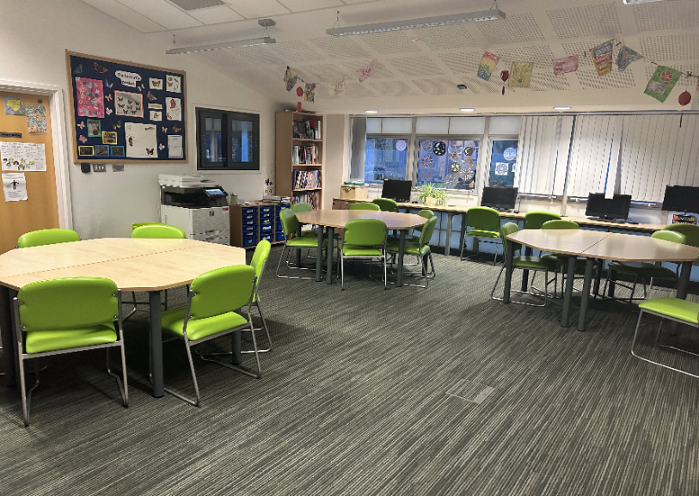

How Will I Begin to Recover?

- By spending time with staff that are trained to help me

- Learning new healthy coping skills

- Thinking about difficult times in my life and finding ways to manage these

- Completing individual care and support plans

- I may require medication to help manage my symptoms

- Going to SAC education so that I continue with my education and keep busy throughout the day

- Knowing that Larkwood ward is a safe place to talk openly and receive support

A stay on Larkwood ward is only the first part of your recovery. The aim is not for you to be completely better when you get discharged, but to be safe and well enough to continue your treatment, and recovery journey, in a general adolescent unit or in the community. There are many negatives to staying in hospital (like missing home and school, and witnessing other people struggling) so we aim to keep admissions to Larkwood ward as short as possible.

DELIVERY OF EVEIDENCE BASED INTERVENTIONS FOR SERVICE USERS.

Young people are allocated a care pathway(s) dependent on their presentation at the point of admission and agreement about what assessment/treatment is required to enable discharge and support recovery. The care pathway determines all the MDT interventions that the young person and their family are offered, including the role of the psychological therapies team. The care pathways are informed by Service Specifications for CAMHS inpatient services, CQC recommendations, NICE guidelines, and the latest evidence and best practice.

Current care pathways are
• Core – PICU and GAU
• Emotion Dysregulation
• Trauma
• Disordered Eating
• Neurodivergent
• Psychosis
• An Eating disorder pathway is being developed currently

Each pathway is regularly reviewed and updated by the MDT team.

Care pathways are regularly monitored and reviewed with young people and their families, and within the psychological therapies and multi-disciplinary teams. Young people can be moved to another care pathway at any point during their admission if clinically indicated.

Please see below the current CORE PICU pathway:

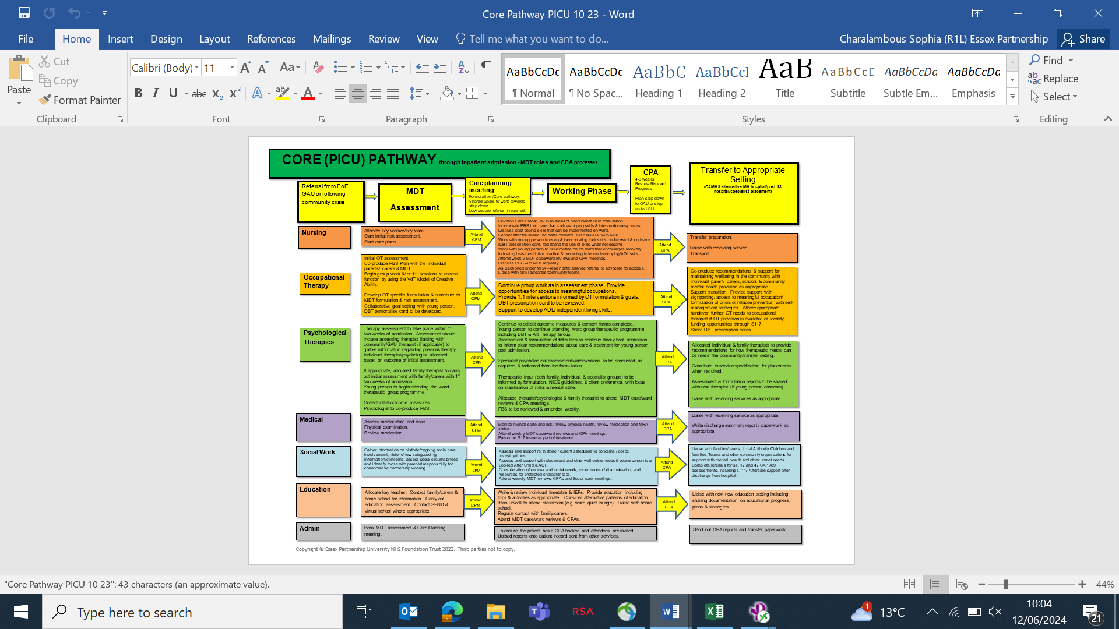
How do staff keep me safe on Larkwood ward?

Observation Levels

While you are staying on the ward you will be regularly observed by members of the nursing team. This means nursing staff will be regularly checking on you to see how you are doing. How often they do this will depend on your level of assessed risk.

Some young people will need a staff member to watch them all of the time, whereas other young people can stay safe while being checked on once an hour. Some young people will have different levels of observations at different times of the day. Usually young people’s observation levels will reduce over the course of their admission.

The different type of observation levels you could be placed on are as follows:
Level 1 observations – young person is observed once every hour. This is the minimum observation level a young person can have while staying on the unit.

Level 2 observations – young person is observed four times in an hour.

Level 3 observations – young person is continually observed by a member of the nursing team.

Young people who have turned 18 years-old on the unit will be nursed on Level 3 observations.

Level 4 observations – young person is continually observed by a member of the nursing team who is within arm’s reach of the young person at all times.

(Sometimes multiple staff may need to complete observations together)

Searches
Staff have the right to ask to search all young people to ensure the ward remains a safe place for all patients and staff.
You are encouraged to abide by the ward boundaries in terms of what items you are allowed to bring onto the unit. As a last resort you can be searched against your will if clearly required to maintain your safety, staff, and other patients.

Restraint
If a young person engages in an activity which may cause themselves and/or others harm, staff have the right to intervene and this could result in physical restraint.

Debriefs
Incidents of self-harm and restraint can be distressing for the person involved and for any other young people who happen to witness this. Therefore young people are offered ‘de-brief’ opportunities after such incidents where they can discuss their thoughts and feelings in relation to what happened. This can enable new insights and learning, thereby reducing the likelihood of future incidents.

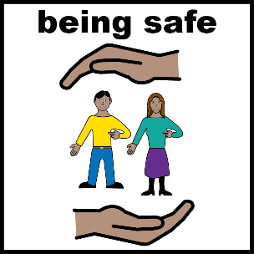

Ward Boundaries

What am I not allowed to bring onto the ward?

The following items are not allowed on the ward or their use will be restricted:

- No clothes with drawstrings / cords, hoodies, or onesies

- No knives, razor blades, scissors or certain glass objects. Glass items like makeup and nail vanish bottles must be kept in the nursing office and can be used under supervision.

- No alcohol or illicit drugs

- No hair dye, aerosols, valuables, chewing gum, bubble gum, towels or flannels (we provide these), staples, or paperclips

- No inappropriate magazines

- No unsealed food or drink items

- No lighters, cigarettes, or vape products.

- Any other items that staff may deem as unsuitable and / or harmful (this will remain at the discretion of nursing staff)

- Cans including Pringles and drinks cans

- Metal ring binder notebooks

- We do not recommend any high value jewellery, electronics or other personal items are brought to Larkwood.




What am I allowed to bring onto the ward?

- Cheap MP3 player
- Money or a bank card
- Basic toiletries
- Slippers
- 1 teddy
- 2 or 3 books
- Sealed food and drink can be brought onto the ward for snack time as part of a balanced diet

- Chargers for electronic devices can be brought on to the unit but must be kept in the nursing office at all times

- Electrical items like hairdryers and hair straighteners must be kept in the nursing office but can be used under supervision

- Clothing for up to 5 days. We recommend high value clothing items are not brought onto the ward.

Some young people on Larkwood ward have found the following to be helpful when struggling. If safe for you to use, we welcome these items on the ward:

- Tangles / fidget toys
- Writing / drawing equipment
- Stressballs
- Puzzle books (Sudoku, word searches etc)
- Journal / diary (not ring binder)





Non-Smoking Policy
In accordance with Essex Partnership University NHS Trust Non-smoking Policy, The St Aubyn Centre is a no smoking area. No smoking is permitted in the building or the grounds for young people and visitors. Young people are not allowed to smoke/vape in vicinity of unit staff, even when on leave with staff.
Health Promotion is a focus of The St Aubyn Centre and you will be prescribed alternatives to smoking if needed, which will be monitored by the medical team.
Code of Conduct
Each and every person on the ward has the right to be treated with respect and dignity including the young people, staff and visitors.

The St Aubyn Centre has a policy of zero tolerance regarding incidents of verbal and physical aggression towards staff and other patients from both patients and visitors. All incidents will be reported to the police. Damage to The St Aubyn Centre property may also result in police reporting, intervention and/or costs for repair being reclaimed from you or your parents/carers.

Zero Tolerance Statement
The St Aubyn’s Centre is a diverse community of patients and staff and we actively welcome and celebrate all the ways that we differ from each other, including: Mental Health Status; Gender; Sexuality; Race; Culture; Age; Belief/ Faith and Differing Abilities.
Many of our patients and staff will have experienced prejudice and hate because of their characteristics, so as part of our commitment to creating a safe environment and valuing all we have a Zero Tolerance approach to discriminatory and hate behaviour.
Anyone engaging in hate behaviours will be, educated, challenged and where applicable reported to the police.


What about your mobile phone?
- On the ward you are allowed access to your mobile phone at all times outside of the ward programme. You must hand in your phone at 09:30 when morning meeting begins and you can have this back at 16:30 when the ward programme finishes. You must hand your phone in at bedtime to encourage good sleep hygiene.
- You must agree to covering up the camera of your phone, (we can provide a sticker for this). This is to ensure that there is no photographing or recording of staff and other young people.
- The phone is not to be used during education and therapy time. There is a contract that outlines all of the expectations around phone use on the ward which you must sign to have access to your phone.
- On the ward there may be restrictions on young people being able to have free use of internet enabled phones due to confidentiality and safeguarding concerns.
- Given the central role of social media and mobile phones in young people’s lives, the ward staff wish to support you to safely manage the use of your phone.

Social Media rules:

- Do not take photos/videos with your phone (including of other patients or staff). You must have your cameras covered at all times
- Do not post anything on social media about other patients and staff
- Do not use inappropriate websites or use any social media platforms inappropriately

Breaching/breaking the phone contract at any point during your admission will lead to you being banned from accessing your phone during your admission. This is to safeguard all young people in our care who may be vulnerable or at risk, cause distress, harm, or violate the privacy of young people and staff on the ward.
Confidentiality
When a worker or organisation says that you can speak to them confidentially, this means what you talk about will be kept as private as possible and that they won't, unless they are very worried about your safety or the safety of others, tell anyone else what you say.
On Larkwood, confidentiality is within the Larkwood MDT, which means at times individual staff members, may need to share personal information you tell them with other key members of the Larkwood team to make sure we are providing the safest and best care for you.
The rules on confidentiality are different depending on your age, but on Larkwood we always try to get your permission before sharing information about you with people outside of the Larkwood team.
We do often find it useful to talk to other people about you (e.g. teachers, community mental health professionals, social workers) so we can understand more about your difficulties and how best to treat you. We do not share information with such people until we have your (or your parents/carer) consent.
If you are under 16 we do not need your consent to treat you, or to share information about you, as long as your parents/carers consent. Once you turn 16, you have a legal right to confidentiality and to refuse or consent to your own treatment, without the need to involve your parents/carers. It can still be useful to involve your parents/carers, so that you can listen to their views and they can try to support you. The difference when you reach 16 is that you make the final decisions.
Important Meetings on Larkwood Ward
- Care Planning Meeting (CPM) (young person does not attend and gets feedback afterwards)
- CPA’s
- CETR
Ward reviews:
- Ward Review Part 1: Every Wednesday morning (young person attends)
- Ward Review Part 2: Every Thursday (young person receives feedback afterwards)

Ward Reviews:
Ward reviews take place in two parts each week.
During Part 1 Reviews you have the opportunity to review your care and treatment with your consultant psychiatrist and a few other key members of the MDT team. This includes making requests about changes in your care plan, leave, therapies, and medication.


During Part 2 Reviews a larger MDT team (including psychiatrist, doctors, therapists, nurses, and education team) discuss your progress over the previous week, as well as your requests, and confirm any changes to your care and treatment plan, which may include current level of risk, leave, medication, and discharge planning. After Part 2 reviews, you are given written and/or verbal feedback from a nurse who attended the review.

MDT Assessment:
An initial Multi-Disciplinary Team (MDT) assessment will take place during the first 2 weeks of your admission. This will involve the members of the SAC team observing you in different environments, and talking to you about your experiences. A senior member of the team will contact your parents/carers to gain further information about your history and presentation, as well as their thoughts about what could help you during your admission.

CPM (Care Planning Meeting):
2 weeks after you admission, a meeting will held with staff who know you well from both inside and outside the hospital. They will share all the information they have gained since knowing you to try and understand why you are currently struggling and what they can do to help you going forwards. A plan will be produced at the end of this meeting explaining what care and treatment you will receive while in hospital. You and your family will receive a copy of this.

CPA:
A Care Programme Approach (CPA) review will occur within 6 weeks of the MDT assessment and then at least every six weeks thereafter. Those involved in your care will be invited to this meeting, including parents/carers and community professionals, as well as Larkwood staff. The meeting will usually be chaired by your consultant psychiatrist, and it is an opportunity to discuss your progress on the ward since admission/last CPA and decide what needs to happen going forwards.
Different options considered at a CPA review may include discharge, transfer, or a longer admission on Larkwood. This depends on a number of factors including: the impact of the admission on your mental health so far, your engagement in the ward programme, and yours and others preferences. You can be accompanied by an independent advocate during this meeting to support you in making your views clear to the team.

Care, Education and Treatment Reviews (CETRs):
Young people with a learning disability and/or autism will be invited to a Care, Education and Treatment Review (CETRs) during their admission.

CETRs are focused on those young people who have either been, or may be about to be admitted to a specialist mental health / learning disability hospital either in the NHS or independent sector. If the young person goes into hospital, the CETR checks their assessment, treatment, and the plan for admission and discharge to ensure that the hospital stay is as short and effective as possible. Parents/carers, community and inpatient professionals are all invited to the CETR. Recommendations can also be made by the CETR panel.

Three Ways a Young Person can be Referred to Social Care for Assessment and Intervention following Admission

Social Care
THREE
ONE
Point of admission

Discharge planning throughout admission

Statutory Obligation on team for referral to access s117 After-Care resources
Consent Required
Team Recommendation

Refer to Social Care when young person on Section 3 of the MH Act for Multi Agency Discharge Planning

No Consent Required / Dependent on Risk
Any point during admission
Refer to Social Care due to Safeguarding concern/health and development is likely to be significantly impaired
TWO
Refer to Social Care as Child in Need due to complex needs & admission to hospital

Larkwood Therapeutic Programme

Larkwood ward has a ward timetable which is designed to bring routine and structure to your days, and to ensure you engage in daily meaningful activity (all of which are very important for good mental health). You are expected to engage in this therapeutic programme on Larkwood.

Morning meetings:

Every weekday morning at 9.30am there is a morning meeting where you are notified of the different appointments, groups and meetings which are taking place on the ward that day, and where you can discuss any concerns about the day ahead. Following this meeting, you are taken directly to the education department to start your school day.

Education:

When you are admitted to Larkwood you are allocated a key teacher who will work with you to plan your education programme. The Head of Education and the key teacher will normally speak to your community school to discuss your educational needs and to get appropriate work. Each young person will have an individual, personalised timetable aimed at meeting their learning and mental health needs.

You will spend the morning of education in your key group of four or five young people each working on you own individually set work. In the afternoons, there are a range of therapeutic group activities which are often creative or physical. There is also the option of a further study session.

Community Meeting:

Every Tuesday at 15.30pm ward staff, MDT members, and all young people meet together to discuss various topics about Larkwood to ensure the ward is a safe and friendly place for the young people to reside. Topics discussed in this meeting include any concerns about the ward, ward dynamics, innovation projects happening on the ward, ward meals, and ward activities. We welcome you to be actively involved in this meeting to provide your views.


Therapy Groups: On most weekdays, there are therapy groups (usually in the afternoon after education) that are facilitated by trained staff from SAC therapies team. These groups include DBT skills group, creative arts therapy group, and occupational therapy (OT) groups.
The groups are designed to offer a range of therapeutic experiences including having different opportunities to express themselves, and learn new coping skills.
DBT Skills Groups:
These groups focus on facilitating you to learn and practise skills and strategies to help you manage distress, difficult emotions, and relationships, more effectively. DBT skills groups also include regular mindfulness practice. ​The DBT ​skills groups take place ​ twice a week for young people on Larkwood and ​are facilitated by a mix of DBT trained clinicians, and teachers from the SAC education department.

Occupational Therapy Group:
There will be a group run on Larkwood by the Occupational therapists as part of the therapeutic timetable. In this group, the meaningful activities you need and want to do in life will be looked at and how you can use coping strategies, adapt your environment and learn new skills to be able to function effectively. These groups are interactive and incorporate psychoeducation, group discussions, practical and creative activities.

Creative Art Therapy Group:
The ward offers you the opportunity to attend creative arts therapy groups. These are spaces where you are able to express themselves without the pressure to use words.

Activity Co-ordinator: On Larkwood we have an activity coordinator who organises activities that are aligned with the young people’s interests. The activity co-ordinator works with you to build a timetable of activities that help you enjoy your interests and explore new creative outlets.

 | Monday | Tuesday | Wednesday | Thursday | Friday
09.30 – 09.45 | Morning Meeting | Morning Meeting | Morning Meeting | Morning Meeting | Morning Meeting
09.45 – 10.45 | Education | Education | Education | Education | Education
10.45 – 11.15 | Break/Snack Time
11.15 – 12.15 | Education | Education | Education | Education | DBT/ Coping Skills group: Distress Tolerance
12.15 – 13.30 | Lunch
13.30 – 14.15 | Education | Education | DBT Group:  Emotion Regulation/  Interpersonal Effectiveness | Education | Education
14.15 – 15.00 | Education | Education | Education | Education | Education
15.00 – 15.30 | Break/Snack Time
15.30 – 16.30 | Nursing Led Activities/Self-led time | Community Meeting | Nursing Led Activities/Self-led time | Art Therapy Group | Nursing Led Activities/Self-led time
16.30 – 17.30 | Nursing Led Activities/Self-led time | Nursing Led Activities/Self-led time |  | Nursing Led Activities/Self-led time | Nursing Led Activities/Self-led time
17.30 – 18.30 | Dinner
18.30 – 19.30 | Social Media Group
19.30 onwards | Nursing Led Activities/Self-led time
*Please note that this timetable is subject to change.
Sample Larkwood Group Timetable

Other appointments
Dependent on individual needs, a number of other therapeutic approaches can be provided to you and your families during your admission to Larkwood. These include: trauma-focused assessment and interventions, cognitive behavioural therapy (CBT), systemic therapy, creative arts therapy and occupational therapy.
Some young people who are admitted to Larkwood ward will meet with members of the therapy team on an individual and/or family basis. It is acceptable for you to miss education or group therapy for these sessions.
You may be offered appointments with an individual therapist or psychologist during your stay to help understand your difficulties more or to receive specialised psychological treatment. Because most admissions to Larkwood ward aim to be short term, if psychological work is provided it will normally be more assessment based and the focus will be on providing recommendations for your future treatment. *
* Like any previous individual therapeutic sessions (assessment and/or therapy), inpatient sessions provide a confidential space where you can explore and make sense of your difficulties and find ways forward. The individual worker will explore with you how information from these sessions will be shared with community professionals and parents/carers (e.g. via the ward reviews feedback and CPA processes). If you have capacity/competency, you have the right to choose who this information is shared with outside of Larkwood MDT, with only safeguarding concerns overriding this consent process. It is essential that you feels safe within this therapeutic space if these sessions are going to be useful to you and aid in your mental health recovery.
You and your family may be offered appointments with a family therapist where you meet as a family to think about ways of communicating with, and supporting each other, more.
You may see the Larkwood social worker for regular meetings if you are either a Looked after Child, open to social care and/or there are any safeguarding concerns.
You may be offered individual appointments with an Occupational Therapist (OT) if you need support to engage in the activities that are important to you in life. The OT will usually complete an assessment to identify any support you may need when you leave hospital. They can also offer support so that you can practice things like daily living skills, learn coping strategies and problem solve barriers that might be stopping you doing the things you need and want to.
You will get to meet with your consultant psychiatrist or a ward doctor during your Part 1 reviews each week but you may require extra meetings if you are having particular mental or physical health difficulties, or need more frequent reviews of your medication regime.

Positive Behavioural Support Plan
Each young person admitted to Larkwood will have a Positive Behavioural Support Plan (PBS) created. This will help you and staff to help identify and understand the function of your negative or challenging behaviours with support of positive behaviour reinforcement.
Contributions to your PBS plan are made by Larkwood MDT, yourself, and your parents/carers. You will meet with a member of the SAC therapy team to gather information to be included in this plan. In the first few weeks of admission, your parents/carers and your key nurse will be asked to complete a crib sheet with similar questions to include their contributions. Your PBS plan is regularly reviewed with you and by MDT members during weekly ward reviews. You can request a copy of your PBS plan at any point.

The Legal Framework for Admission and Treatment
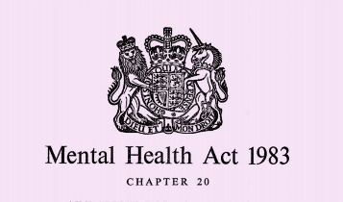
Treatment under the Mental Health Act

All young people admitted to Larkwood are detained under the Mental Health Act. The Mental Health Act is the law used to admit, detain, and treat adults, children and young people who need assessment and treatment for a mental disorder. Its full name is the Mental Health Act 1983 and it was amended by the Mental Health Act 2007.

If you are a detained patient under the Mental Health Act, you are still encouraged to take an active part in your management plan. You can, however, be kept on a ward against your will to ensure your safety and/or the safety of others, and receive clinically indicated assessment and treatment even if you do not consent to this. If you do not feel you should be detained under the MHA, you can request to appeal your detention.

Treatment with Consent

Some young people on Larkwood will have their section removed during their admission. Once this occurs discharge or step down should be planned promptly, but the young person will be an informal patient while they wait for this.

As an informal patient your consent is sought regarding restricting your liberty at times for your own safety. This may include limiting your leave out of the unit, implementing restrictive practices such as level 3 and 4 observations, searches, and/or restraints. If you do not consent to these restrictions, consideration will be given to either ending your admission and you being discharged with a robust community plan, or seeking another assessment under the Mental Health Act.

If, as an informal young person, you request to leave hospital, a thorough risk assessment will be undertaken. If you are deemed safe to leave hospital, you cannot be detained against your will. In some cases there may not be a safe discharge destination yet identified. In these circumstances The Children Act 1989 may be used do what is reasonable to safeguard or promote your welfare whilst you remain in hospital (including preventing you leaving on a short term basis).

As an informal patient, your competence (under 16) and capacity (16 and over) to consent to admission and treatment is regularly reviewed. If, at any point, you lack the ability or willingness to consent, consideration to the Mental Health Act or other forms of legal framework for the admission will be considered.

Contact and visiting on Larkwood
Contacting us: Parents/carers can reach the SAC between 9am-5pm weekdays on: 01206 334600, or call directly through to Larkwood Ward any other time on: 01206 334622/23.
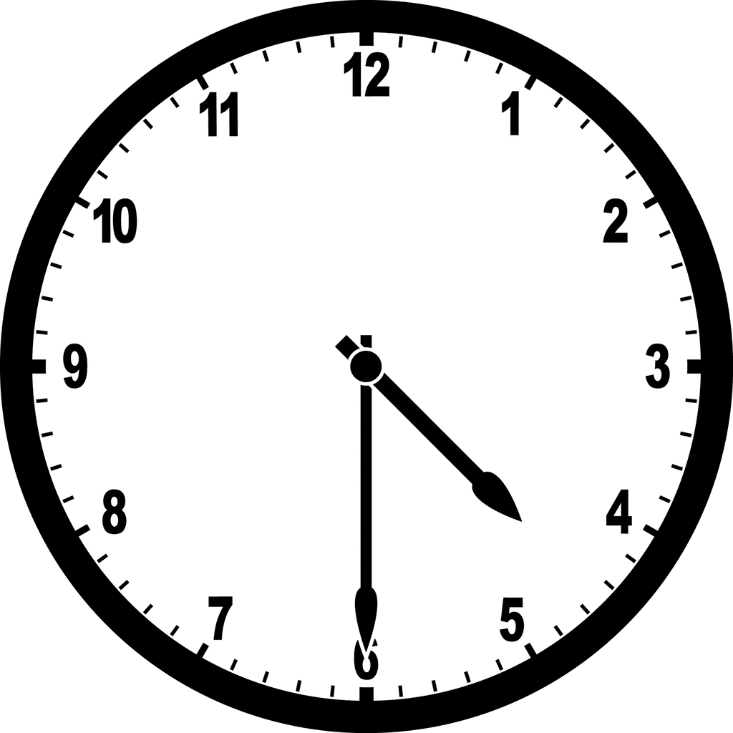
Visiting times: Visits take place between 4:30pm – 9pm weekdays or any time before 21:00 on weekends and school holidays. The ward should be made aware of any visits beforehand so that an appropriate visiting room can be booked.
Any under 18 year-old visitors should be accompanied by an adult.
All visitors will be asked to place any restricted items as well as any mobile devices into a locker when they arrive at the unit. Bags will also be searched for the safety of the young people.
When we will contact parents/carers: A young person’s key nurse will contact families/carers at least once per week to offer updates (including risk incidents), support and advice. Parents/carers are welcome to call anytime 24/7, although the ward cannot always guarantee a telephone response time. If there is no answer this may be due to the team supporting young people on the ward at the time.

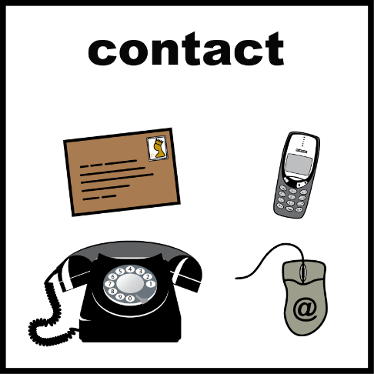

Leave

Leave refers to the time you are allowed to have away from the ward. Unfortunately it is not possible for you to have leave whenever you feel like it because the staff need to be able to manage your safety and the safety of the other patients.
Leave is part of the treatment process as you make your journey back to living in the community. Leave is important so you can practice coping in a non-hospital environment and so you can potentially maintain connections with your community (e.g. family, school, community professionals).

You can discuss your treatment plans and leave allowance in your part one ward reviews each week.

Leave may be in the grounds of the hospital, in the local area (i.e. Colchester), or at home. Your leave may be escorted (i.e. with a staff member), accompanied (i.e. with a family member), or unescorted (i.e. on your own).
All leave has a time limit which could be anything from five minutes to a number of days and nights in a row (i.e. extended overnight leave). The length and type of leave you are given is based on your treatment plan and level of assessed risk.
When a young person is initially admitted to Larkwood ward they will be granted minimal leave off the ward. As the team become more aware of a young person’s mental state and risks, leave may be gradually increased, usually starting with escorted leave in the grounds. All leave from the ward is thoroughly risk assessed at the time leave is scheduled and may be suspended if it is not safe to take place.

Young people who are detained under the Mental Health Act need a Section 17 leave form to be written up by their responsible clinician prior to them being able to access their leave. The form will be written after the team and you agree to it together. Leaves cannot be granted without the forms being completed in advance.
Advocacy

Advocacy means getting support from another person to help you express your views and wishes, and to help make sure your voice is heard. Someone who helps you in this way is called your advocate. (Mind, 2017)
What does an advocate do?
How your advocate helps you is up to you – they're there to support your choices. For example, they can:
- listen to your views and concerns
- help you explore your options and rights (without advising you in any particular direction)
- give you information to help you make informed decisions
- help you contact relevant people, or contact them on your behalf
- accompany and support you in meetings or appointments

An advocate will not:
- give you their personal opinion
- solve problems and make decisions for you
- make judgements about you

Larkwood advocates contact details:
If you are on Section 2 or 3 of the Mental Health Act you are entitled to be supported by an Independent Mental Health Advocate (IMHA) from Rethink – Claire Jackson can be contacted by calling 0300 790 0559 or emailing claire.jackson@rethink.org. You can also ask ward staff who will be happy to make a referral for you.

If you are an informal patient you can choose to have an advocate from Barnardos. Please call 0800 652 4546 (free from a landline) or 01268 558448, or email NEEMAS@barnardos.org.uk.

What it is like to be away from home?

Lonely A relief

Being away from home

A needed Scary
break

If you are upset, worried, stressed or feeling in any way distressed about being away from home, please let us know so we can support you. Being away from home can be very difficult.

Sleep Hygiene
Sometimes being so far away from home, being in new surroundings, or having difficult with your mental health can impact upon your sleep. If this happens to you please ask us to help.
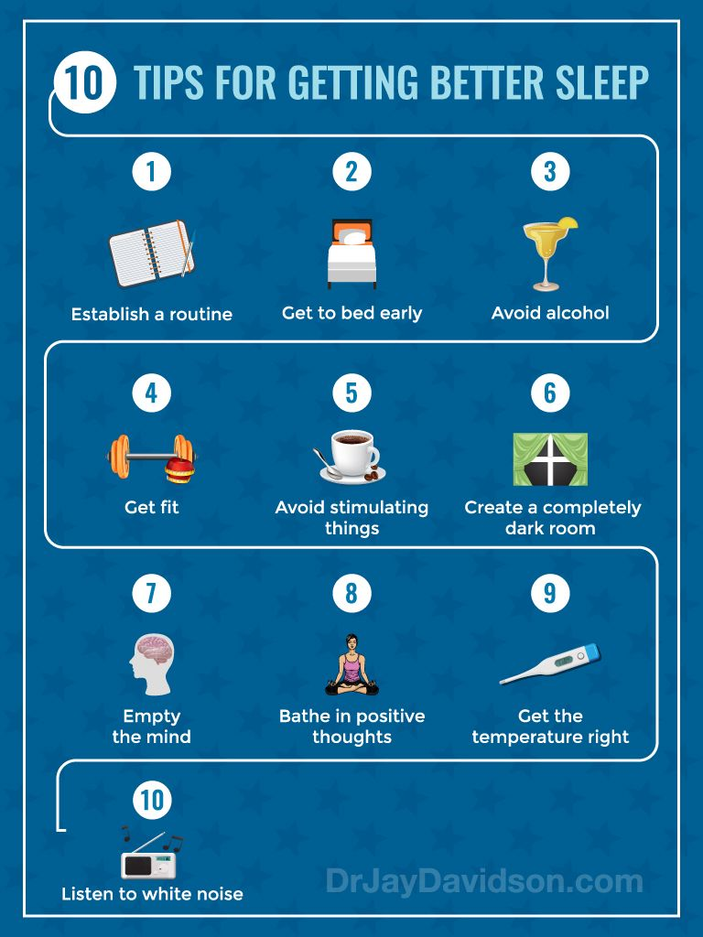

App & Resource Bank for Young People
The St Aubyn Centre wish to ensure that young people feel well supported before and during their admission. Accessing online materials is one way you can independently access support.
It isn’t unusual for young people to find admission to hospital challenging, so it is important young people are reminded how to access support during this time.
CAMHS approved Resources Website:
https://www.camhs-resources.co.uk/
CAMHS approved videos for Mental Health & Wellbeing:
https://www.camhs-resources.co.uk/videos
The CAMHS approved website also has a collection of downloadable self-help guides exploring Mental Health & Wellbeing, Self-harm, Resilience building, Neurodiversity and more: https://www.camhs-resources.co.uk/downloads
CAMHS have created their own website that acts as a resource bank. This website can be used by young people, carers, and professionals.
Quick Access: Apps | Quick Access: Websites | Quick Access: Books
Low Mood, Depression & Anxiety:  - MoodGym  - What’s Up  Self-harm / suicidal thoughts:  - Calm Harm  - My 3  ASD:  - Chill Panda  Getting support:  - Me2  Sleep hygiene:  - Sleep Restore  Pain:  - Overcoming Pain | Low Mood, Depression & Anxiety:  - Anxiety UK  Self-harm / suicidal thoughts:  - National Self-Harm Network  Mindfulness / Meditation:  - Wee Seeds  ASD:  - Operation Diversity Academy  Getting support:  - Young Minds | Low Mood, Depression & Anxiety:  - Depression A Teen’s Guide to Survive  - My Anxiety Handbook  Self-harm / suicidal thoughts:  - Can I Tell You About Self-Harm?  ASD:  - The Autistic Brain / M is for Autism  Getting support:  Don’t Let Your Emotions Run Your Life

