The St. Aubyn Centre
Child and Adolescent Mental Health Unit

Longview Ward

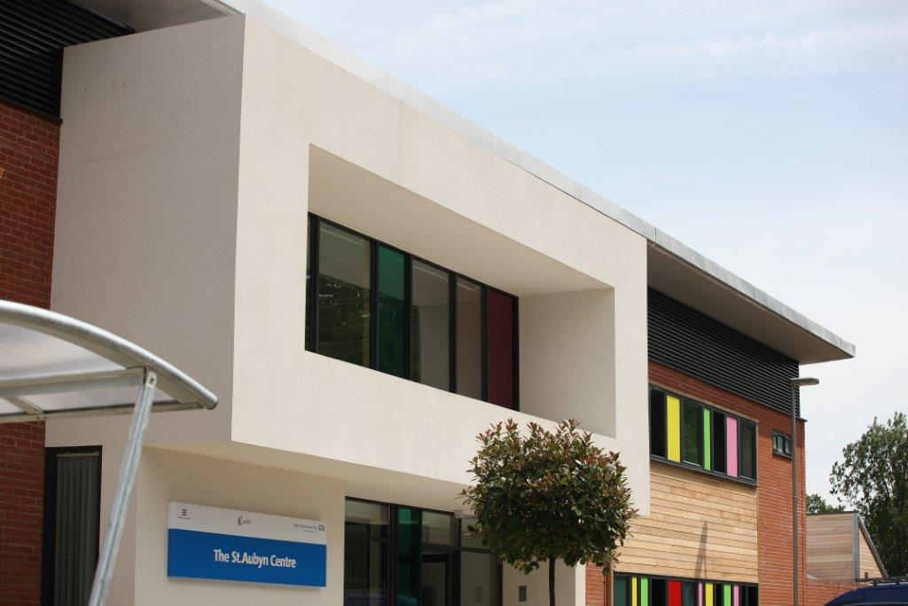

A Guide for the Parents / Carers of Young People staying on Longview at the St. Aubyn Centre (SAC)

Table of Contents
Contact numbers and Address 4
Welcome to your young person’s care team ……………………………………….5
Organisational structure …………………………………………………………………6
Introduction to the Unit ……………………………………………………..………..7-10
About the St Aubyn Centre …………………………………………………………..7
Facilities 8-9
Bedrooms 10
SAC Education 10
Delivery of evidence-based interventions for service users……..………….11-12
Keeping your young person safe 13-15
Helping your young person feel safe on the ward ….13
Observation levels 14
Searches 14
Restraints 14
Debriefs ….15
Ward boundaries 16-20
What is not allowed to bring onto the ward 16
What is allowed to bring onto the ward 17
Confidentiality and Information sharing 18
Non-smoking policy 18
Code of conduct 18
Use of mobile phones and associated rules 19
Zero Tolerance statement 20
Treatment at the St Aubyn Centre 21-29
The aim of treatment at the St Aubyn Centre 21
Care pathway for Longview 22
Stage 1 and 2 22
Stage 3 23-24
Stage 4 24-25
Stage 5………………………………………………………………………….26-27
Social care 28
Positive Behavioural Support Plans 29
Longview Therapeutic Group Programme 30-32
Morning meeting 30
Education 30-31
Community meeting 31
Therapy groups 32
DBT groups 32
OT group 32
Creative Art Therapy group 32
Online Parent and Carer group 32
Sample Longview Group Timetable 33
Other important meetings 34
Weekly ward review 34
CETRs 34
Visiting and Leave 35
Visiting hours 35
Leave 35
Other services 36-40
Advocacy 36
Spiritual Needs 36-37
Translation Services 37
Sign Language Specialist 37
Speech and Language Services 37
Obtaining second opinion 37
Accessing Health Records 37
Patient Advice and Liaison Service (PALS) 37-38
Family Ambassadors 39
Legal Framework 40
Treatment with consent……………………………………………………………40
Treatment under the Mental Health Act 40
Providing Feedback 41
Compliments and Complaints 41
Testimonials 41
Websites and Apps 42-44
Definitions/Acronyms ….…………45

Contact Numbers

St Aubyn Centre Main Reception 01206 334600 Please use between 9am–5pm, Mon-Fri

Longview Ward 01206 334612 / 13 Please use after 5pm and at weekends

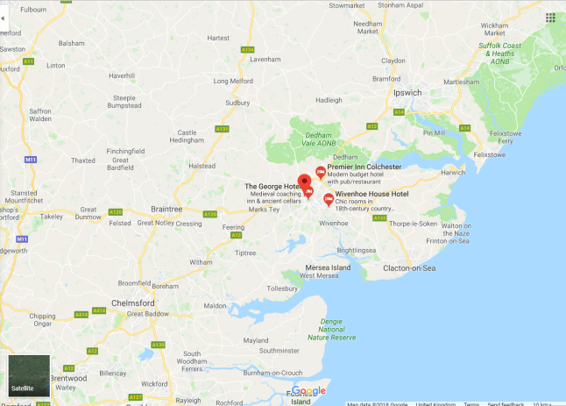

Address and Location

The St Aubyn Centre
2 Boxted Road
Colchester
Essex
CO4 5HG

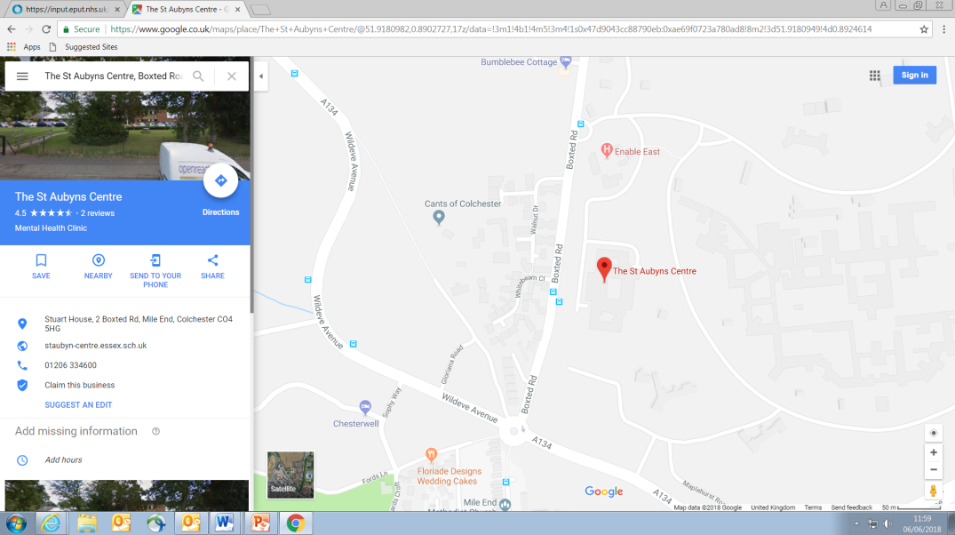

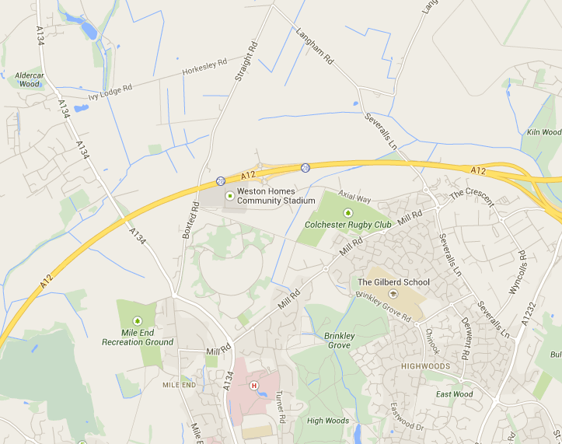
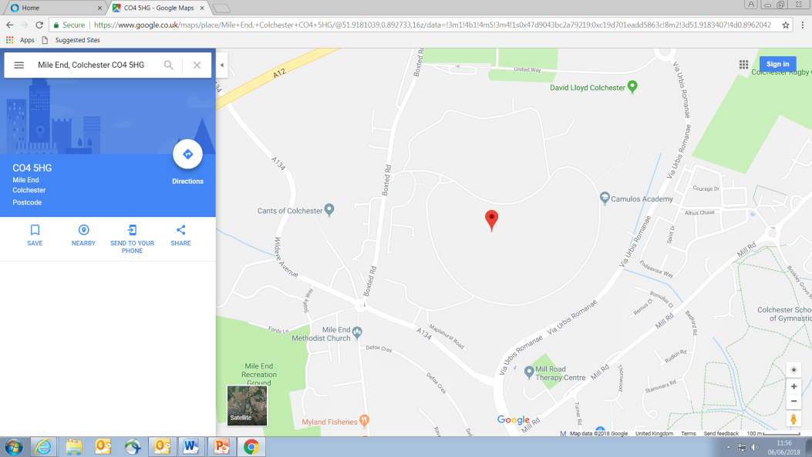

Welcome to your Young Person’s Care Team

When every young person is admitted to Longview, they are assigned a core care team. The people identified as your young person’s core team will be the key points of contact whilst your young person is under our care:

Consultant Psychiatrist /Responsible Clinician
Key Nurse
Key Teacher
Ward Social Worker
Key Team
Ward Manager
Modern Matron
Community Care Coordinator

(Admin: please complete as much as possible and send to parents/carers within 72 hours of admission

Organisational Structure
Multi-Disciplinary Team (MDT)

- Psychologists
- Psychotherapists
- Family Therapists
- Occupational Therapists
- Consultant Psychiatrists
- Specialty Doctors
- Social Workers
- Education team
Nursing Team
- Charge Nurses
- Staff Nurses
- Associate Practitioners
- Health Care Assistants

Longview Ward Manager
Nursing Team
- Charge Nurses
- Staff Nurses
- Associate Practitioners
- Health Care Assistants
Larkwood Ward Manager
Unit Manager / Modern Matron

Associate Director
Director

Introduction to the Unit
About the St Aubyn Centre
The St Aubyn Centre was opened in June 2012. It was designed specifically for the needs of young people with mental health difficulties aged between 13 and 18 years old.

Longview ward:
Longview is a general adolescent unit (GAU) for young people with a range of mental health difficulties including depression, self-harm, severe anxiety problems, and psychosis. Young people are admitted to Longview because their difficulties have become so severe that they are unable to manage everyday life appropriately and safely in the community.

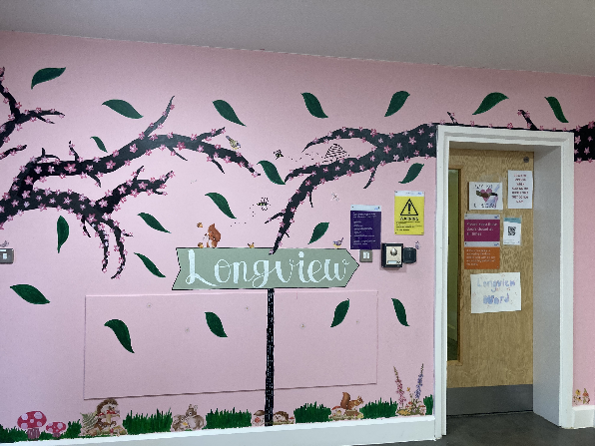

Larkwood ward:
Larkwood ward is a regional secure ward providing a Psychiatric Intensive Care Unit (PICU) service. Larkwood caters for young people with severe mental health difficulties that cannot be safely managed on a generic ward. The primary role of Larkwood is to stabilise patients and establish if they need longer term care in a secure environment or can be treated on a general adolescent unit (GAU). All of Larkwood’s patients are detained under the Mental Health act at point of admission.
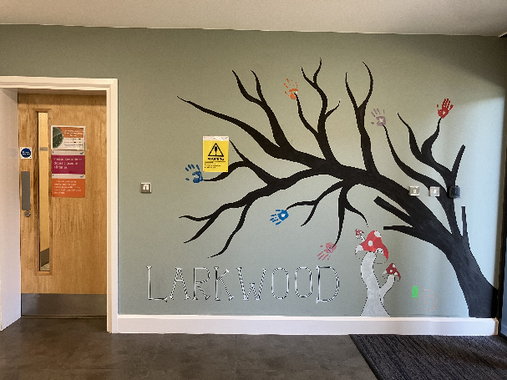

Facilities
At SAC, we have many area for sports and leisure activites including an outdoor courtyard on each ward, a multi-purpose sports court, a gym, pool table, ping pong table, cinema space, sensory room, music room, art room, and a large social area on each ward.
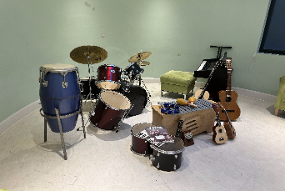
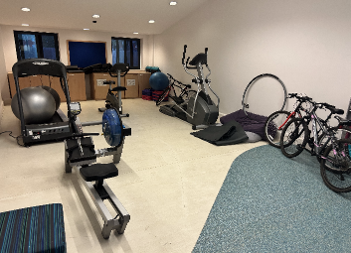
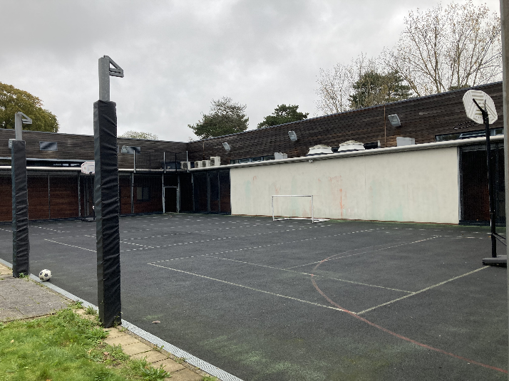

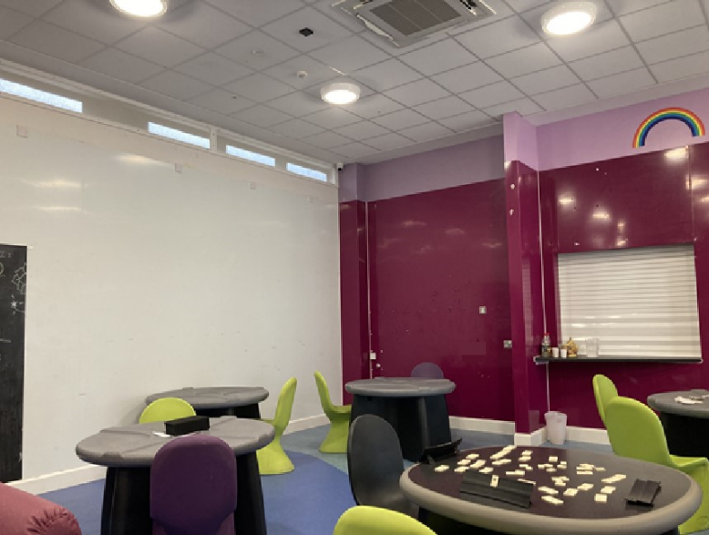
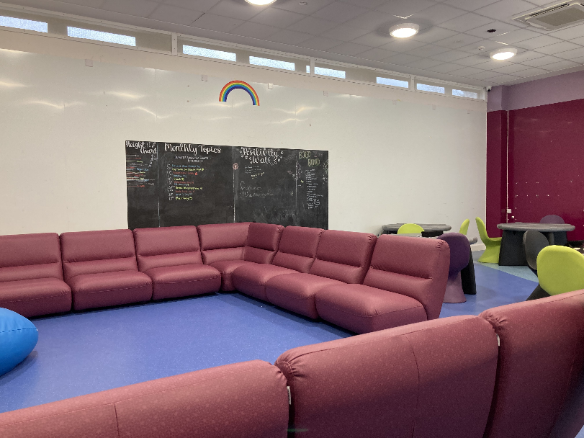

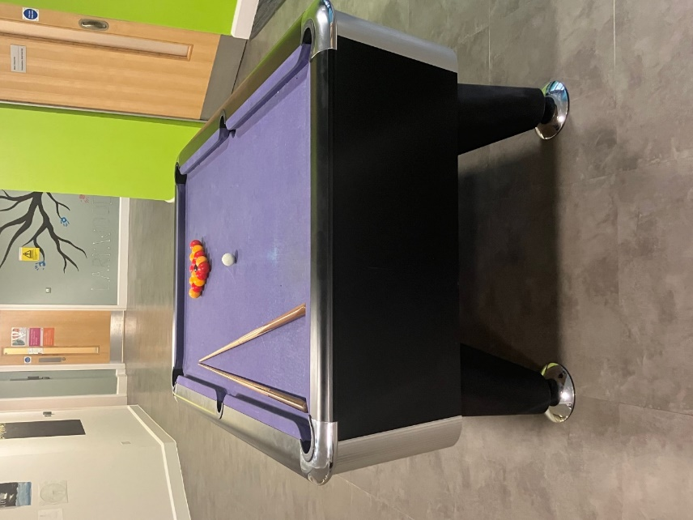
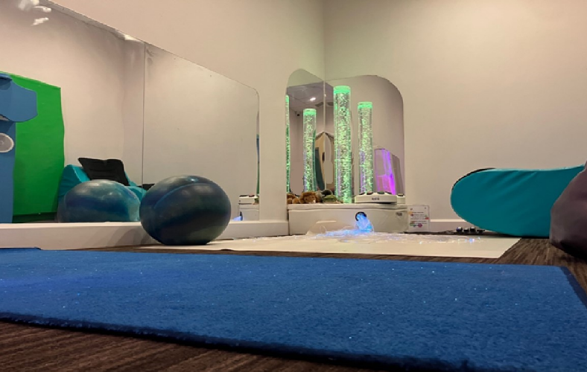
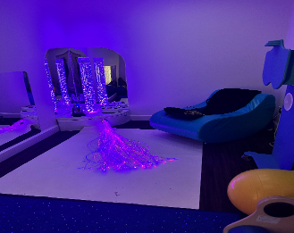
]

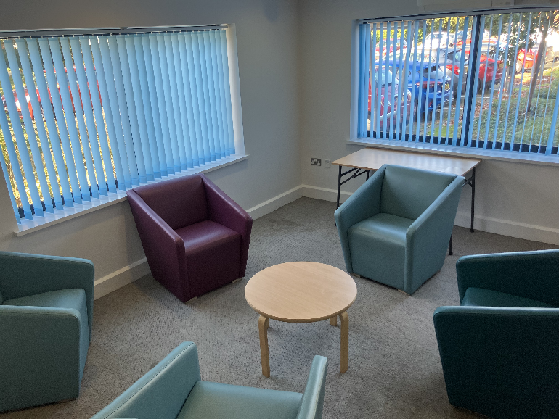
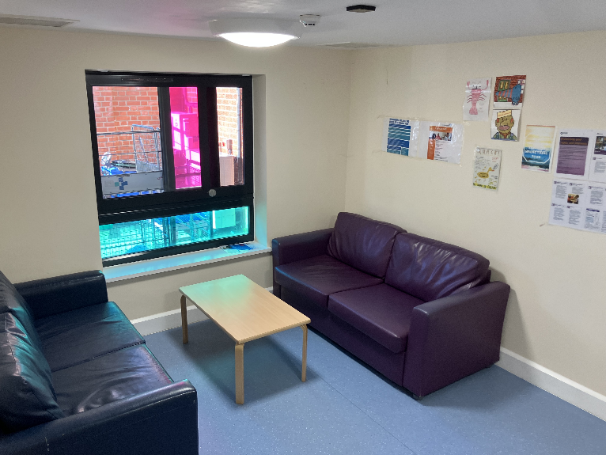
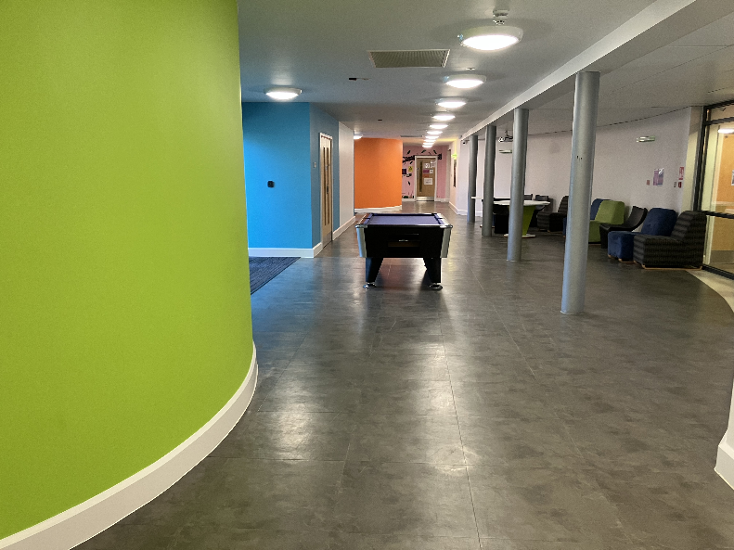
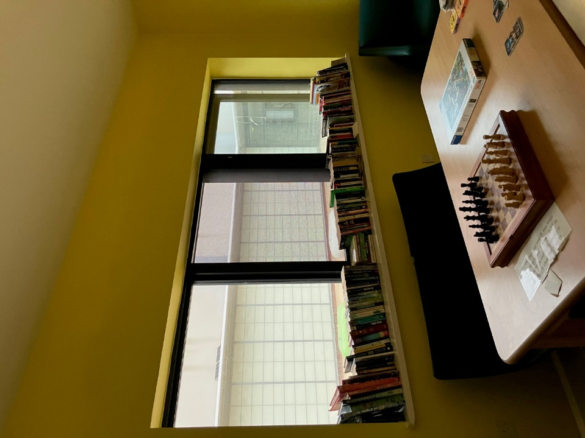

Pictures – left to right:
Music room; sports court; pool table; Longview social area; gym; Longview dining area; sensory room (lights on); sensory room (lights off); art room; The Street; family therapy room; visiting room

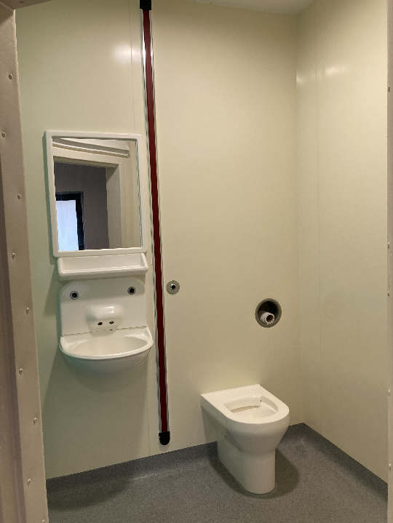
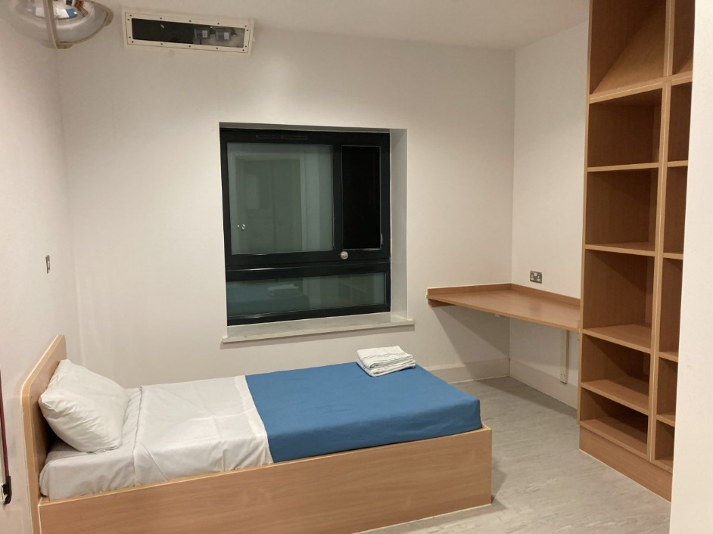
Bedrooms
Each bed space has space for your belongings, an en-suite and can be customised with posters, drawings and artwork.

SAC Education Department
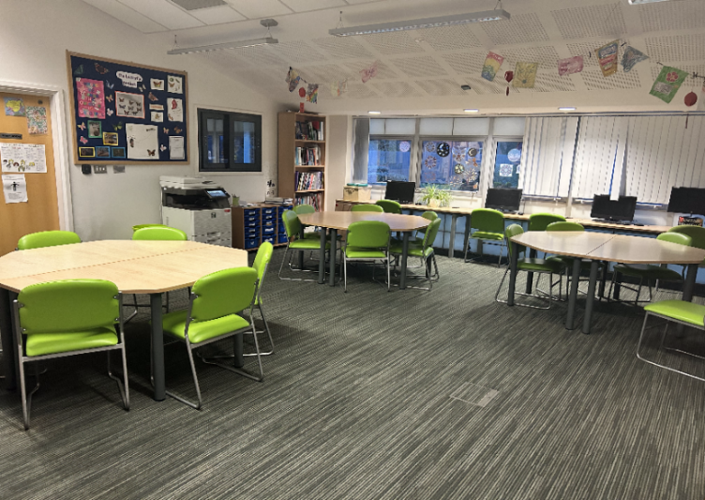
SAC also has a Therapeutic Educational Department where you can continue your studies whilst in hospital.

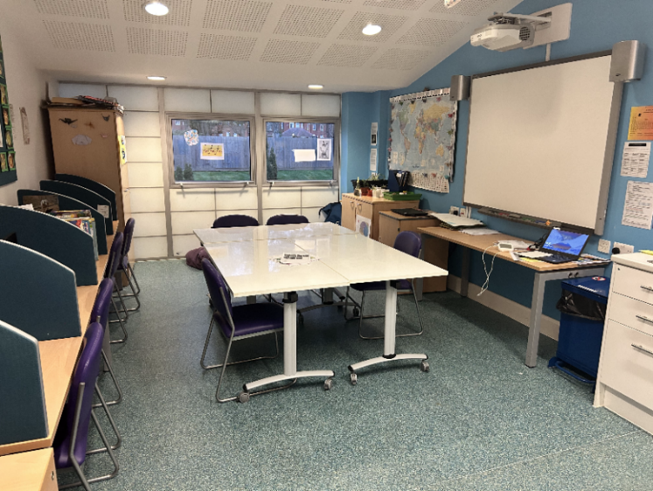

DELIVERY OF EVIDENCE BASED INTERVENTIONS FOR SERVICE USERS.

Young people are allocated a care pathway(s) dependent on their presentation at the point of admission and agreement about what assessment/treatment is required to enable discharge and support recovery. The care pathway determines all the MDT interventions that the young person and their family are offered, including the role of the psychological therapies team. The care pathways are informed by Service Specifications for CAMHS inpatient services, CQC recommendations, NICE guidelines, and the latest evidence and best practice.

Current care pathways are
- Core
- Emotion Dysregulation
- Trauma
- Disordered Eating
- Neurodivergent
- Psychosis
- An Eating Disorder pathway is currently being developed

Each pathway is regularly reviewed and updated by the MDT team.

Care pathways are regularly monitored and reviewed with young people and their families, and within the psychological therapies and multi-disciplinary teams. Young people can be moved to another care pathway at any point during their admission if clinically indicated.

The core pathway is outlined below. Information about the other care pathways can be found on our website.

Please see below the current CORE GAU pathway:

Keeping your young people safe

Helping your young person feel safe on the ward

We understand that being admitted to a mental health ward can be a worrying experience for some young people. We will do our best to help your young person to feel safe while they are with us.

We will show your young person around Longview ward when they arrive to try to make them feel more comfortable with the environment.

The ward bedrooms are separated into male and female areas. Your young person will be assigned to an area based on the gender they identify as, unless a risk assessment indicates otherwise.

Your young person will have the support of the nursing team during their stay with us. The nursing team will be regularly checking on your young person’s wellbeing throughout their stay and they will do their best to make your young person feel safe and comfortable. Your young person may even have a staff member with them at all times depending on their observations levels (see Observation Levels section).

There are weekly community meetings facilitated by staff where young people can discuss any worries they may have with the group. If they do not feel comfortable talking to the group about their concerns then they can talk to any member of the team, including their key nurse, doctor, therapist, or the ward manager. Your young person can also speak to the independent advocates that regularly visit the unit.

Your young person will be able to shut their own bedroom door at night to prevent other young people from entering their bed-space. Only your young person and staff members will be able to access their room.

Observation Levels

All young people staying on the ward need to be regularly observed by members of the nursing team and the frequency and nature of the observations is determined by the young person’s assessed level of risk at any one time. Your young person may be the nursed on the following:

Level 1 observations – young person is observed once every hour. This is the minimum observation level a young person can have while staying on the unit.

Level 2 observations – young person is observed four times in an hour.

Level 3 observations – young person is continually observed by a member of the nursing team. Young people who have turned 18 years of age will be nursed on level 3 observations at all times.

Level 4 observations – young person is continually observed by a member of the nursing team who is within arm’s reach of the young person at all times

Sometimes young people will have different levels of observations at different times of the day or when they are in different parts of the ward.

Sometimes observation levels will need to be carried out by multiple members of staff to ensure staff and/or patient safety, for example, a patient who is on observation level 3 (2:1) must be continually observed by two members of staff at any one time.

Searches
Staff have the right to ask to search young people and visitors to ensure the ward remains a safe place for all patients and staff.
If a visitor declines to be searched, staff have the right to decline them access to the unit.
Young people are asked to abide by the ward boundaries including what items are allowed to bring onto the unit. As a last resort young people can be searched against their will if clearly required to maintain the safety of that young person, staff, and/or other patients.

Restraint
If a young person engages in an activity which may cause themselves or others harm, staff will have the right to intervene and this could result in physical restraint.

De-briefs
Incidents of self-harm and restraint can be distressing for the person involved and for any other young people who happen to witness this. Therefore young people are offered de-brief opportunities after such incidents where they can discuss their thoughts and feelings in relation to what happened. This can enable new insights and learning, thereby reducing the likelihood of future incidents.

Ward Boundaries

What your young people is not allowed to bring onto the ward:

The following items are not allowed on the unit or their use will be restricted:

- No clothes with drawstrings / cords, hoodies, or onesies

- No knives, razor blades, scissors or certain glass objects. Glass items like makeup and nail vanish bottles must be kept in the nursing office and can be used under supervision.

- No alcohol or illicit drugs

- No hair dye, aerosols, valuables, chewing gum, bubble gum, towels or flannels (we provide these), staples, or paperclips

- No inappropriate magazines

- No unsealed food or drink items

- Any other items that staff may deem as unsuitable and / or harmful (this will remain at the discretion of staff)

- Cans (including Pringles and drinks cans)

- Metal ring binder notebooks

- We do not recommend any high value jewellery, electronics or other personal items are brought to Longview.




What your young person is allowed to bring onto the ward:


- iPod or MP3 player
- Money or a bank card
- Basic toiletries
- Slippers
- 1 teddy
- 2 or 3 books
- Age appropriate DVDs
- Sealed food and drink can be brought onto the ward for snack time as part of a balanced diet

- Chargers for electronic devices and can be brought on to the unit but must be kept in the security office at all times.

- Electrical items like hairdryers and hair straighteners must be kept in the security office but can be used under supervision.

- Clothing for up to 7 days. We recommend high value clothing items are not brought onto the ward.


Some young people on Longview have found the following to be helpful when struggling. If deemed safe for your young person to use, we welcome these items on the unit:

- Tangles
- Writing / drawing equipment

- Stressballs
- Puzzle books (Sudoku, word searches etc)
- Journal / diary (not ring binder)

Confidentiality and Sharing Information
There is a form entitled Information Governance and the Limits of Confidentiality which you and your young person will be expected to sign at the point of admission. This form explains how we record and share information. If you have any further questions please consult a member of the ward team.

On page 26 is a flow chart that details when we will share information with Social Care and the potential referral routes for Social Care intervention and support.


Non-Smoking Policy
In accordance with Essex Partnership University NHS Trust Non-smoking Policy, The St Aubyn Centre is a no smoking area. No smoking is permitted in the building or the grounds for young people and visitors. Young people are not allowed to smoke/vape in vicinity of unit staff, even when on leave with staff.

Health Promotion is a focus of The St Aubyn Centre and young people will be prescribed alternatives to smoking if needed, which will be monitored by the medical team.

Code of Conduct
Each and every person on the ward has the right to be treated with respect and dignity including the young people, staff and visitors.

The St Aubyn Centre has a policy of zero tolerance regarding incidents of verbal and physical aggression towards staff and/or patients from both patients and visitors. All incidents will be reported to the police. Damage to The St Aubyn Centre property may also result in police intervention and costs for repair being reclaimed from the young person and/or parents/carers.

Use of Mobile Phones and Associated Rules

On the ward young people are able to use their phones after signing a phone contract.


Young people will be able to use their phone outside the therapeutic programme. For example, their phone is handed to the nursing team to be stored in the security office during education (9am-3pm), therapeutic groups (3.30-4.30pm), individual therapy sessions and at bedtime (10pm weekdays and 11pm weekends).

Given the central role of social media and mobile phones in young people’s lives, the ward staff wish to support young people to safely manage the use of their phone. Therefore, your young person must sign a phone contract which outlines expectations around phone use whilst on the ward. If your young person does not sign the contract, they cannot use their phone during their admission. If your young person is under 16, parents/carers must also give their consent for your young person to attend phone group.

On Longview there are restrictions on young people being able to have free use of internet enabled phones due to confidentiality and safeguarding concerns.

Phone rules your young person must adhere to:

- Do not take photos/videos with their phone (including of other patients or staff). They must have their cameras covered at all times.
- Do not post anything on social media about other patients and staff.
- Do not use inappropriate websites or use any social media platforms inappropriately.

Breach/break of the phone contract at any point during your young person’s admission will lead to the phone being confiscated by staff. This is to safeguard all young people in our care who may be vulnerable or at risk, may cause distress or harm, or violate their privacy of young people and staff on the ward.

Zero Tolerance statement
The St Aubyn Centre is a diverse community of patients and staff and we actively welcome and celebrate all the ways that we differ from each other, including: Mental Health Status; Gender; Sexuality; Race; Culture; Age; Belief/Faith and Differing Abilities.

Many of our patients and staff will have experienced prejudice and hate because of their characteristics, so as part of our commitment to creating a safe environment, and valuing all, we have a Zero Tolerance approach to discriminatory and hate behaviour.

Anyone engaging in hate behaviours will be, educated, challenged and where applicable reported to the police.

We welcome your support with our Zero Tolerance approach.

Treatment at the St Aubyn Centre

The aim of treatment at The St Aubyn Centre

The main goal of the assessment, treatment, advice, and support that you and your young person will receive whilst on Longview is to stabilise and contain your young person’s difficulties.

We seek to keep admission length as short as is safe to do so to reduce the risks associated with staying in hospital, which can include institutionalisation, contagion (copying peers behaviour), distress associated with witnessing other young people struggling, and becoming detached from protective factors, including support networks, in the community.

When your young person is transferred/discharged from Longview, their difficulties may not be completely resolved, but they will be managing well enough to continue with treatment and support from their community mental health service or other appropriate services/units.



Care Pathway for Longview

A care pathway is the step by step process of assessment and treatment your young person will receive whilst they are at the St Aubyn Centre.

Stages 1: Referral

Stage 2: Admission

Stage 3: Initial CPA

Stage 4: Interventive Assessment and Treatment Phase

Stage 5: CPA Review

Stages 1 and 2: Referral and Admission

Young people are referred to the unit by either a crisis team, a community mental health team, or they come into the unit in an emergency. Alternatively they may have been transferred from another unit. The Longview team will have received comprehensive information from the referrer prior to the young person being admitted. Information about the young person’s current mental state and circumstances will also be gathered by the admitting nurses and doctors. These sources of information inform initial care plans for the young person while an initial CPA (see Stage 3) is being arranged.

During the admission procedure a member of the Longview team will go through the admission pack and record information about the young person’s physical, psychological and emotional needs. We need to be aware of any physical health problems, including allergies and current treatment. We will also need to be aware of appropriate contacts and visitors during the young person’s stay. There will also be some consent forms to sign. The young person’s age will determine who signs the consent to treatment forms. Any young person over the age of 16 is automatically considered competent to make their own decisions about their treatment. However, if this competence is in doubt then a capacity assessment may be undertaken.

When a young person arrives on the unit our expectation is that they bring one small bag of clothing and toiletries (enough to last one week) and no significant items of value. The young person will need appropriate clothing for everyday wear. This will include attending the school within the unit. They will also require clothing for sports as well as nightwear. We have laundry facilities and provide all bedding and towels.

Stage 3: Initial CPA

Whichever way a young person has arrived at the unit, an initial CPA meeting will be arranged for them, ideally within 5 working days of their admission date. Those involved in the young person’s care will be invited to this meeting, including parents/carers and community care co-ordinators, as well as members of the Longview team. The meeting will usually be chaired by the young person’s consultant psychiatrist, and it is an opportunity to discuss why the young person needs to be in hospital, and to make treatment plans for the young person going forwards. The young person will be accompanied by an independent advocate during the meeting to support them in making their views clear to the team.

The initial CPA allows some exploration about the history of the young persons’ difficulties. We seek to understand what may have triggered the decline in their mental health, what is unhelpfully keeping the difficulties going, and what strengths the young person and those around them have in managing the difficulties.

Following the initial CPA, a working formulation is developed to inform the initial treatment package a young person and their family/carers will receive. This treatment package will be in place whilst the more in depth interventive assessment is completed (please see Stage 4 for more information about this).

Stage 4: Interventive Assessment and Treatment Phase

After the admission and initial CPA, the young person will be offered a range of interventive assessments and/or treatments dependant on individual need. A more in depth assessment to help the young person and those involved in their care and treatment better understand their difficulties and to learn how to manage them more effectively may be necessary. Such an assessment is part of the young person’s treatment, in that, by learning what the factors are that may have led to their difficulties, triggered them, and kept them going, it may help us learn the best way to manage them.

If the young people have already undergone some of these assessments in the community, or in another unit, we will not repeat them but use the information from these assessments to help inform the young person’s formulation and treatment.

Assessments/treatments may include:

- Psychology/Psychotherapy: Meetings with a psychologist/psychotherapist can allow a more in-depth assessment of a young person’s presentation. Psychologists may use interviews, questionnaires, cognitive assessments and/or personality assessments, to gain a greater understanding of a young person’s difficulties as well as the interventions required to support them.

Some young people may undertake brief individual therapy with psychologists/psychotherapists to help achieve stabilisation and, in some cases, to start trying the treatments that are being recommended for them in future settings.

Therapeutic models psychologists/psychotherapists may use to inform interventive work with young people on Longview ward include Cognitive Behaviour Therapy (CBT), Dialectic Behaviour Therapy (DBT), Eye Movement De-sensitisation Re-processing (EMDR), Acceptance and Commitment Therapy (ACT), Psychodynamic Psychotherapy, and Systemic therapy.

On some occasions the community team may be asked to continue or commence assessment/intervention sessions while a young person is still on Longview to prevent multiple transitions between therapies and therapists.

- Psychiatry: - Regular reviews with the ward doctors during the initial weeks of admission will allow the doctors to assess the nature of the young person’s mental health difficulty and decide whether medication may be useful. The effectiveness of medication, plus any side effects, will be regularly monitored by the ward doctors throughout a young person’s admission, as will any physical health conditions.

- Family Therapy: - All young people who will be returning home following discharge from hospital will be offered a family therapy assessment, and usually subsequent sessions, with their parent/carers. Conversations in Family Therapy sessions will often focus on what might be useful to aid the young person’s recovery, and to improve communication and understanding between all.

- Occupational Therapy: - The aim for Occupational Therapy is to conduct a comprehensive assessment of the Young Person to identify any difficulties or barriers that are impacting on their function and ability to engage in meaningful activities. The assessment process focusses on four main areas: self-care, leisure, social and productivity and incorporates interviews with the Young person and their parents or carers, observations during individual and group sessions and the use of specialist assessment tools. OTs work with the Young Person to identify meaningful goals and develop a plan of how to achieve these through individual interventions, group work or by making recommendations for adaptations or equipment. Interventions may include practising daily living skills, learning coping strategies, and developing functional routines in both the ward and in the community, in preparation to improve functioning post discharge.

- Education: - Teaching staff will gather information from the young person's current educational placement and will also carry out a range of assessments to identify the young person's educational strengths and needs. Education staff will explore with the young person how their mental health difficulties have impacted on school and examine how this could be managed in the future. This information will help the education team establish the best way of supporting the young person in the unit and during their reintegration back into education, training or employment. If the initial assessments indicate that further investigations would be helpful the education team can refer to the unit psychologists or, in some cases, the young person's local educational psychologist. Where there is an EHCP in place the education staff will work with the local authority to update the recommendations if necessary. They can also support schools or parents in applying for an EHCP where this would be useful.

- Social / Safeguarding: - Led by the ward social worker, team members will gather information to assess your young person`s current situation to check if they are at risk of harm or neglect. This includes establishing that your young person’s living arrangements and family circumstances are stable and appropriate for their needs. Any issues and/or concerns arising from this assessment would be dealt with appropriately by working in partnership with families/carers and other agencies such as social care and the police. The desired outcome is to safeguard the physical, mental and emotional wellbeing of your young person while in hospital and after discharge. The ward social worker will make referrals to Social Care in line with Statutory and Legal obligations (see chart on p.23).

- Nursing Assessment: - The nursing team conducting a full observation of the young person over 24 hour periods allows exploration of the impact of the young person’s mental health on their overall functioning, and helps identify positive strategies for the young person to manage more effectively.

Individual therapeutic sessions (assessment and/or therapy) provide a confidential space where young people can explore and make sense of their difficulties and find ways forward in their mental health recovery. The individual worker will explore with your young person how information from these sessions will be shared with the inpatient team, community professionals and parents/carers e.g. via the ward reviews feedback and CPA processes. A young person with capacity/competency has the right to choose who this information is shared with, with only safeguarding concerns overriding this consent process. It is essential that your young person feels safe within this therapeutic space if these sessions are going to be useful to them and aid their mental health recovery.

Stage 5: CPA Review

A CPA review must occur within 6 weeks of the initial CPA but may often be scheduled sooner depending on the treatment plan.

Transition, discharge and further treatment
The goal of The St Aubyn Centre interventions are rapid stabilisation of immediate risk and crisis. Longer term interventions, treatments and supports will be engaged at this point in the community. At the CPA Review the young person, their family / carers and professionals should now have an increased understanding of the origins, the triggers and the maintaining factors that lead to the young person’s crisis and risk behaviours. Thus future crisis can be managed and prevented.

The following options will be considered at the CPA Review:

Discharge with transition package
At the CPA review it may be decided that the recent crisis period has been resolved, and that the young person, their parents/carers, and the community professionals involved have an increased understanding of the young person’s difficulties and are thus more able to prevent/manage a future crisis. In this case it would be appropriate to discharge the young person imminently. It is common for a young person to engage in a short transition period before official discharge. The transition package usually involves significant periods of leave to home and may include crisis / home treatment (if available within your young person’s local area), mental health team input and monitoring, educational support and reintegration, and (where indicated and appropriate) social care input and support.

Step up to specialised care
If, at the CPA review, the team agree that the young person needs more specialised input, the young person will be referred to a more specialised unit / service.

Transfer to other residential provision
If it has been identified that the young person requires a longer term residential environment, rather than the short term acute psychiatric environment of The St Aubyn Centre, the young person will be referred to an appropriate service.

Further 4-6 weeks of treatment
If, at the CPA review, the team agree that the young person is not ready for discharge and requires additional interventions, the young person will be offered a further 4 – 6 weeks treatment which will be subject to weekly review, and a CPA Review at the end of that period of time.

Three Ways a Young Person can be Referred to Social Care for Assessment and Intervention following Admission

Social Care
ONE
Statutory Obligation on team for referral to access s117 After-Care resources
No Consent Required / Dependent on Risk
Consent Required

Team Recommendation
Point of admission
TWO
THREE
Any point during admission
Refer to Social Care as Child in Need due to complex needs & admission to hospital
Refer to Social Care due to Safeguarding concern/health and development is likely to be significantly impaired

Discharge planning throughout admission

Refer to Social Care when young person on Section 3 of the MH Act for Multi Agency Discharge Planning

Positive Behavioural Support Plan (PBS)

This is a document created to help identify and understand the function of your young person’s negative or challenging behaviours with support of positive behaviour reinforcement. Contributions to this plan are made by the MDT, the young person and parents/carers.

Your young person will meet with a member of the therapy team to gather information that will be included in this plan. Parents/carers and the Key Nurse will be asked to complete a crib sheet with similar questions that the young person will answer. When this PBS crib sheet is discussed with, or sent to you, please return this to Longview staff as soon as possible.

Your young person’s PBS plan is regularly reviewed by MDT members during ward reviews and you young person.

Longview’s Therapeutic Group Programme
Longview has a daily ward timetable which is designed to bring routine and structure to the young people’s days, and to ensure the young people engage in daily meaningful activity.

Morning Meeting
Each weekday there is a morning meeting between 9.30am and 9.45am facilitated by nursing, therapy and teaching staff. All young people are expected to attend. The meeting is where the young people are notified of the different appointments, groups and meetings which are taking place on the ward that day and it is a forum where the young people can discuss any concerns about the day ahead. Following this meeting the young people are taken directly to the education department to start their school day.

Education
The St Aubyn Centre Therapeutic Education Department (SACTED) is a Local Authority school situated within the St Aubyn Centre hospital. Our team consists of qualified teachers, Learning Support Assistants, a Careers and Engagement Mentor, and a business and admin manager. We have close links with Essex University and frequently have undergraduate psychology students on placement as well as regular volunteers. We are rated as outstanding by OFSTED.

Education staff run a full school day which includes therapeutic activities as well as academic learning. All young people are expected to attend education and it is seen as an integral part of the Longview programme.

SACTED work very closely with the hospital team. Education staff attend CPA reviews, ward reviews and multidisciplinary team meetings. This ensures that the nursing, clinical and education programmes for each young person are fully aligned.


When young people are admitted to the hospital they are automatically enrolled at SACTED, but they will also remain on role at their community school. We normally contact the community school to gather information and will liaise with them throughout the admission. Where appropriate, the young person’s community school will be asked to provide work to ensure that they are covering the same areas as their peers. The community school will usually be invited to the CPA reviews.

Post 16 students who are not currently in education, employment or training will work with our Careers and Engagement Mentor to identify next steps.
When young people are admitted to Longview they are allocated a key teacher who will work with them to plan their programme. Each young person will have an individual, personalised timetable aimed at meeting their learning and mental health needs. Students spend the morning in their key group of four or five students each working on their own individually set work. In the afternoons there are a range of therapeutic group activities which are often creative or physical. There is also the option of a further study session. If your young person has permission to go on leave they may be able to attend SAC education trips such as trampolining, geocaching, or the nurture farm. This would depend on your young person’s ability to co-operate with staff and keep themselves safe and would need to be risk assessed before each leave.

When young people are preparing for transfer or discharge from Longview, education staff will liaise with their next hospital, placement, community school, or education provider and arrange a reintegration plan which might include visits, planning meetings and accompanied lessons to ensure a smooth transition.

Many young people admitted to the hospital have mental health difficulties which have impacted on their education, and sometimes their education has had a negative impact on their mental health. SACTED work with the young person and their community school to try to resolve some of the difficulties they may have faced and they advise schools on strategies for supporting the young person.

If students are unable to return to their previous community school we will work with parents/carers and the local authority to identify suitable provision.

Young people who are preparing for exams can continue studying with SACTED and can, if necessary, sit exams with in Longview education as we are a registered exam centre.

Our education staff team are highly skilled and have a wealth of experience. We will always balance a young person’s learning needs with their mental health needs and we work flexibly, with understanding and compassion.

For more information please see our website at www.staubyn-centre.essex.sch.uk or contact your young person’s key teacher or the Head of Education.

Community Meeting: Every Tuesday at 15.30pm ward staff, MDT members, and all young people meet together to discuss various topics about Longview to ensure the ward is a safe and friendly place for the young people to reside. Topics discussed in this meeting include current and concerns about the ward, ward dynamics, innovation projects happening on the ward, ward meals, and ward activities.

Therapy Groups
On most weekdays, there are therapy groups (usually in the afternoon after education) that are facilitated by trained staff from SAC therapies team. These groups include DBT skills group, creative arts therapy group, and occupational therapy (OT) groups.

The groups are designed to offer a range of therapeutic experiences including young people having different opportunities to express themselves, and learn new coping skills.

DBT Groups:
The ward DBT skills groups focus on facilitating the young people to learn and practise skills and strategies to help them manage distress, difficult emotions, and relationships, more effectively. DBT skills groups also include regular mindfulness practice. The DBT skills groups take place three times a week for young people on Longview and are facilitated by a mix of DBT trained clinicians, and teachers from the SAC education department. Young people who wish to take part in these groups will need to attend a commitment meeting where the benefits and expectations of the groups will be explained.

Occupational Therapy Group:
There will be a group run on the ward by the Occupational therapists as part of the therapeutic timetable. They look at the meaningful activities that young people need and want to do in life and how young people can use coping strategies, adapt their environment and learn new skills to be able to function effectively. This group is interactive and incorporates psychoeducation, group discussions, practical and creative activities.

Creative Art Therapy Group:
The ward offers young people the opportunity to attend creative arts therapy groups. These are spaces where young people are able to express themselves without the pressure to use words.

Online Parent and Carer Group:
A regular online group is facilitated for the parents/carers of young people admitted to any one of the three EPUT CAMHS wards. In the group, parents/carers can learn about the wards (including the people and processes involved), gain peer and facilitator support, and learn stress management and communication strategies, to help them support their young people more effectively. The online parent and carer group runs in six weekly session blocks and is facilitated by different members of the multidisciplinary teams across the three EPUT CAMHS wards.

SAMPLE LONGVIEW GROUP TIMETABLE

LONGVIEW | Monday |  | Tuesday | Wednesday |  | Thursday |  | Friday
9.30-9.45 | Morning meeting |  | Morning meeting | Morning meeting |  | Morning meeting |  | Morning meeting
9.45-10.45 | Education |  | Education | Education |  | Education |  | Education
10.45-11.15 | Break/Snack time
11.15-12.15 | Education |  | Education | Education |  | Education |  | Therapeutic Group
12.15-13.30 | Lunch
13.30-14.30 | Education |  | Education | Education |  | Education |  | Art Therapy Group
14.30-15.00 |  |  |  |  |  |  |  | Education
15.00-15.30 | Break/Snack time
15.30-16.30 | DBT Skills Group | Nursing-led Group | Community Meeting | DBT Skills Group | Nursing-led Group | DBT Skills Group | Nursing-led Group | OT Group
16.30-17.30 | Nursing led activities/self-led activities
17.30-18.30 | Dinner
19.00 onwards | Nursing-led activities/self-led activities
*Please note that this timetable is subject to change.
Other Important Meetings:

Weekly Ward Reviews
Ward reviews on Longview take place in two parts each week.

During Part 1 Reviews (held on Monday mornings for Longview patients) your young person has a chance to review their care and treatment with their consultant psychiatrist and a few other key members of the MDT team. This includes making requests about changes in their care plan, leave, therapies, and medication.

During Part 2 Reviews (held on Wednesday mornings for Longview), a larger MDT team (including psychiatrists, doctors, therapists, nurses and education team) discuss the young person’s progress over the previous week, as well as the young person’s requests, and confirm any changes to the young person’s care plan, which may include current level of risk, leave, medication, and discharge planning.

Parents/carers will be emailed on a weekly basis to provide feedback for Part 2 ward reviews and/or if you have any questions you would like the inpatient team to consider during Part 2 reviews.

The ward team also track the progress of the young people recovery via outcome measures which are completed by the young people on a weekly basis and Longview MDT.

After Part 2 reviews, young people are given written or verbal feedback from a nurse who attended the review. Parents / carers are emailed feedback. If you have specific requests regarding your young person’s care or leave for a particular week it is recommended you make contact with the ward prior to Part 2 reviews so this can be considered when the key decisions are being made.

Care, Education and Treatment Reviews (CETRs)
Young people with a learning disability and/or autism will be invited to a Care, Education and Treatment Review (CETRs) during their admission. CETRs are focused on those children and young people who either have been, or are about to be admitted to a specialist mental health / learning disability hospital in the NHS or independent sector. If the person goes into hospital, the CETR checks their assessment, treatment and the plan for admission and discharge to ensure that the hospital stay is as short and effective as possible. Parents/carers, community and inpatient professionals are all invited to the CETR. Recommendations can also be made by the CETR panel.

Visiting and Leave

Visiting Hours

Our visiting hours are between 4.30pm - 9pm on weekdays, and we allow more flexible visiting over the weekend and school holidays. We are also able to be more flexible with visiting times when families are travelling significant distances to the unit. Please call the ward to arrange visiting so that we can book a family visiting room for you. Any additional visiting arrangements will need to be agreed with the young person and The St Aubyn Centre team.

Leave
A young person’s leave from the St Aubyn Centre will be determined by their treatment plan. When a young person is initially admitted they will be granted minimal leave off the unit. As the team become more aware of a young person’s mental state and risks, leave will be gradually increased, usually starting with escorted leave in the grounds and increasing to overnight leaves to home. All leave from the unit, including escorted leave with staff, and unescorted leave, is thoroughly risk assessed at the time leave is scheduled and may be suspended if it is not safe to take place.

Leave is part of the treatment process as the young person makes their journey back to living in the community. A leave plan is always developed prior to parents/carers taking a young person on leave so there is clear guidance about how to support your young person during this period.

Visiting will also be based on the treatment plan so the frequency of visits and who can visit will be based on the treatment needs of the young person and their family / carers.

No under 18s may visit this unit without an adult carer / parent present. ID may be requested if the age of a visitor is unclear. Those under 18 who are visiting must call ahead to enable a suitable visiting room to be arranged.

Other Services


Advocacy
Advocates can:
- listen to young people’s views and concerns
- help young people explore their options and rights (without advising them in any particular direction)
- give them information to help them make informed decisions
- help young people contact relevant people, or contact them on their behalf
- accompany and support them in meetings or appointments
An advocate will not:
- give their personal opinion
- solve problems and make decisions for young people
- make judgements about young people
Longview advocates contact details:
- If you are on Section 2 or 3 of the Mental Health Act you are entitled to be supported by an Independent Mental Health Advocate (IMHA) from Rethink – Amanda Weston and Lois Dunne can be contacted by calling 0300 790 0559 or emailing essexadvocacy@rethink.org. You can also ask ward staff who will be happy to make a referral for you.

- If you are an informal patient you can choose to have an advocate from Barnardos. Please call 08006524546 (free from a landline) or 01268 558448, or email NEEMAS@barnardos.org.uk. Lisa Wicks can be individually contacted on 07912205336 (Tue-Fri) and Marion Barnard on 07912205352 (Tue&Wed).

Spiritual Needs
We understand that many of the young people who stay on Longview come from many different cultures and backgrounds.

We like to celebrate all beliefs, religions and cultures on our unit.

We have a Spiritual Lead on Longview who will ensure, as will all of our staff, that your young person’s spiritual needs are met. We will also ensure that any spiritual materials your young person needs such as books, bibles or prayer mats are also available.

We will also ensure that any special dietary requirements your young person has are catered for.

Please talk to the staff and let us know what your young person needs. We are happy to help.

Translation Services
If English is not your first language and you struggle to understand English, we offer interpretation services. A member of staff should offer these to you but if they do not and you feel you require them, please make a request.

Sign Language Specialist
If you are hard of hearing we can arrange for a sign language specialist to come and visit you. They can also be available to assist you during ward meetings and assessments.

Speech and Language Services
Speech and language services are available through our education department. Staff can advise you on how to access these services.

Obtaining a Second Opinion
In the event that you would like a second opinion in regards to your young person’s treatment/care, please approach a member of the nursing team who will action this for you. If a request for a second opinion is refused you can seek advice from PALS.

Access to Health Records
You have the right to request to see your young person’s health records under the Data Protection Act 1988. However medical professionals holding your records have the right not to give you this information if it may harm the physical/mental health of the young person.

If you want access to the health records you should write to the Trust. The nursing team can provide you with this address. They should release your records within 40 days. Due to rules on confidentiality, the record holder within the NHS will not release the young person’s health records to someone without the expressed consent of the young person.

If you would like to receive a copy of your young person’s care plan then please speak to a member of the nursing team, who will arrange this for you, subject to your child’s consent.

Patient Advice and Liaison Service (PALS)
If you feel you need help, advice and support about issues relating to the care and treatment you receive, or the treatment received by a friend or family member our Patient Advice and Liaison Service (PALS) is a free and confidential service that provides a listening ear and offers practical help.

PALS can also give you information about other services available from the NHS, Social Services and other organisations that support people with mental health or substance misuse problems.

How to contact PALS:

By Phone: 0800 0857935
This helpline is open Monday to Friday, 9am – 5pm. Please leave a message outside these hours and we will contact.
By Email: epunft.pals@nhs.net
Please do not include any confidential information about your mental health status or care in any email.

By Post: Patient Experience Team
EPUT
The Lodge
Lodge Approach
Runwell, Essex
SS11 7XX

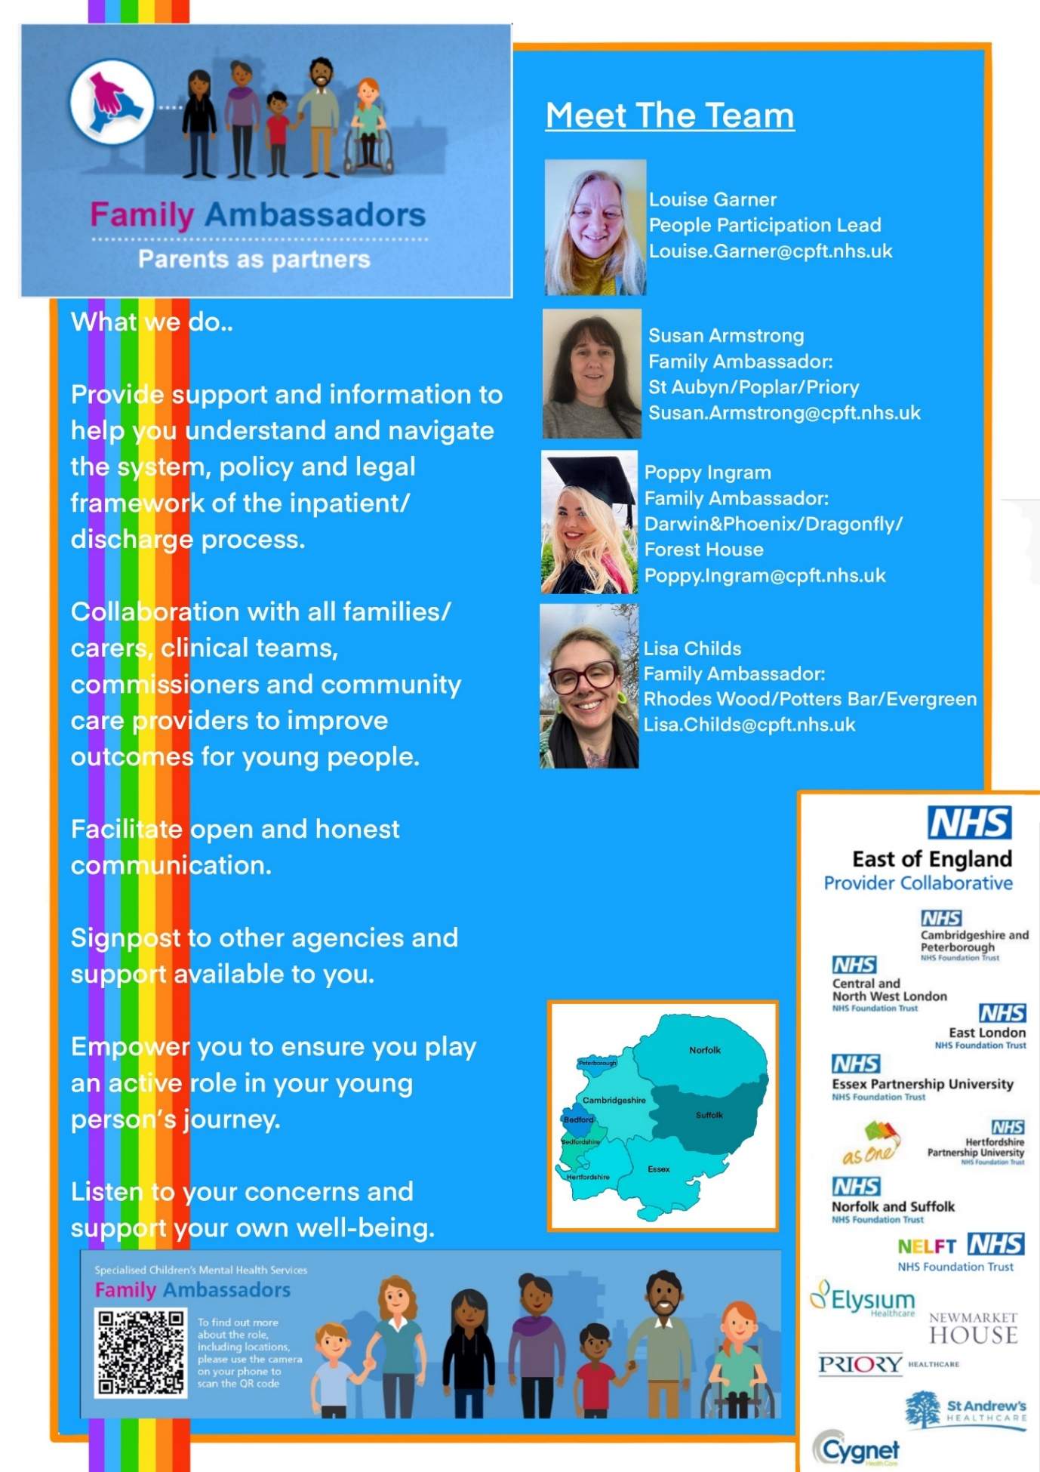

The Legal Framework for Admission and Treatment

Treatment with Consent
Most young people who are admitted to the unit are considered ‘voluntary / informal’ patients. As an informal patient a young person’s consent is sought regarding restricting their liberty at times for their own safety. This may include limiting their leave out of the unit, or implementing restrictive practices such as level 3 and 4 observations, searches, and restraints. This is likely to be the case at the beginning of the admission when the young person’s risks may be considerably higher and the team have not yet gained a clear understanding of the young person’s risks to themselves and/or others. If young people do not consent to these restrictions consideration will be given to either ending their admission and them being discharged with a robust community plan, or detaining them under the Mental Health Act.

If an informal young person requests to leave hospital a thorough risk assessment will be undertaken. If a young person is deemed safe to leave hospital, they cannot be detained against their will. In some cases there may not have been a safe discharge destination yet identified. In these circumstances The Children Act 1989 may be used do what is reasonable to safeguard or promote your young person’s welfare whilst they remain in hospital.

A young person’s competency (under 16) and capacity (16 and over) to consent to admission and treatment are regularly reviewed throughout the admission. If the young person lacks the ability or willingness to consent, consideration to the Mental Health Act or other forms of legal framework for the admission will be considered.

Treatment under the Mental Health Act
The Mental Health Act is the law used to admit, detain and treat adults, children and young people who need assessment and treatment for a mental disorder. Its full name is the Mental Health Act 1983 and it was amended by the Mental Health Act 2007. If a patient is detained under the Mental Health Act this person can be kept on a ward against their will and receive clinically indicated assessment and treatment even if they do not consent to this.

Providing Feedback

Compliments and Complaints
We strive to deliver high standards of care and aim to provide a quality service. If you are unhappy with the service you have received please do speak to a member of ward staff or contact PALS (see details below).

We also like to record any positive feedback that you may have. If you would prefer to speak to the Unit Manager / Modern Matron or the Operational Manager then please leave a contact telephone number or address and you will be contacted in person.

Other information leaflets are available in the reception area.

Testimonials

“I just wanted to say thank you for all of your help and support. You always showed an interest. It honestly means a lot.”
Young Person
“We could not have managed without your support.”
Family
“You made me feel welcomed. I could tell you were well boundaried but very caring, supportive and protective.”
Young Person
“Thank you all for being so supportive, I couldn’t of imagined myself like this now without the help of everyone here.”
Young person
“We are so very grateful for the outstanding level of care you gave”
Parents
“I appreciate everyone giving me opportunities to get involved and experience all that I have over the last 4 weeks.”
Young person
“It has been so reassuring to know that * has been looked after with such caring and dedicated staff.”
Parents

Websites and Apps

Please find below a list of websites and telephone numbers that you could use as a resource or to direct young people to for further information to help support them during their journey.

Animated Minds
Animated Minds is a series of short animated documentaries which use real testimony from people who have experienced different forms of mental distress. A single aim underpins all the films: to help dispel myths and misconceptions about ‘mental illness’ by giving a voice to those who experience these various difficulties first hand:
www.animatedminds.com

Bullying
A very useful website with advice on all different types of bullying including cyber bullying:
www.antibullyingalliance.org.uk

B-eat
A website providing information on eating disorders
www.b-eat.co.uk or www.beateatingdisorders.org.uk/, Tel: 0808 801 0677

ChildLine
A free and confidential support service for children
www.childline.org, Tel: 0800 1111

EYPDAS
Essex Young People’s Drug and Alcohol Service. Service for under 18s who live in Essex and are effected by either drug or alcohol use (their own or someone else’s).
www.eypdas.org.uk, Tel: 01245 493311 or text EYPDAS to 80800

Essex Youth Service / Young Carers
Practical and emotional support for young people who support a family member.
Email: young.carers@essex.gov.uk
Tel: 07920 286370
http://youth.essex.gov.uk

HeadMeds
Launched by YoungMinds, HeadMeds gives young people in England general information about medication. HeadMeds does not give medical advice.
www.headmeds.org.uk

National Self Harm Network
Supporting individuals who self-harm to reduce emotional distress and improve their quality of life.
www.nshn.co.uk

NSPCC
Aiming to stop child cruelty.
www.nspcc.org.uk, Tel: 0808 800 5000

Rethink
Information about how to look after your mental health and different mental health problems.
www.rethink.org, Email: info@rethink.org, Tel: 0300 5000 927

Samaritans
A 24 hour service offering confidential support to anyone who is in crisis
www.samaritans.org, Tel: 116123

The Hideout
Offers support to young people living with domestic abuse
www.thehideout.org.uk

Young Minds
Information for young people about emotional and mental health issues.
www.youngminds.org.uk

Youth Access
Puts young people in touch with local contacts for counselling, advice and information.
www.youthaccess.org.uk, Tel: 020 8772 9900

Websites for helping young people stay safe online:
www.thinkuknow.co.uk
www.childnet.com/resources
www.childline.org.uk/Explore/OnlineSafety
www.commonsensemedia.org
www.net-aware.org.uk
www.internetmatters.org

Potentially helpful apps for young people:

Self-help for Anxiety Management (SAM) – SAM is a friendly app that offers a range of self-help methods for people who are serious about learning to manage their anxiety.

Headspace – Headspace is an app where people can learn the essentials of meditation and mindfulness to help with stress, sleep, and overall emotional health.

Calm Harm - Calm Harm provides tasks to help young people resist or manage the urges to self-harm.

iCouch – iCouch is based on CBT principles and helps people keep track of their thinking, analyse their emotions, and change their outlook.

Definitions / Acronyms

The Care Programme Approach (CPA): If someone has mental health problems or a range of different needs their care may be coordinated under the Care Programme Approach (CPA). This is a particular way of assessing, planning and reviewing someone’s mental health care needs. CPA meetings take place at regular intervals and care plans should always be produced and reviewed as part of the process.

A care plan is an agreement between the young person, their family/carers and their health professionals to help them manage the young person’s mental health day to day. It is a written document that the young person will be required to sign. The young person and their family/carers will receive a copy of the care plan. The care plan contains a set of written instructions including how the young person will be cared for, what their treatment will be, who will carry out the treatment, how their difficulties will be responded to in a crisis and how often their leave is.

MDT: Multidisciplinary Team – a team of professionals made up of clinicians trained in a wide range of disciplines.

High Dependency Unit (HDU): An area for young people who temporarily require more intensive support within a generic ward environment.

Long term segregation (LTS): This is an area where young people are nursed with high levels of supervision if they are unable to be nursed safely in the presence of other young people.

Seclusion: Seclusion involves a young person being nursed in a locked area of the ward, away from other young people. Seclusion is used as a last resort and is for the management of serious violence and aggression. It is used for the shortest period of time possible and is subject to stringent reviews.

De-escalation room: An area where young people are taken to help calm them in times of significant distress. The area is a low stimulus room and staff remain with the young person in this room at all times.

Positive Behavioural Support (PBS) Plan: This is a document created to help understand and support behaviour change in children and young people who have challenging or negative behaviours. Contributions to this plan are made by the MDT, the young person and their parents/carers.

If you require further information on any of the points addressed in this booklet please ask unit staff to provide appropriate policies or leaflets.

