Poplar Adolescent Unit
Information & Resources for Young People.


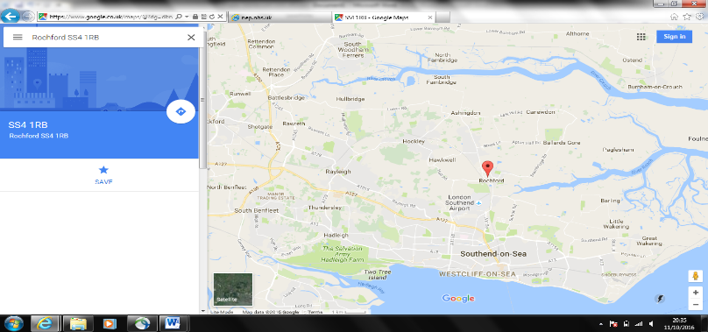

Ward Details
Rochford Hospital,
Rochford
Essex
SS4 1RB
Direct dial - 01702 538114
EPUT switchboard - 0300 123 0808
Email – EPUNFT.poplarcommunications@nhs.net

How to get here:


The hospital has a free car park for visitors to the ward, or you can park at Rochford train station is a 10 minute walk from Rochford hospital. The station car park is pay and display.

Rochford train station is accessible on the Southend Victoria Line.

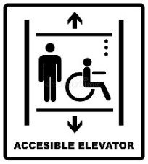
Poplar is an upstairs ward that has both stairs and lift access.
Welcome to Poplar Adolescent Unit
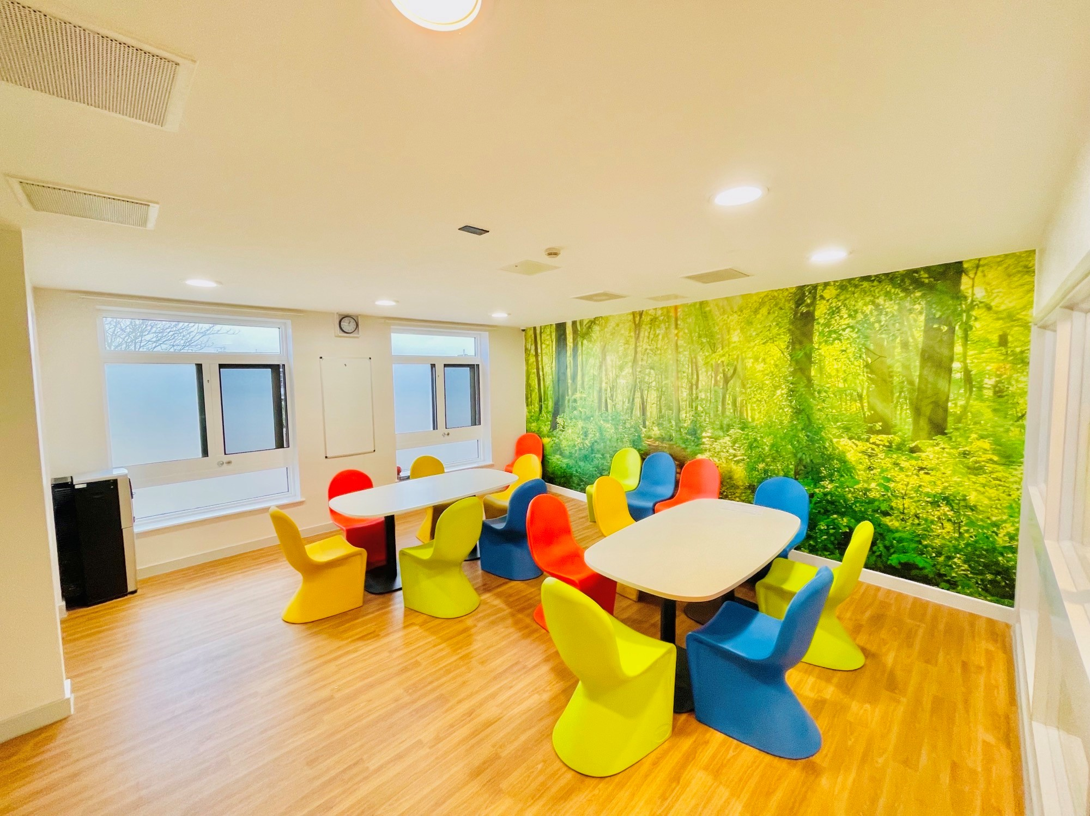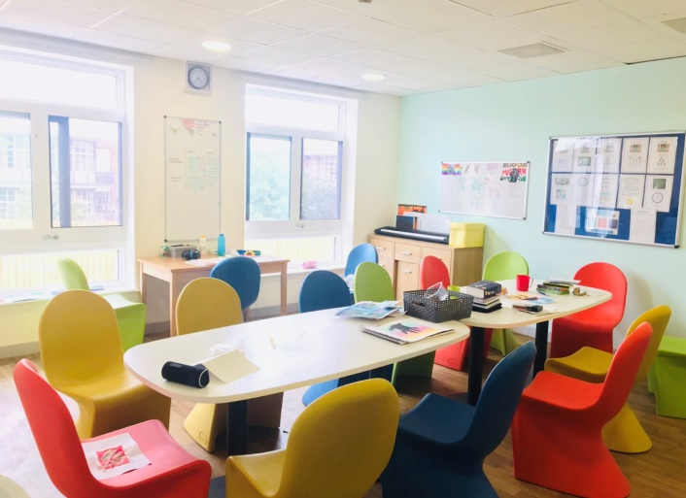

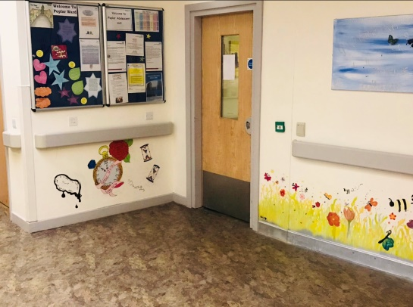

Poplar Adolescent Unit is an inpatient service providing specialist mental health services and a safe place of treatment for young people aged 13-18 years who require inpatient care. Referrals into the unit are from community mental health services as a planned or unplanned admission, crisis assessment teams, and emergency admissions under the Mental Health Act. Sometimes young people come as a planned transfer from other units.

- We have 13 ensuite bedrooms for young people aged 13 to 18.
- We also have one High Dependency Unit.
- Bathrooms (including an assisted bathroom)
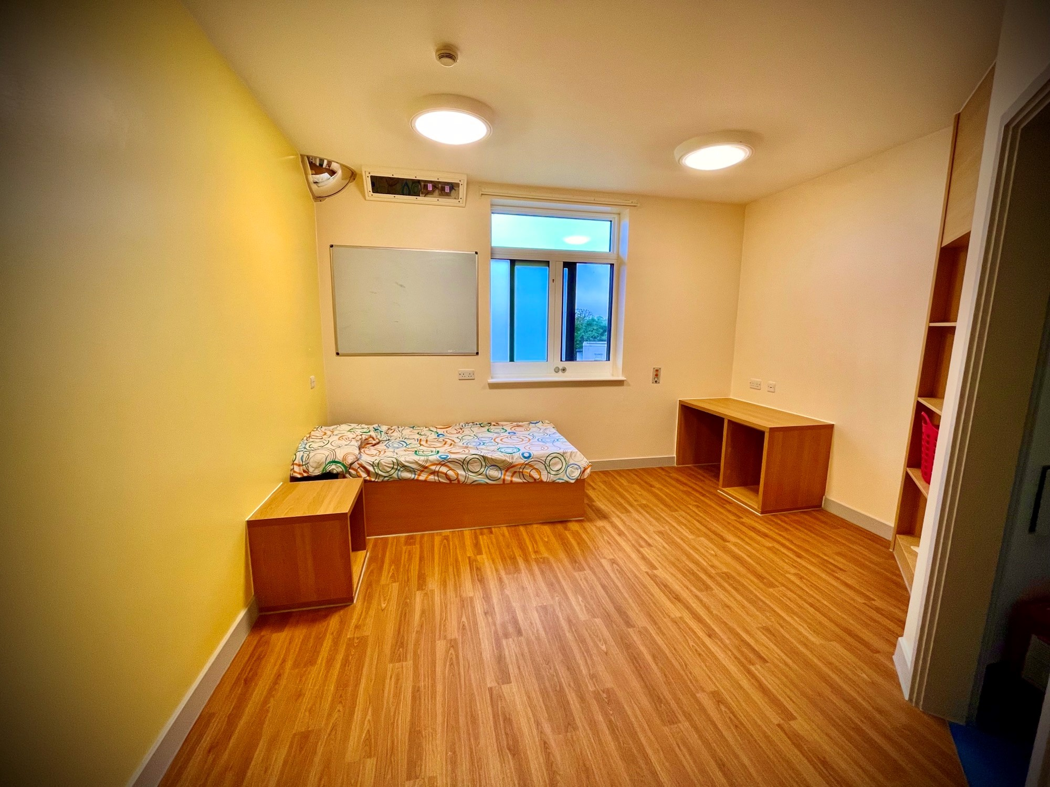
- Two lounges
- One dining room
- One chill out room
- One quiet room (the snug)
- Therapy and meeting rooms
- Nursing office
- Family visiting room
- Outside garden
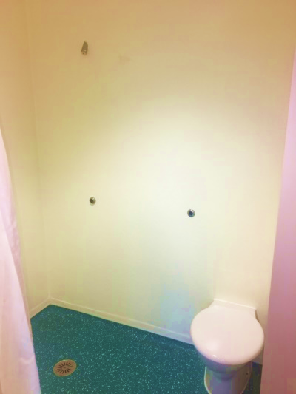
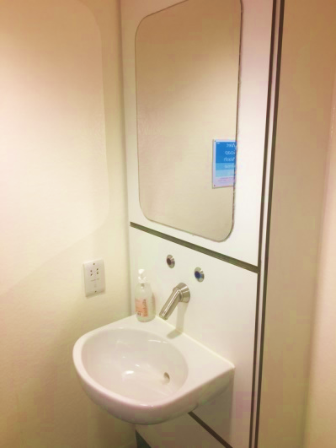

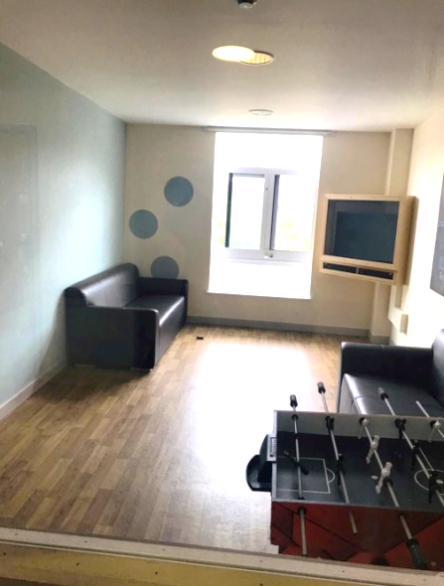

Poplar’s team of highly qualified professionals provide assessments, treatments, educational resources and short term rehabilitation for young people and their families. The unit is a safe place where staff, aim to help you, and each young person feel cared for, secure and protected.
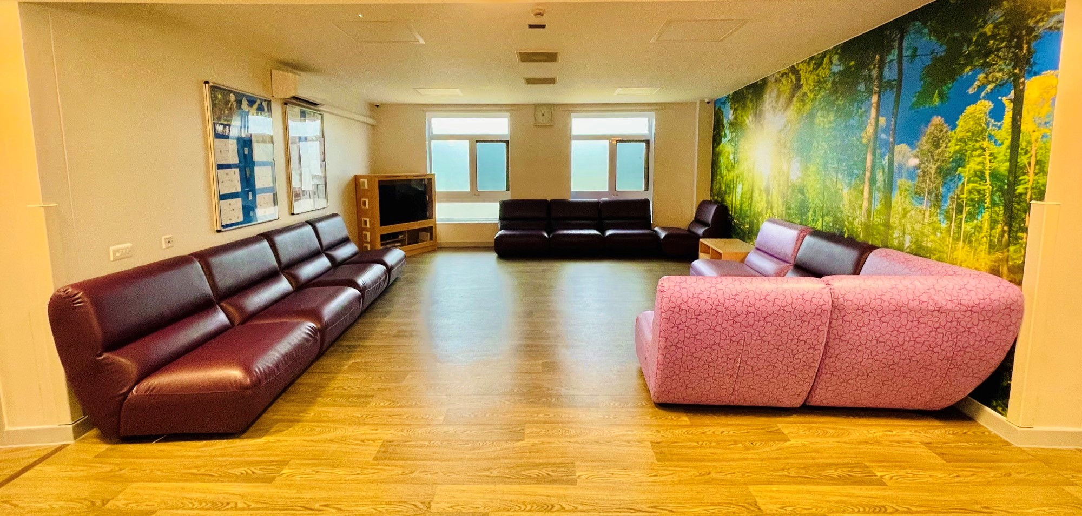
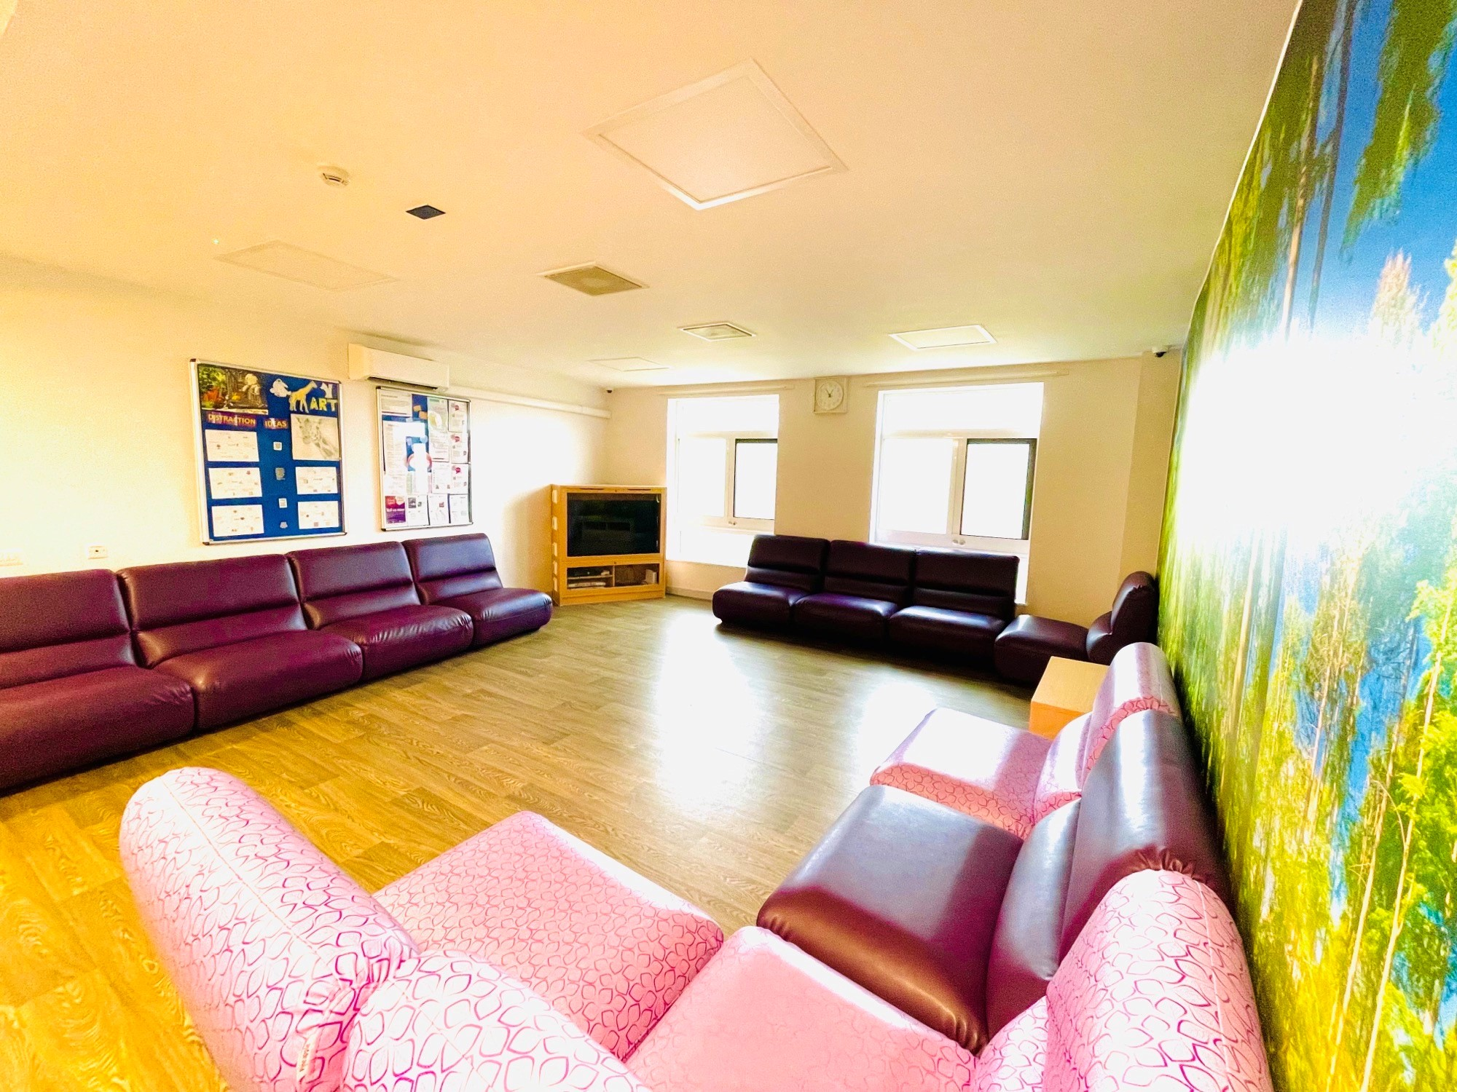
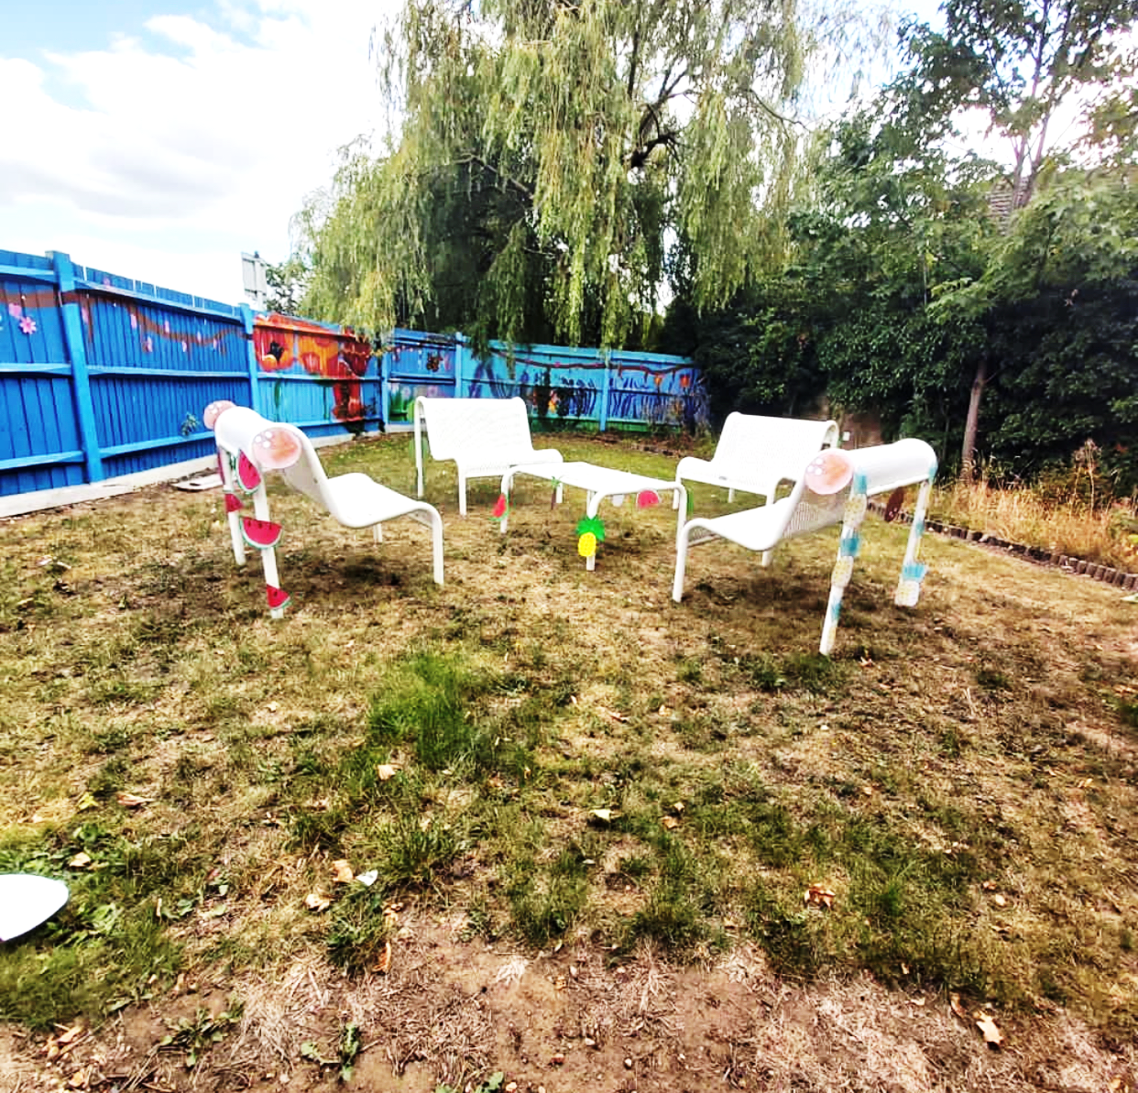

Poplar Adolescent Unit
Aims & Goals
An admission to hospital is always a last resort and can be disruptive to your life. A central philosophy for our work is therefore to revolve the system around you as much as possible in your care so that the hospital admission can be as undisruptive as possible. This means that we seek to work as a team together with outside agencies and families / carers, supporting you to work towards discharge as soon as this can safely be achieved. We like to involve families/carers in the treatment from the outset and support as much leave outside of hospital as possible, seeing this very much as part of your treatment and recovery. An admission to Poplar Adolescent Unit will be different for each individual, and we always aim for a “person centred approach”, which means that the care and treatment you will receive, will be individual to each Young Person and based on their needs. This includes considering your history, how you were managing before the admission, and the risks you present with which meant you were unable to be supported by the community teams.
We aim to practice as an “evidence-based” unit, which means we use research findings, theories, and outcomes of studies to help improve our practice. We always aim to use a “lessons learnt” approach within EPUT. We practice in accordance with NICE Clinical Guidelines, and Royal College of Psychiatrist recommendations, as well as guidelines of the British Psychological Society. We aim to work collaboratively with other agencies, to achieve the best outcomes and support package of care for the young person. This may include social care, education, and voluntary organisations.
Our aim is for young people admitted to Poplar Unit to be supported to a point that they are safe to return to the community. At this point the young person is usually still recovering and may need to be supported by the community teams for some time, but that their needs can safely be met in the community and they no longer need to stay in hospital. Please be mindful that a stay in a CAMHS inpatient service can be disruptive to many aspects of a young person’s life. Ideally, mental health issues should be treated in the context in which they occur, so that a holistic approach can be adopted. When the risk levels make the treatment difficult to deliver in the community, it is still vital to involve the systems around the young person who are involved in the treatment so that the desired outcomes can be achieved.
This means, that the parents, carers, social workers, community care co-ordinators, teachers, remain very much part of the treatment team and regular meetings with wider systems are essential for the young person’s recovery.
A stay on Poplar is only the first part of your recovery. The aim is not for you to be completely better when you get discharged, but to be safe and well enough to continue your treatment, and recovery journey, in the community. There are many negatives to staying in hospital (like missing home and school, and witnessing other people struggling) so we aim to keep admissions as short as possible.

Expectations
Staff expectations of young people- The team would expect that you engage with the programme and support offered. You should be respectful towards staff and peers on the unit. You are expected to adhere to all boundaries and agreed behaviours whilst on the unit. We also ask that you should be mindful of others in language and behaviour. Adhere to your agreed personal treatment programme. In an emergency, you will follow staff instructions to maintain their own safety and the safety of others.
What young people should expect from staff- Young people should expect that staff should always be respectful in their behaviour and language. Staff should show a compassionate and caring attitude towards you and their individual needs. Staff on duty act in accordance with EPUT policy and procedure and are aware of their professional role.
Family/carers/visitors/professionals expectations- Staff will always remain respectful. Staff will liaise with others involved in your care where appropriate and adhere to all confidentiality and sharing of information policies. Staff will always safeguard you and be aware of Trust safeguarding policy and procedures. Visitors will adhere to the guidance provided on contraband items brought into the unit and shared with you. Families/carers will share important information with the team which may affect the management and treatment of young people. Visitors adhere to the unit guidelines regarding visiting, to support the operational activities of the unit. Families/carers will support you to adhere to the programme throughout your admission and support the treatment/ behaviour management approach that the team advise for you. Families/carers should expect a good level of communication regarding their young person and should feel involved in their young person’s care where appropriate. Families/carers should feel able to approach the team for further advice, information about their young person.
We will always aim to meet your individual spiritual and cultural needs. We will discuss these at some point during the admission process, however, please ensure that you make us aware of any needs or requirements that you may have, including reading material, and prayer room facility.
Our unit aims to respect all aspects of cultural, ethnic and gender diversity. We will discuss your personal preferences at some point during the admission process, but we encourage you to raise any thoughts, concerns, or requests that you may have to ensure your individual needs are met.




Meet the Team

Your Team:
Parents/Carers:
Consultant Psychiatrist: Dr. Westbury
Speciality Doctor: Dr Ahmed/Dr Mansour
Matron: Rachael Smith
Ward Manager: Mahmuda Ahmed
Clinical Psychologist: Kelly Mann/Karin Sjostrom
Family Therapist: Gerhard Pretorius
Occupational Therapist: Penny Calder
Keyworker:
Associate Worker:
Key Teacher:

During the admission, the team will be aiming to gather as much information as possible about you to help in the assessment and understanding of your difficulties. This will include an assessment of your needs, including family and carer’s assessment if needed.

Nursing Team
You will be allocated a key nurse on admission, who will start to work on understanding your needs; this will often remain an ongoing piece of work as we gather further information during the admission. The key nurse will also support you to write some care plans. The care plan is designed to identify your needs, and an action plan agreed of how the team can work with you in working towards meeting those needs. The care plan will include goals and achievements towards recovery and will be individual for you. The frequency of meeting with your key nurse will vary, but we would expect you to meet and review your plan of care each week. You will also be allocated an associate nurse, who will be a support worker on the unit; they will support the role of the key nurse and offer additional support. The role of the key nurse will also be to liaise with the families/carers of the young person and engage them in the care plan where appropriate.

Meet our Matron
My name is Rachael and I am the Matron for Poplar Adolescent Unit, and I am a Registered Mental Health Nurse. I have worked in CAMHS since 2009 and started my nursing career on Poplar for many years before working in Community CAMHS as well. My role is primarily to have oversight on the overall running of Poplar, and ensuring that we are compliant with policies and procedures. My role is also to support service improvements and development, and include ideas from young people, carers and staff.

I oversee the whole team and support training and learning within the team to make sure that we have the skills required to deliver the service which is needed. I am responsible for the budget, including staffing, training, buildings and estate. I support the service with any audits and quality visits which we need to comply with and am responsible for ensuring all actions are completed.
I work alongside the Consultant Psychiatrist in responsibility for the ward, and am always available to speak with any young people, families or carers if you need any additional support or help from the CAMHS inpatient service.

Medical Team
During the admission, you will also be allocated a ward doctor. They will review your care each week in the weekly Clinical Review Meeting (CRM). They will also meet with you at other times during the week to review their care. The ward doctors will feed back the reviews with you to the unit consultant psychiatrist. The consultant psychiatrist is responsible for your clinical care and will also attend the Clinical Review Meeting each week. The consultant is also available to meet with young people and their families / carers at other times by prior appointment arranged through our ward administrators.

Psychological Therapies Team
Every young person admitted to the ward sees a Clinical Psychologist for psychological assessment and/or therapeutic intervention as appropriate. Routine outcome measures (rating mood, behaviour, resilience, and risk) are collected for everyone. If appropriate, more individualised psychological assessments may be carried out. Psychological therapy may include treatment relating to past or present traumas, difficulties with mood or emotional regulation. Therapy may be aimed at alleviating symptoms (e.g. by learning coping strategies to use when in distress or in a crisis). Individual work is always tailored to the individual, and may be informed by multiple therapeutic models, including Dialectical Behaviour Therapy, EMDR, Cognitive Behaviour Therapy, Cognitive Remediation Therapy, Systemic therapy, Attachment Therapies, Solution Focused Therapy, Acceptance and Commitment Therapy and Compassion Focused Therapy. Young people meet with their Psychologist on a weekly basis or more depending on need.

You will be offered time with a Family Therapist. The difficulties young people face when they come into hospital not only affects the young person, but often impacts on relationships and family life. Young people and families face unique challenges when someone is admitted to an inpatient unit. Family and systemic psychotherapy (known as family therapy) can help those in close relationships to better understand and support each other. It helps family members to express and explore difficult thoughts and emotions safely, understand each other’s views, appreciate each other’s needs, build on family strengths, and work together to improve their relationships and their lives. On Poplar Unit young people and families are offered an initial meeting with the Family Therapist to explore the current situation and discuss if Family Therapy would be helpful. Sessions are tailored to family members. Family sessions can be used in lots of different ways. Some families choose to have frequent regular sessions during the admission, while others might wish to only meet once, or occasionally, to address specific issues.

When you have settled in on the ward, the Occupational Therapist (OT) will arrange to meet with you discuss your needs. The aim of Occupational Therapy is to identify if you’re experiencing any difficulties with your mental or physical health, which is preventing you from being independent with the activities that you want or need to do. These activities may include learning, gaining employment, socialising, caring for yourself and maintaining a balanced routine which includes things that they enjoy doing or which help them to relax. The OT may do some assessments to better understand your needs. A treatment plan can be agreed with you, to support you to problem solve any difficulties. You will have the opportunity to attend a group programme and/or individual sessions which are tailored to your needs and interests and it will also be considered whether any equipment or adaptation to the environment would help you to achieve your goals. You will be supported to develop coping skills and strategies to help you to stay well and to lead the life you choose when you are ready to be discharged.

The psychological therapies team also coordinate and run the therapeutic group programme, which is open to every young person admitted to Poplar Adolescent Unit. More details on this can be found in the section on what you can expect from your admission.
Physical Health Clinic
A physical health clinic will be offered every Tuesday, whereby young people on the ward will have their physical health monitored and be given the opportunity to discuss any concerns that they may have regarding their medication or health. They also might have bloods and ECG’s taken during this time if required.


Smoking
The hospital operates a No Smoking Policy in line with the Trusts Policy and Procedures. This is an evidenced based policy, which promotes healthy lifestyles. The staff on the unit will support young people in smoking cessation and are able to prescribe nicotine replacement therapy and offer smoking cessation advice.
Young people will not be able to carry smoking related items on the unit. They will be held in the unit safe if they are brought to the unit until your parent/carer can collect them.

Covid-19 Guidance
As a ward we have to adhere to covid-19 guidance.
We will ask you to complete PCR (covid swab) test on the first day you are admitted. The results take 24hours to return and you will need to isolate in your bed area until the results return. But do not worry, staff will still be with you and we have activity packs to help pass the time. Staff will be wearing a face mask when they talk to you until the results return. If your results are negative then you do not need to isolate. If your results are positive for covid, you will need to remain in isolation until the results are negative.
On day 3 and day 7 of your admission we will ask you to complete a lateral flow test (LFT) which takes 30minutes to return the results.
If you have any overnight home leave from hospital you will need to take an LFT on your return.
It is no longer a requirement for NHS staff to wear masks, however some staff may still be wearing masks and we ask that everyone is respectful of this. You also have the right to request staff wear masks when communicating with you if you wish,


WARD ROUTINES AND PROCEDURES
What you might expect
What Can I Bring Onto Poplar Ward?

It is important that you feel comfortable during your stay on the unit, however the unit is within a hospital site, and therefore we are required to uphold standards of health and safety and hygiene. Therefore, we would ask that you bring in a small amount of clothing (4-5 days’ worth). There are laundry facilities in the unit which young people have access to.

Items you CAN bring to the unit | Items NOT authorised on the unit
Nightwear | Illicit drugs/alcohol
Seasonal appropriate clothing (please include gym clothes for physical activities in the group programme) | Knives, razor blades, scissors, glass containers
Two pairs of shoes (please include trainers for physical activities in the group programme) | Aerosols
A small soft toy (if desired) | Hair dye
Books to read, journal book to write in, pens, puzzles/colouring books. | Age inappropriate media (DVDs, Magazines)
MP3 player/iPod/mobile phone | Lighters
Small amount of money

Information about money on the ward:
While there is no need for money on the ward, the hospital is next to Rochford square where young people can visit shops whilst on leave from the hospital. We do not hold responsibility for any money that you bring into the ward and trust that you will be able to keep this safe. We are able to store up to £10 in our safe, if you require further money we can arrange for this to be looked after by the Hospital Welfare department.
Items which may be restricted on an individual basis
- Clothing with drawstring i.e. hoodies, tracksuit bottoms, pyjama bottoms
- Make up with plastic or breakable cases

This list is not exhaustive but is a guideline for families and young people of appropriate, useful, and restricted items. The Nurse in Charge or security nurse on duty will be able to guide you further if you have questions about property being brought into the unit.





Mobile Phone Access

Young people can bring mobile phones onto the ward. The use of these phones is subject to a contract being signed in relation to their safe and proper use, as detailed below.

Phones will be available outside of the ward programme to encourage participation and concentration. This includes education, therapeutic groups and individual therapy sessions.

Phone are only used in designated agreed areas, unless individually agreed otherwise by staff team and documented.

Mobile phone use must be appropriate, and not in a way which could cause harm to the young person or other young people and not in a way that violates the privacy, causes harm or disturbs another person, patient or staff member on Poplar Adolescent Unit.

The misuse of mobile phones by an individual leads to their initial 24 hour removal. Persistent issues will lead to them being permanently removed from that young person. They will then need to use the ward phone to maintain contact with friends and family. This will be under supervision to maintain safety.

If the young person declines to return the device to the staff team, then this could result in the person who owns and pays for the handset being asked to give permission for the device to be checked, although this will be carried out sensitively by the staff team.

If there is a serious safe-guarding risk concern, then the staff team may seek legal advice on how to access the information to be able to maintain the safety of the unit.

Mobile phones will not be used during mealtimes to promote social inclusion and social skills.

The recording and camera facility on the device will not be used whilst on the unit.


Visiting Times

Monday to Friday: 18.00-21.00
Saturday and Sunday: 09.00-21.00

We would ask that all visitors sign in the visitor’s book on arrival and sign out when leaving.
We would ask that you discuss any plans for under 12’s to attend the unit in advance, and an appropriate visiting room will be booked to support this visit. If the person you are visiting has ground leave, please feel free to make use of the hospital grounds and gardens.

Any visitor under 18 will need to be accompanied by an adult, unless already discussed and agreed with Nurse in Charge.

During your stay, we will be agreeing periods of leave away from the ward accompanied by your family/carers. This may be initially short periods of leave, leading to longer periods of leave including overnight. This will be agreed individually with your team and family/carers. It is unbelievably valuable to have feedback from yourself following the leave, to ensure that the team can support you to have further periods of leave.

We would ask that parents/carers speak to a member of staff following leave. There are also leave feedback forms available should you wish to write this down and share with the team.
We would ask that you could return to the ward by 8pm, to ensure a safe handover of patient information to the next shift coming on duty. If there are reasons this is not possible, please feel free to speak to the nurse in charge of the shift.


Mealtimes

Breakfast 07.30 – 09.00
Lunch 12.00 - 13.00
Dinner 17.00 - 18.00

We would ask that your family/carers plan their visits around our mealtimes, unless otherwise agreed by Nurse in Charge.

The hospital caterers provide the food, which is on a rolling 4-week programme to provide some variety. Young people are involved in the choice of some of the menu when this is reviewed by the trust.

Two evenings per week, we have ADL (Activities of Daily Living) evening. This means the staff will prepare the food with you. Young people will be involved in choosing the menu, and in cooking on a rota basis. This is another form of therapeutic activity which involves 1:1 time, learning new skills, and communication.



Leave Arrangements

During your admission, the team will encourage you to have leave away from the unit. Any leave will be decided with the team, the young person, and family/carers. Leave arrangements will take into account:
- Risks assessed over the past few days
- Previous leave arrangements
- Views of the person taking responsibility for the young person whilst off the hospital site
- Current mental state of the young person
- Plans for the leave period
- Engagement in the programme
- Mental Health Act status

Leave usually starts as escorted leave supported by staff/family/friends. A young person may be granted unescorted leave, which would need to be agreed by the person with parental responsibility and the ward team. You will be encouraged to take local area leave, and home leave as part of their treatment. This helps the team along with you and your family/carer to look at how well you are managing whilst away from the unit. We would ask that families and carers feed back to the staff how the periods of leave have been for everyone involved. This helps us to plan for further periods of leave, gradually building up time away from the unit. We would ask that you ensure you return from weekend leave by 9pm to ensure there is adequate time for this handover of information to take place.



Observation levels

During the admission, all young people will be observed and monitored by the team. Some young people are on a more enhanced level of observation than others depending on individual risks and needs. The team refer to the EPUT Observation and Engagement Policy and this will be referred to as level 1, 2, 3 or 4 observations.

- Level 1 - staff to observe patient once in every one hour
- Level 2 - staff to observe patient 5 times in every one hour at intermittent intervals
- Level 3 –staff to observe patient within eyesight at all times
- Level 4- staff to observe patient within arm’s length distance at all times

Resources available for you to use on the ward
(Please speak to Nursing Staff as some items may be restricted).

- Relaxation: chill out room with music, beanbags, weighted blanket.
- Keeping your fingers busy: tangle teasers, stress-balls, playdough, sand animals
- Staying in the moment: oils, MP3 players with mindfulness / relaxation exercises, handouts from groups with ideas.
- Distraction: DVD films library in the nursing office, books, puzzles, board games, arts, and crafts.
- Problem solving / solution focussed: handouts from Emotions Group, whiteboard in bedrooms.
- Social support: one to one with a member of staff, mobile phone to phone a relative or friend.
- Exercise: yoga mats, weights, stepper, hoops, exercise balls.
- Spiritual / religious resources: Bible, Quran, Multi-faith room.
- Outdoors: Gardening, sensory garden, going for a minibus trip.



What it is like to be away from home

If you are upset, worried, stressed or feeling in any way distressed about being away from home, please let us know so we can support them. Being away from home can be exceedingly difficult.

Sleep Hygiene

Sometimes being so far away from home, being in new surroundings or having difficult with your mental health can impact upon your sleep. If this happens to you please ask us to help.

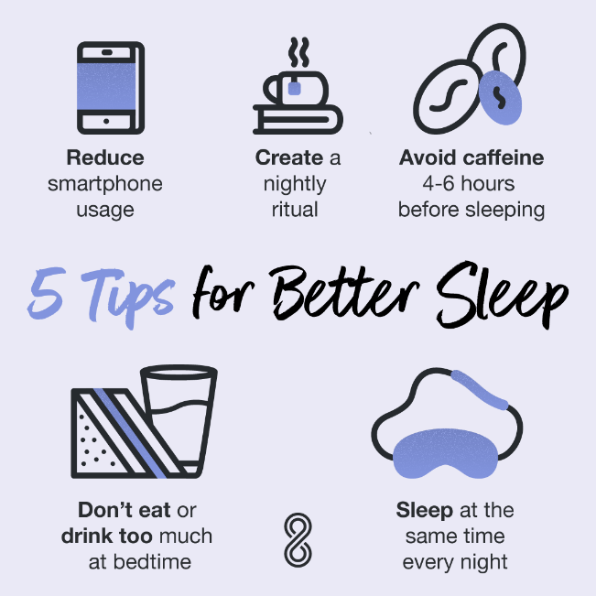

Your Rights in Hospital

Confidentiality
Confidentiality means that what you talk about with us will be kept private unless we are worried about your safety or the safety of other people. On Poplar, confidentiality is within the team, so staff members may share information with each other in order to provide the best and safest care. We may want to share information with professionals from community teams, but will ask for consent prior to doing this. We like to involve parents / carers in a young person’s care and treatment, and aim to do this with the young person’s consent. If a young person is under 16 we can share information as long as we have parental consent. Young people over the age of 16 have a legal right to confidentiality, and to refuse or consent to their own treatment, without needing to involve parents / carers.

Treatment with Consent
Most young people are admitted to hospital voluntarily. This means that they agree to a period of assessment and treatment in hospital. They are free to take discharge if they and their family feel this is in their best interest. As an informal patient, a young person’s consent is sought regarding any restrictions or limits placed on them for their own safety – for example limiting leave outside of the unit, searching a young person or their room, or if restraints or higher levels of observations are needed to keep a young person safe. If a young person does not agree with their restrictions, it may be that ending the admission with a community support plan will be the best way forwards. A thorough risk assessment will be completed as part of this planning to ensure that his is a safe option.

Treatment under the Mental Health Act
Sometimes young people do not want to come to hospital, but the risks to themselves or others are deemed high, so it is felt that a period of time in hospital is needed. The Mental Health Act 1983/2007 is a legal framework ensuring a young person’s rights during their admission to hospital, and it is designed to support the patient during a period of assessment or treatment.
- Section 5(4) is a Nurses holding power. A registered nurse can use this holding power for up to 6 hours, to prevent a patient from leaving the unit due to concerns of risk to themselves or others. This will need to be referred to a duty doctor for further review.
- Section 5(2) is a Doctors holding power. A doctor will be able to apply this section for up to 72 hours, to prevent a patient from leaving the unit if there are concerns of risks to themselves or others. This will need to be referred to an Independent Approved Mental Health Practitioner and an independent Dr for review.
- Section 2 MHA lasts up to 28 days, which allows for a period of assessment.
- Section 3 MHA lasts up to 6 months, and has regular reviews monitored by the Mental Health Act Administrators for the Trust.
- Section 17 MHA is authorised leave given to the patient from the Responsible Clinician (usually the consultant from the ward). This will support the young person to have leave off the grounds of the hospital.
If you feel you should not be detained under the MHA, you can request to appeal your detention.

Advocacy

Advocacy is a process of helping someone to speak up for themselves, or making sure they are heard at a time when speaking up for themselves may be difficult. The advocacy service is independent from all other services and roles and is totally young person led.

What does an advocate do?
Advocates are there to support your choices. For example, they can:
- listen to your views and concerns
- help you explore your options and rights (without advising them in any direction)
- give you information to help to make informed decisions
- help you contact relevant people, or contact them on their behalf
- accompany and support you in meetings or appointments

An advocate will not:
- give you their personal opinion
- solve problems and make decisions for you
- make judgements about you
(Mind, 2017)



Poplar Timetable
Monday |  | Tuesday | Wednesday | Thursday | Friday | Saturday | Sunday
8.00am  Wake up |  | 8.00am  Wake up | 8.00am  Wake up and get P.E. gear ready | 8.00am  Wake up | 8.00am  Wake up and get P.E. gear ready | 9.00am  Wake up | 9.00am  Wake up
Breakfast @ 8.30 am Breakfast @ 8.30am Breakfast @ 9.00am
Education  9am-10am  English  Break 10.00am – 10.15am  Education  10.15-11.15am  Humanities  Goal Setting Group  11.15am – 12.15 | Education  9am-10am  Maths  Break 10.00am – 10.15am  Education  10.15-11.15am  Thinking skills  Education  11.15-12.15pm  Art and Design |  | Education  9am-10am  English  Break 10.00am – 10.15am  Education  10.15-11.15am  PSHE / ASDAN  Community Meeting  11.15am – 12.15pm | Education  9am-10am  Maths  Break 10.00am – 10.15am  Education  10.15-11.15am  Course Work  Education  11.15am – 12.15pm Science | Education  9am-10am  Coursework Poplar Press  Break 10.00am – 10.15am  Education  10.15-11.15am  Coursework  Community Meeting  11.15am–12.15pm | Tidy Room / Laundry  9.30am – 11.00am  Cooking Group  11am – 12pm |  | Tidy Room / Laundry  9.30am – 11.00am  Indoor / Outdoor Games  11am -12pm
Lunch @ 12.15pm – 1pm Lunch @ 12.15pm – 1pm Lunch @ 12.15pm – 1pm
Education  1.15pm- 3pm  Music  Art  ADL  Cooking Group  3.15pm–5.00pm  DBT Skills Group  4.00 – 5.00pm  O.T Group | Education  1.15pm- 3pm  Physical / creative activities  O.T Group |  | Education  1.15pm- 3pm  Beliefs and Values  Cooking Group  3.15pm – 4pm  DBT Skills Group  4.00 – 5.00pm | Education  1.15pm- 3pm  Physical/Community activities  DBT Skills Group  4.00 – 5.00pm  O.T Group | Education  1.15pm- 3pm  Physical/creative activities | 1.15pm – 5.30pm  Free Time | 1.15pm – 5.30pm  Free Time
Dinner @ 5.00pm – 6.15pm Dinner @ 5.00pm – 6.15pm Dinner @ 5.00pm – 6.15pm
Visiting Time/Individual Support Time  6.15pm – 9pm | Visiting Time/ Individual Support Time  6.15pm – 9pm |  | Visiting Time/ Individual Support Time  6.15pm – 9pm | Visiting Time/ Individual Support Time  6.15pm – 9pm | Visiting Time/ Individual Support Time  6.15pm – 9pm | Visiting Time  6.15pm – 9pm | Visiting Time  6.15pm – 9pm
Supper & Medication @ 9.00pm – 9.30pm Supper & Medication @ 9.00pm – 9.30pm
Bedtime @ 10.30pm Bedtime @ 10.30pm Bedtime @ 10.30pm

Therapeutic Groups
The psychological therapies team run the group therapies offered on Poplar. Therapy groups are run every weekday outside of the times young people spend in education.
- There are three weekly Dialectical Behaviour Therapy (DBT) groups, focusing on Distress Tolerance, Emotional Regulation and Interpersonal Effectiveness Skills. These groups also incorporate elements of Mindfulness.
- We have a weekly Goal Setting Group where the young person is encouraged to take an active part in planning their recovery journey and enlist the support of others around them (staff and peers) in achieving their weekly goals. We encourage young people to use the weekly Clinical Review Meeting to discuss their goals and to be an active participant in the Multi-Disciplinary Team working towards recovery.
- On most days there are also groups led by the Occupational Therapist, including relaxation groups, creative activities, and activities of daily living focused groups.
- Finally, there is a weekly Community Meeting, where young people and staff can raise issues to be discussed and addressed.
We would ask that all young people agree to attend the groups, as they are structured to ensure they support many areas of the young person difficulties and introduce the use of positive coping strategies. They can help encourage peer support and can help with personal goal setting towards recovery.

Poplar Education Unit

As part of the structured programme, the unit provides 25 hours of educational provision per week. Poplar Education Unit is in the main hospital building and consists of three classrooms. It is supported by a head teacher, key teachers who are subject leads, and learning support assistance. The education unit is staffed by teachers from Essex County Council, and the unit is Ofsted Registered.

The unit follows the National Curriculum. All young people are assessed to attend our unit soon after admission, and each young person is allocated a key teacher. Part of the role of the education team is to liaise with a young person’s current school/college/education provider and work and progress can be shared to continue to support your learning whilst in hospital. They also support reintegration back into a young person’s own school/college. The education programme includes trips off the hospital site for educational learning. Parents/carers will be provided with regular updates on progress from education team.



Important Meetings

A 5 day CPA (Care Plan Approach)
This is an information gathering meeting to learn as much as possible from the people that know the young person best (e.g. Family, community worker, social worker, school etc.). We aim to hold this meeting within five days of admission. It consists of a multi-disciplinary team assessment (i.e. by doctors, psychologist, therapists, nurses, education) who pull together what is known about the young person so far, and to discuss how best to support him/her. Family / carers and anyone involved in working with the young person in the community are also invited to attend, as well as the young person themselves. Sometimes it is decided that the best place to support him/her is in the community, and she/he will then be discharged. Sometimes it is decided that she/he needs a longer stay in hospital. If so, a further CPA meeting date is set.
CPA (Care Plan Approach) Review Meeting
This is a meeting that happens every 4-6 weeks where a young person’s progress since admission is reviewed and plans are made for what needs to happen going forwards. Potential discharge is discussed, and plans are made for how to work towards / manage discharge. If a further period of stay in hospital is needed, the focus of work of such a stay is discussed. This meeting is attended by the Poplar staff involved, as well as any community workers that are, or will be, involved in working with the young person (from education, community mental health services, and social services) as well as family / carers and the young person themselves.
Clinical Review Meeting (CRM)
This is a weekly review meeting where plans are made for the coming week (e.g. leave, areas of work to focus on) and any work done in the previous week is reviewed. CRM takes place every Wednesday, and each young person has a time slot when they can come in and discuss with the team anything that relates to their admission, including therapy, reintegration to school, medication, leave off the ward and discharge planning and preparation. Young people are given a CRM preparation sheet the day before CRM where they can write things they may want to discuss to help them prepare. The Goals set in the weekly Goal Setting Meeting is also discussed in CRM.

Post Discharge – What Will Happen?


Generally the best place for a young person to have support for mental health issues is in the place where they live. A period of time in hospital will only be recommended when it is felt that supporting the young person is the community is not safe. A young person will be discharged from hospital as soon as it is felt that it is safe to do so.
Ideally, when you are ready to leave you will have a community team in place to support you.
Community support may include Social Workers, School staff; as well as support from Community Mental Health team (e.g. Psychologists, Psychiatrists, Occupational Therapists, Family Therapists etc.)
You are likely to still need to continue therapy/assessments in the community which can be done on a 1:1 basis or in a group format.
On occasions where you are unable to return home, alternative solutions will be sought during admission via Social Care.



Understanding Self Harm

Self-harm can take lots of physical forms, including cutting, burning, bruising, scratching, hair-pulling, poisoning, and overdosing. Self-harm is not usually a suicide attempt or a cry for attention. Instead, it is often a way for young people to release overwhelming emotions. It is a way of coping. Whatever the reason, it should be taken seriously.

Why children harm themselves
The exact reasons why children and young people decide to hurt themselves are not always easy to work out. In fact, they might not even know exactly why they do it.

Underlying reasons can include:
- low self-esteem and low confidence
- loneliness
- sadness
- anger
- numbness
- lack of control over their lives
Often, the physical pain of self-harm might feel easier to deal with than the emotional pain that is behind it. It can also make a young person feel they are in control of at least one part of their lives.

What you can your parents/carers do about self-harm?
Ask them to show you understanding. Discovering that your child is self-harming will inevitably have a big emotional effect on you. But however it makes you feel, it is important that you stay calm and let them know that you are there to help and support them. Try not to jump to conclusions or to find instant solutions. And never give the impression that their self-harming has created a big problem for you.

The severity of the injuries does not reflect the young person’s suffering. Something has caused them to self-harm – so it is always helpful to be sensitive. Saying things such as “the injuries aren’t that bad” or “what have you done to yourself?” could make things worse. Try not to take it personally or blame yourself either. Just concentrate on showing you understand and want to help.

Talk it over
If you wants to talk about your self-harm and why you are doing it, ask your parent/carer to sit down with you and listen. If you are struggling to talk, it may be easier for you to write your feelings down.

Discover the triggers
Try to get to the bottom of what makes you start to self-harm and think about how triggers can be avoided. If you think these might be linked to time they spend on the internet. Addressing the causes is going to be much more effective than removing the methods of self-harm like scissors or razors because anyone who really wants to hurt themselves is always going to find a way. Tell the child that you understand that self-harm helps them to cope but that this is only a temporary relief. Explain that you want to help them with the problems that make them want to hurt themselves so that they can feel happier in the long run. And see if you can help them find other ways to cope.

Build their confidence
Think of things they can do well and be praised for. It could be arranging a surprise party for a friend or even learning to play the guitar – it doesn't matter, as long as they enjoy doing it.

Show you trust them
Your instinct might be to constantly keep your eye on your child, and that is understandable. But by giving them their own space you will help build up their confidence and trust. Try to find a balance between monitoring what they're doing and respecting their privacy.

Help them find new ways to cope
Instead of telling them to stop self-harming, it is often more constructive to suggest alternative coping techniques. There are a few things you can suggest. They might not seem like they will work, but lots of children have told us that techniques like these have helped them:
- paint, draw or scribble in red ink
- hold an ice cube in your hand until it melts
- write down your negative feelings then rip the paper up
- listen to music
- talk to friends or family
- take a bath or shower
- exercise
- watch your favorite funny film

Emergency Pack of Coping Strategies

These strategies are here for you to use to help you cope when things have been overwhelming. You will be learning these and more during their admission.

Self Soothe

First steps to get ready:
Download the app STOP, BREATHE and THINK

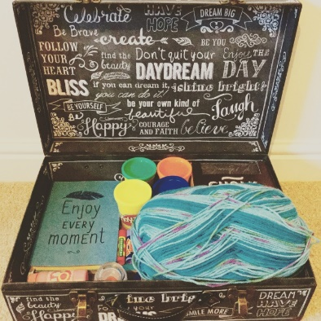
Find an empty box with a lid. Call it a soothing box.
Here are some ideas for what to put in it:
- Photo of a place you love and felt calm
- Nice smelling lotion
- Nice smelling candle (when you are off ward)
- Your favourite chocolate
- Nail varnish
- Soft toy or comfort soft cloth


Use your senses to observe the moment
Focus on one thing you can see and describe it to yourself.
Focus on what you can hear and describe it to yourself
Focus on what you can smell and describe it to yourself
Focus on what you can feel on your skin and describe it to yourself
Or focus on something you can taste when you eat or drink something.
Doing this is a form of mindfulness and distraction which will give you space.

Other self-soothe activities using the senses:
Seeing: Go to your favourite place and take in all the sights. Look at a photo album. Zone out using a poster or a picture. Notice the sunset. Do people/cloud watching.
Hearing: Listen to your favourite music and play it repeatedly. Listen to the sounds of nature around you or the sound of traffic. Focus on what you can hear.
Smell: Put on your favourite lotion. Smell a candle. Smell fresh coffee. Smell nature.
Taste: Eat something nice and really taste it. Drink something nice and really taste it.
Touch: Take a long bath or shower. Stroke a pet. Change into your most comfortable clothes. Stroke your hair. Touch something soft like a blanket or a soft toy.
Movement: Rock yourself gently. Stretch. Go for a walk. Do yoga. Dance.

Wobble factors
Now, let us identify what the factors are which may make you to feel worse.
Can you think of what they are, and can you write them down?
Think for a minute how these factors make you feel? Could you write that down, please?
Then, let us think about what you are likely to do when you feel like that – what urges to you have?
Identifying your wobble factors early will give you a better chance of managing them.

Trigger Factors | Feelings | Urges | Actions


Stop and Pause

When you have intense feelings, you tend to rush into an action to take the feelings away.
When you have those feelings again, STOP and PAUSE for 5 minutes.
Follow the steps on the next few pages to help distract you while you pause. Once you have stopped and started to calm down you will be able to THINK and then your actions will be more effective afterwards.

Focus on your breathing

Take a deep breath Hold it in for 4 counts Breathe out slowly to the
in while counting to 4. count of 8.

When you do this, try and focus only on your breathing.
Imagine you breathe in a relaxing colour (for most people this tends to be green or blue).
As you breathe out imagine breathing out the colour red. Try to keep your mind focussed only on your breathing and not on any other thoughts or feelings.
Imagine your breaths are like waves on the beach – watch them come and go.
Breathing in this way will keep you mindfully in the moment and it will help your body to relax.

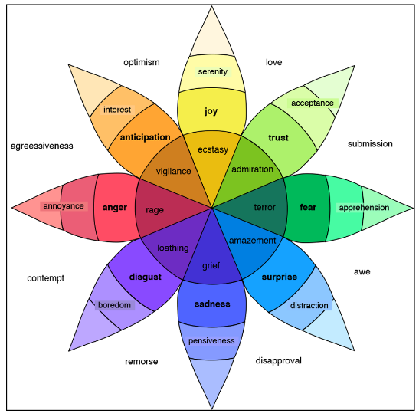
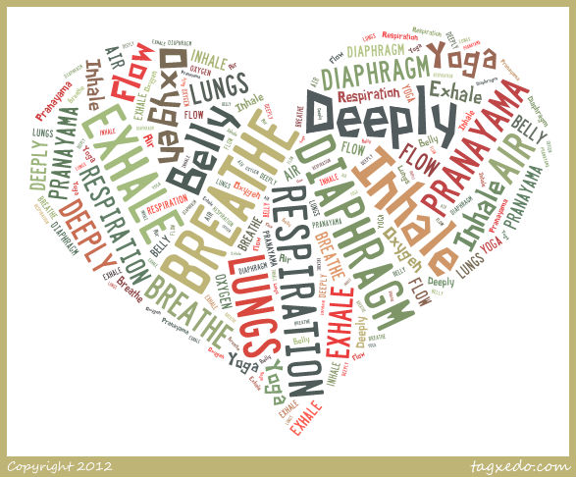

If you feel distressed or overwhelmed: use TIPP!
(Reference: Rathus & Miller, 2015)

TIPP is Temperature
Intense exercise
Paced breathing
Progressive muscle relaxation

This is a widely used technique that can help you manage overwhelming feelings. TIPP is a set of behaviours you can carry out; some people find it more helpful to act rather than talk when feeling overwhelmed.


Temperature
Drop the temperature of your face with cold water to calm down fast when distressed:
Hold your breath, put your face in a bowl of cold water or put a bag of cold ice on your eyes, or splash cold water on your face.
When you struggle to sleep at night, put an additional blanket on your bed, or put on your dressing gown. This will warm you up and in doing so, it will help you relax and fall asleep. When you get hot in the night, you can kick it off in your sleep.


Intense exercise
Engaging in intense exercise for a short while (10-15 minutes).
This may include any exercise such as sprinting, skipping, jumping jacks, weightlifting, push-ups etc. There is some exercise equipment available on the ward for you to use. Just ask a member of staff what is available.

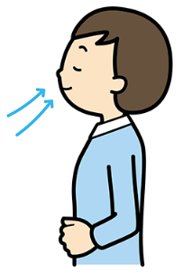
Paced breathing
Slow down the pace of your breathing
Breathe in deeply from your abdomen – put your hand on your tummy and feel the breath come in. Then breathe out more slowly than you breathe in.
Experiment with different ratios (counts), trying to count double for the outbreath than for the in-breath – e.g. 3:6 or 4:8

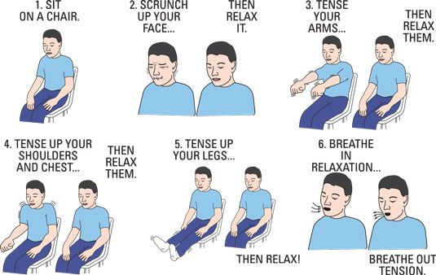
Progressive muscle relaxation
Tense and relax each muscle group from head to toe
One muscle group at the time
Tense for 5 seconds
Then relax
Then move on to the next muscle group

Distraction
Do something different….

- Create a different feeling by for example: watching a funny TV show or get active when feeling sad
- Push away: build an imaginary wall between you and the distressing feelings, or
- Put the pain in a box and tell yourself that you will attend to it another time
- Occupy your mind with something else, such as cross word puzzle, count numbers, count colours in a picture
- Intensify other sensations – hold an ice cube, listen to loud music, take a cold shower, squeeze a stress ball.

Helpful v Unhelpful

It will take some time to replace old unhelpful coping strategies with new ones.

It may feel a little strange and awkward at first, but remember when you first tried something new, like swimming, riding a bike, or learning to read and write!

You need to practice, practice, and practice!

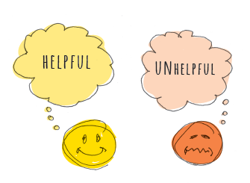


Complaints/Concerns
We always like to offer a local resolution to any concern you may have, please feel free to raise this with a member of staff, or make an appointment through our ward administrators who will arrange for the Unit Manager and/or Consultant to meet with you to discuss your concerns.

Our promise to you -
Whatever you think about our services or staff we want to hear from you. You may want to suggest or comment; you may want to send a compliment about a staff member or service, or you may want to complain. If you do, we promise to:
- Take you seriously
- Listen carefully
- Provide you with an explanation
- Do all we can to make amends to you and your family
Your care will not be adversely affected by any comments or complaints you make – in fact, it is more likely to help things improve for everyone.

Making a complaint
If you have an issue you want to raise with us, there are several ways of doing so just choose the one that suits you:
- You can call the PALS team on 0800 085 7935 and we will try to resolve your issue within 24 hours. If we cannot do so or if you are not satisfied with the response, we will arrange for it to be investigated.
- You can email a complaint (or a comment or compliment) to complaints.department@nhs.net or telephone the Complaints Department on 01268 739717 between 09.00 and 17.00.
- You can speak to any manager at any Trust location and they will try to sort issues out within five days, or in a timescale agreed with you.
- You can write to the Chief Executive: Miss Sally Morris, The Lodge, The Chase, Wickford, Essex, SS11 7XX.
- You can contact ICAS – the Independent Complaints Advocacy Service – on 0300 456 2370 between 09.00 and 17.00 Monday to Friday (they have an answer phone service outside these hours). For Southend residents please contact Healthwatch on 01702 356066.

Compliments
We welcome your compliments about our staff and services. Please to let us have your compliments by contacting us (details below). There are several ways you can tell us something or send a compliment –
- You can call on free phone and tell us
- Making comments and suggestions
- Use a freepost comment card (available at every Trust location
- Fill out surveys
- Become a Mystery Shopper

What will happen? Whatever way you choose to get in touch we will give you an acknowledgement (within three working days). We will offer to discuss
- Your concerns and what you would like to happen.
- How we will handle the issue and.
- The timescales for doing so.
- We will agree these with you.
- You will be involved when we investigate your issues.
- We will keep you updated in a way you choose.
- Once we have reached conclusions, we will give you an explanation.
- If we have made a mistake, we will give you a full apology and tell you how we will learn from your experience.
- After this, if you remain unhappy you can ask the Parliamentary Health Service Ombudsman to investigate your case. You can call their helpline 0345 015 4033 Monday – Friday 08:30 –17.30, or email phso.enquiries@ombudsman.org.uk

Taking you seriously
We hope that you find this process easy to use and helpful. If you are unsure about what to do, please contact us and we can discuss the options. We know that some people will be anxious about speaking up, but please be reassured, we will take you seriously and we will give you an explanation. That is our promise. Lastly please know that should you feel the need to complain, you will not be discriminated against and your care will not be compromised in any way.

Online Parent/Carer Group

Parents/carers of young people who are admitted to the ward have an opportunity to attend a regular group where they can:

- Learn about the ward and the people and processes involved in the young peoples’ treatment.
- Gain support from the other parents and facilitators during what can be a very stressful time for parents and carers.
- Learn stress management strategies to help parents and carers manage their own stress, as well as understand the techniques their young people are being taught.

The group sessions take place on Thursday afternoons between 2pm and 3.30pm on Microsoft Teams.

The group will be facilitated by two to three facilitators each week including, Gerhard Pretorius (Poplar Specialist Systemic and Family Psychotherapist).

The group runs in blocks of six consecutive weekly sessions. You are welcome to attend all, some or just one of the sessions – each group should be useful as a stand-alone session.

This group is a great opportunity for parents and carers to feel more involved in their young peoples’ care, and to gain valuable support, advice and skills.

We look forward to seeing you there (virtually)!

Friends and Family Test
On Poplar we ask everyone to complete a ‘friends and family test.’ This gives the service an indication on how you felt the service we provided has been. We ask for your honest opinion, we welcome feedback and we try and utilise the information we receive to improve where necessary to ensure we are providing the best service we can for Young People.
Your feedback is paramount to this process.
An example of a change we made following this process was – following feedback from a Young Persons family, we changed the way we feedback information to families following Clinical Review Meetings (CRM) meetings each week. We now aim to provide thorough feedback each week. We did this by allocating a Nurse to attend CRM for the full day and then contact families to give feedback at the end of the day once the CRM meeting has finished.
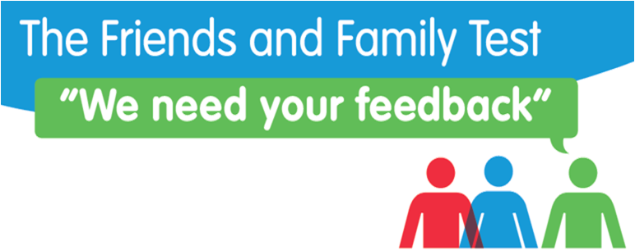

Other Feedback Questionnaires
Young Person Care Questionnaire:
Young people will also be asked to complete a care questionnaire on a weekly basis. This questionnaire will be completed anonymously and encourages young people to offer their feedback on their care/treatment whilst at Poplar Ward. Questions involve communication with staff, care plans, discrimination and opportunities to praise certain staff or raise concerns about particular aspects of the ward. Responses will be analysed to identify areas for improvement.
Parent/Carer Communication Questionnaire:
Parents/Carers will be contacted every three weeks to offer their feedback on the communication that they receive from the team at Poplar including: general feedback, reports, care plans and incidents that involve their child. This questionnaire will be sent via email and responses will be analysed to identify any areas that may require improvement.

Further reading and resources
Information about Adolescence
- Brainstorm by Dan Siegel
- Blame my brain: My amazing teenage brain by Nicola Morgan

Information about Self-Harm by the National Self-Harm network
http://www.nshn.co.uk/

Information about Hearing Voices - from the International Hearing Voices Network
http://www.intervoiceonline.org/children-and-young-people

Information about Psychosis - by Young Minds
https://youngminds.org.uk/find-help/conditions/psychosis/

Information about Trauma by Young Minds
http://www.trc-uk.org/

Information about OCD - by OCD UK
https://www.ocduk.org/childrens-ocd-guide

Information about Eating Disorders
http://anorexiafamily.com/
Book: Eva Musby: Anorexia and Other Eating Disorders

Information about Autistic Spectrum Condition - by the National Autistic Society
http://www.autism.org.uk/

Support Services You Can Access -
Having a child in hospital can be an incredibly stressful and daunting experience. If you need to access support or speak to someone, please find details below –

NSPCC-
Helpline (adults): 0800 800 5000

Samaritans-

24-hour helpline: 116 123 (free phone)

Parenting and Family Support- Family Lives (formerly Parent line Plus)-
Helpline: 0808 800 2222.

Therapy for you (self-referral)-
01268 739 128 (local South Essex number)
This is a free and confidential service to help support you. If you are not local, please search for your nearest I.A.P.Ts (Improving Access to Psychological Therapy) service via the link below –
http://www.nhs.uk/Service-Search/Psychological%20therapies%20(IAPT)/LocationSearch/10008
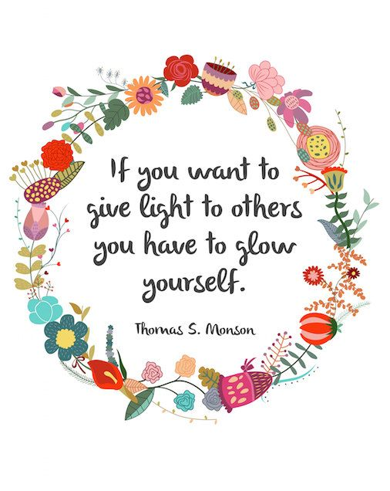


This booklet has been written and compiled by Dr Karin Sjostrom (Clinical Psychologist), Caoimhe Forbes & Charlotte Drewery (Assistant Psychologists).
The information within this booklet has been derived from the practitioner’s knowledge base, a wide range of internet sources and input from the Young People on Poplar Ward.

