Return to Practice AHP
To register your interest in returning to practice with EPUT please complete the form below.
* Required

1.Full name*


2.Email address*

3.Contact Telephone number*

4.Date of last registration with HCPC (or years away from practice)*

5.Which profession were you registered as?*

Arts Therapist
Chiropodist/Podiatrist
Dietitian
Occupational Therapist
Paramedic
Physiotherapist
Practitioner Psychologist
Speech and Language Therapist


6.Reasons for leaving the HCPC register*

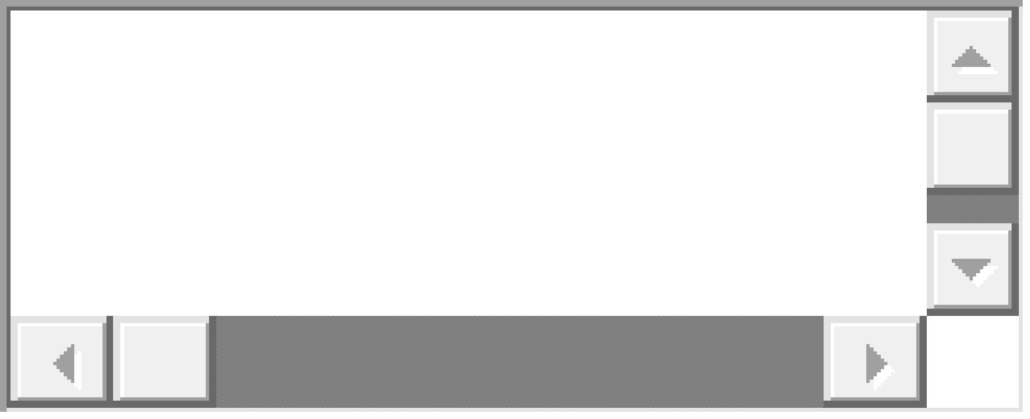

7.Reason for wishing to return to practice*

8.If you trained overseas and never formally registered with the HCPC please advise where you trained and what profession.

9.Summary of previous employment*

10.Preferred clinical area*

Mental Health
Learning Disabilities
Adults
Older People
Child/Adolescent
In-patient
Community

11.Preferred geographical location*

Bedfordshire
Luton
Mid Essex
North Essex
South East Essex
South West Essex
West Essex

12.When are you looking to return to practice*

0-3 months
3-6 months
6-months or more
I am not sure, I would like more information

13.Current employer (please note we will not contact your employer)*

14.Where did you hear about this opportunity?*
EPUT website
Contact within EPUT
Social Media


