
Together with Baby
Parent Infant Mental Health Service
Cherry Trees at St Peter’s Hospital
Maldon, Essex
CM9 6EG
epunft.pimhs.eput@nhs.net
01621 866900

Together with Baby are Essex’s Parent-Infant Mental Health Service (PIMHS). We provide specialist assessment and intervention to caregivers and their infants up to the age of two who are experiencing difficulties within the caregiver-infant relationship. We also work with women antenatally. In addition to our direct client provision, we provide consultation and training to the Early Years workforce and mental health professionals. We work with a psychological formulation based approach which means creating a shared understanding of a person’s current difficulties by exploring their past experiences and the social context they are in.
This guide has been designed to support professionals with the referral making process. It outlines the support that we do and do not offer to families and professionals, our referral criteria, and information on how to complete our referral form. This document is not exhaustive and if you have any further questions please do get in touch via the main office details at the top of the page or with the practitioner from your locality below. We are available to consult on cases to support with formulation of the parent-infant relationship or if you are considering a referral to us.
Staff name | Job title | Locality | Contact details
Dr Ellen Auty | Consultant Clinical Psychologist and Service Lead | Mid | ellen.auty@nhs.net
Dr Naomi Sams | Principal Clinical Psychologist and Team Lead | West | naomi.sams@nhs.net
Hamish Seymour | Child and Adolescent Psychotherapist | North | hamish.seymour@nhs.net
Lesley Morris | Art Psychotherapist and Parent-infant Therapist | South | lesley.morris8@nhs.net
Teresa Bell | Parent-infant Therapist | South | teresa.bell1@nhs.net
Jo Hawkins | Administrator | Essex wide | joanne.hawkins@nhs.net
Ella Beatty | Assistant Psychologist | Essex wide | ella.beatty@nhs.net
Karen O’Neill | Psychotherapist and Parent-Infant Therapist | Mid | k.oneill7@nhs.net
Alria Williams | Trainee Clinical Psychologist | South | alria.williams4@nhs.net
Emily Sigston | Trainee Clinical Psychologist | North/Mid | emily.sigston1@nhs.net
Sally Perry | Parent Infant Therapist | Thurrock | sally.perry4@nhs.net
 | Student Psychologist | Essex wide

Index
Referral criteria and exclusions………………………………………………………….……..4
Referral pathway & how to refer..…………………………………………….………………...5
What we offer and what we don’t offer..……………………………….………………………6
Completing the referral form…………………………………………………….………………7
Completing the form: filling out the boxes…………………………………………….……….9

Referral criteria
Referral suitability is assessed on an individual basis. As a team we review each referral, exploring the client’s needs and current context as well as considering their ability to access and engage in Parent-infant work. The service provides support to parents experiencing the difficulties below:
- Parent is concerned they are not bonding or connecting with their infant
- Parent is concerned that their baby is not bonding with them
- The parent has a difficult history of being parented themselves and this is impacting on parenting their own infant - e.g. they may want to parent differently but are not sure how to
- Parent may have been in care during their childhood and experienced ruptures in their caregiving experience, which is causing them to find the experience of parenting challenging now
- There are significant relational difficulties that are impacting on the parent-infant relationship – e.g. the parent may have a history of difficulty in relationships (family, peer, or romantic relationships)
- Parent has experienced trauma that is impacting on their developing relationship with their child – e.g. birth trauma that has created a negative association with their infant
- Parents are facing additional difficulties such as physical or emotional ill health that may be having a negative impact on their experience of becoming a parent
- There is evidence of, or risk of, the relationship between caregiver and infant being ruptured
- Feelings of shame or lack of confidence within the parent-infant relationship
- Previous infant/ child loss impacting on capacity to connect with current pregnancy/ new baby
- The infant has a disability and the parent feels that this is impacting on their bonding
- The baby was born prematurely or spent their early moments in a NICU, meaning that there were possible early separations from their parent(s)
- Parents that have previously had a child removed but have plans for their current pregnancy/ new baby to remain in their care

Exclusions
- The parent and infant do not live in Essex
- The infant is over 24 months in age
- The referred parent is not the infant’s primary caregiver
- The relationship is not at risk
- The parent is unable to engage in parent-infant work due to their current context – e.g. social difficulties such as housing or being unable to attend appointments regularly, mental health difficulties that are not being supported, or there may be various other services currently involved
- The primary difficulty is not within the parent-infant relationship
- The parent has not consented to a referral

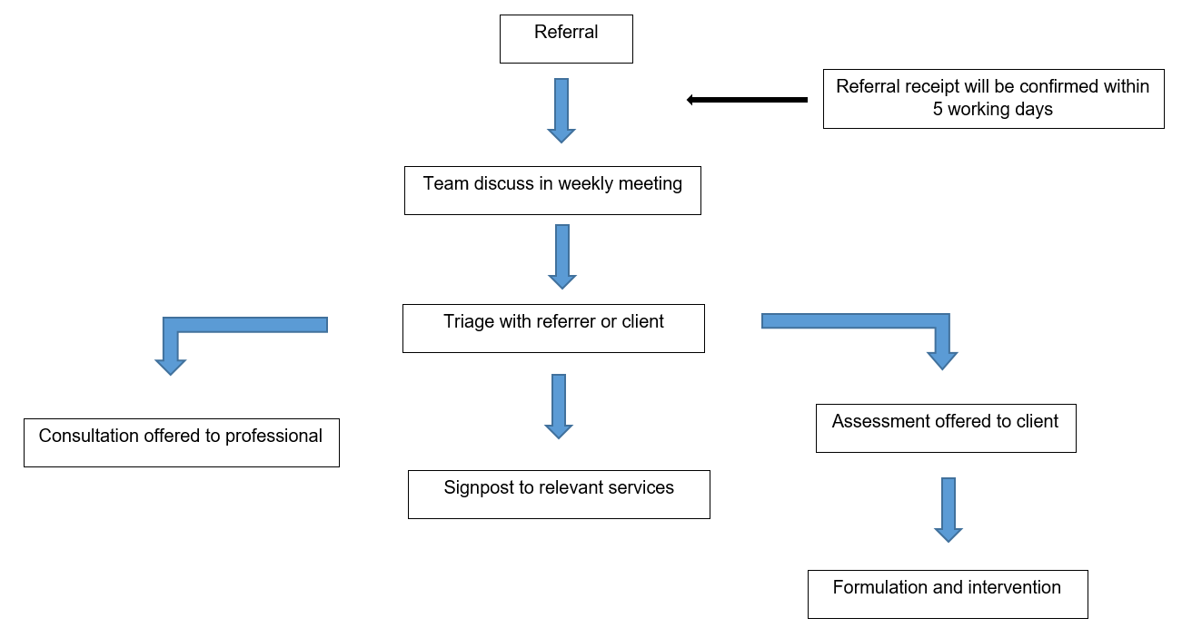
Referral Pathway

In the first instance a referral will be triaged for relational and safeguarding risk, to ascertain the network involved, and to see what levels of support are currently being accessed. There will be different routes the referral will take during the triage process:
- The referrer is contacted for further information and advice and consultation is provided
- The referrer is contacted and signposted to other forms of support and intervention as well as provided with advice and consultation to support the family with next steps
- The referral is accepted for assessment and added to our waiting list. The family will then be met by a practitioner to complete the assessment but this does not always lead to intervention. The clinician will bring the assessment information to the team and formulation of need will take place. From this a decision will be made as to whether an intervention is indicated or if the family can be signposted to other agencies and organisations.

How to make a referral
- Please use the information in this guide for supporting the referral process
- Alternatively if you would like support with completing the form or have a query regarding the suitability of a client, you can email epunft.pimhs.eput@nhs.net or call on 01621 866900 prior to making the referral
- Complete the referral form and send to epunft.pimhs.eput@nhs.net
What we offer
Relational trauma in the earliest years of life can have lifelong negative impacts on a person’s social, emotional, physical, and intellectual development. Together with Baby provide intervention at the earliest stage to support with building a positive connection between parent and baby and improve outcomes for the infant as they move through childhood and beyond.
Direct client work:
Please note that this list is not exhaustive and the interventions provided will vary dependent on the parent-infant needs and formulation.
- Comprehensive assessments including observations of the parent-infant dynamic
- Circle of Security: an attachment based intervention that supports parent’s to better understand their children’s needs (see overview video: https://www.youtube.com/watch?v=1wpz8m0BFM8)
- Video Interactive Guidance: a strengths-based approach where parents are recorded interacting with their infant and shown micro-analysed moments that show ‘better than usual’ interactions (see overview video: https://www.youtube.com/watch?v=YRVaL_ZlxHs)
- Parent-infant-Psychotherapy: exploring the parent’s early history and own experiences of being parented and thinking about how this impacts on their parenting now
- Art Therapy Group for Pregnant Women
- Watch Wait Wonder – a child-led approach where parents are encouraged to take a curious observer stance and allow their infant to interact with them and explore this with their clinician afterwards
- New Born Observation – a tool whereby the practitioner explores a baby’s communication and behaviour to support the parent’s understanding of their baby
Consultation and training for professionals
- Consultation
- Reflective practice groups
- Workforce training (level 1 & 2 meeting AIMH competencies)
- Individual service training on agreed topics/ needs

What we don’t offer
- Parenting capacity assessments
- Care coordination / mental health monitoring
- Birth trauma processing
- Post-birth loss support (unless this is in the context of a new pregnancy/ baby)

Completing the referral form
Things for referrer consideration
Parent readiness
We work with parents who experience mental health difficulties however the service is not commissioned to offer direct mental health interventions and care-planning. It is a psychotherapeutic service and is led with psychological case-holding and oversight. We work in partnership with Adult Mental Health provisions such as the Perinatal Mental Health Service and Community Mental Health Services. In the event that a parent experiences a deterioration in their mental well-being, parents will be referred to the appropriate services for assessment and intervention to manage their safety and mental health risks. The parent-infant work may well be paused to allow for recovery and then resumed when the parent feels able to engage in the work.
With this in mind, before making a referral please consider the parent’s current ability to access and engage with additional support from our service. You can contact us to discuss suitability prior to making the referral or consider the following prompts:
- Is the parent experiencing a mental health difficulty? If so, are these needs being held appropriately by services and with sufficient support?
- Would the addition of extra professionals/therapy/services be overwhelming and unhelpful?
- Does their social context allow them to attend appointments safely and regularly?
- Are there more prominent difficulties that a parent would need support with first? e.g. housing, financial difficulties
- Are there outstanding safeguarding/ risk concerns that have not been addressed? Safety plans would need to be in place in order for us to start working with a family
- Is the parent expressing more ambivalence than motivation to engage in the work? (please see Voice of the Referred Parent section below for more details on this)
If a parent is not currently in a position to engage with our service directly, we can offer consultation to the professional network to provide a parent-infant relational perspective and indirect support to the family instead.
Infant age
Our cut-off age is at the infant’s second birthday and we are not commissioned to work with parent-infant relationships outside of this age bracket. Therefore to be able to provide a meaningful intervention to the family we ask that this is considered at the point of referral. For example, if an infant is referred at 20 months or older, we will still aim to offer an assessment and consultation to the network as a discrete piece of work. However, depending on service capacity and waiting times this may not always be possible and we would instead complete a triage/ discussion with you regarding which other services you may be able to refer or signpost onto. We work antenatally with parents from the age of conception and would encourage referrers to make referrals as early as possible if relational difficulties have been identified.

Family composition
As a service we understand that families come in many different forms and we therefore accept referrals for all people that identify as a primary caregiver for their infant. It is not a requirement for a caregiver to be a biological parent to access our service and we welcome requests for support for single parents, step-parents, parents from the LGBTQIA+ community, parents from ethnic minorities, parents that conceived via adoption, surrogacy or IVF methods, and so on. We are friendly, non-judgemental, and ready to work with people that have become parents through both traditional and non-traditional routes.
Our capacity as a service
As the demand for the service increases steps will be taken to ensure that service capacity can be utilised in a timely and effective way. In the first instance we encourage professionals to seek support for their clients on a consultation basis prior to making a direct referral. This would allow professionals to begin working with their clients within a parent-infant framework informed by Together with Baby whilst reducing waiting time for the client.
To ensure we are meeting the needs of vulnerable families the following is taken into consideration when determining the priority of a referral:
- Relational risk and increases to this (e.g. if there has been birth trauma, multiple children)
- Other risks such as social context, mental health
- Age of the infant
- Pregnancy and length of gestation
- Parents who may be at increased risk of relational difficulties – e.g. those who have a history of relational trauma

Completing the form: filling out the boxes
Voice of the referred parent / caregiver
In this section we would like to hear the referred parent’s understanding of the relational difficulties and what they personally feel they are struggling with. This may include, but is not limited to:
- Their feelings about the infant and their relationship with them
- Their own experience of being parented and what this means for becoming a parent themselves
- Have they experienced any relational difficulties with any previous children?
- How does the relationship impact the parent and how they feel about their self and their abilities to parent?
It can be challenging to explore our earlier experiences and consider how they might be linked to our current difficulties. Therefore engaging in parent-infant work requires the parent to feel willing and able to do this in order to meaningfully access the work. However, it is not uncommon for parents to express some ambivalence about engaging in this work and part of our role may be around supporting the parent to develop on this. If you are unsure whether a parent may be ready to engage in parent-infant work, please contact us to consult on the case.
It may be helpful to consider the following with the referred parent when completing this section:
- Their motivation to work on relationship
- Their ability to mentalize the infant’s experience – e.g. how might the relationship/environment be impacting on the infant and how are they expressing this? (See voice of the infant below for further information)
- Risk/ safeguarding – are there imminent risks to the infant or parent’s safety that require additional support? E.g. domestic violence in the home
- Other factors that might make it difficult for the parent to engage e.g. mental health difficulties or social/ environmental difficulties

Voice of the infant
As we work with infants up to the age of 2 we would like to hear their hypothetical “voice” by considering their non-verbal communication and behaviours that might indicate their experience of their caregiver relationships/ environment, e.g. expressing distress.
By “voice” we are thinking of how the infant might be making sense of their environment and care they are receiving? If they could speak how might they describe how their needs are being met or not met? What words might someone who could speak use if were in the infant’s situation? How does the infant cue to their caregiver that they need something?
It can be helpful to consider how infants are entirely reliant on their caregivers to meet their needs and they learn very quickly to adapt their behaviour and presentations in line with the care they receive. Some ideas to consider:
- Behaviour / body language (looking away, covering face with hands, tense/ stiff body with arched back?)
- Communication (eye contact, babbling/cooing, reaching out hands/pointing?)
- Sensory difficulties (e.g. sensitive to touch/sound/light/movement, overstimulated quickly, non-reactive to changes in environment?)
- Sleeping (do they have trouble falling or staying asleep?)
- Feeding (do they have trouble feeding/swallowing/vomiting?)
- Bodily functions that may suggest dysregulation (e.g. stomach problems, colic, reflux?)
- Temperament (are they settled or dysregulated more of the time)
- Crying (are they settled when comforted, who do they seek comfort from, are they crying a lot, are they a very quiet baby who rarely/never cries?)
- Meeting developmental stages (e.g. ASQ-SE?)
- Does the infant have a preferred attachment to a certain caregiver
- What might the infant need more or less of from their caregiver to ensure their emotional, social, physical needs are met

Voice of the other parent / caregiver
The other parent may not be present or available when you make the referral however it is still useful for them to be held in mind throughout the process. It is helpful to know what their relationship with the infant is like and their level of involvement/ parental responsibility. It is also helpful to consider how the other parent may be experience the relationship between the infant and the referred parent, how the introduction of a new infant has changed the romantic relationship (if applicable), and where they fit in the family dynamic. It can also be helpful to know if there are any other family members/ caregivers closely involved with the infant.

What are the hopes and concerns of the referred parent for this referral?
In this section we would like to hear what the referred parent may wish to learn or changes they would hope for within the parent-infant relationship. It can also be helpful to list any concerns the parent may have e.g. worries around speaking to professionals if they have had negative experiences of this previously.

Any other info?
In this section it is helpful to list any other relevant information which is not limited to but may include:
- Other support they are receiving, e.g. social care or advanced health visiting programmes
- The level of mental health support they are receiving and what their care plans involve
- Any information on social or cultural contexts
- Other services involved e.g. third party/ charitable services
- Has the parent struggled to engage with professionals in the past?

We have also provided 2 example referral forms that you may wish to use as a reference when completing your referral.

