Essex Perinatal Mental Health Service
Is this referral (please see Severity Guide at end of form)
☐URGENT (please phone the team) | ☐ROUTINE

Area
☐South East Essex | ☐South West Essex
☐North East Essex | ☐Mid Essex
☐West Essex

Referrer details
Name:
Agency:
Contact Number:
Email Address:
Has the patient consented to the referral and being contacted by PNMHS ☐Yes ☐No
(this can be via text/ telephone or letter and it will be from withheld number please advise client at time of doing referral )

Patient Details |  |  |  |  |  | Antenatal Referral
Name:  Preferred Name: |  |  |  |  |  | EDD:
DOB: |  |  |  |  |  | Gestation:
Contact no:  PLEASE ENSURE CORRECT NUMBER |  |  |  |  |  | Gravida/Parity:
Address: |  |  |  |  |  | Any previous losses:
 |  |  |  |  |  | Community Midwife:
NHS No:  Ethnicity: |  |  |  |  |  | DOB (Baby):
Interpreter required?
Remedy/Mobius number: (If known) |  |  |  |  |  | Health Visitor:
GP Surgery: |  |  |  |  |  | Other agencies involved:
 | Reason for referral
 | ☐Tokophobia (fear of childbirth)
 | ☐Prescribing advice in pregnancy and breastfeeding (for valproate treat as urgent and phone in)
 | ☐Preconception counselling – for valproate please refer to local FRT/AAT
 | ☐Moderate – severe mental illness: |  |  | ☐Current |  |  | ☐Past |  | ☐Both
 | ☐Depression | ☐Anxiety |  | ☐PTSD |  |  | ☐OCD |  | ☐Personality disorder
 | ☐Bipolar affective disorder |  |  | ☐Schizophrenia/Psychosis |  |  |  |  | ☐Personality disorder
 | ☐Family / Personal history of Bipolar affective disorder or post-partum psychosis
 | ☐Other (please describe)

When Perinatal red flags are present please consider urgent referral /discussion with our team and CRHT – 01375 364632 (For Professionals Only!)
• Recent and significant mental state change/ sudden fluctuation and deterioration in mood
• New thoughts/acts of self-harm or harm to others (baby in particular)
• Estrangement from infant/ inadequacy as a mother
• Thoughts / acts of absconsion
• Previous history of suicide /self-harm

 | Risk: | ☐Self (self harm / suicide) |  |  |  |  | ☐Others |  |  |  | ☐Baby
 |  | ☐Vulnerability |  |  |  |  | ☐Self neglect |  |  |  | ☐Exploitation
 | Please describe in detail:
 | Additional Risk Factors:
 | ☐Substance Misuse |  | ☐Current |  |  |  | ☐Past
 | Substance Details |  | Type: Click here to enter text. |  |  |  | Amount: Click here to enter text.
 | ☐Learning Disability |  | ☐<18 year old
 | ☐Social Situation |  | ☐Unemployed |  | ☐Financial difficulties |  |  |  |  |  | ☐homeless
 |  |  | ☐Isolated |  | ☐Communication issues
 | ☐Medical-physical health or obstetric problems (please list if pregnancy is high risk and why)
 | ☐Other
Current treatment and support in place
Current Medication:
Primary Care Treatment prior to referral:
(For women with mild- moderate depression/anxiety first step treatment as per CG 192 should be tried ie first line medication and IAPT/enhanced HV support ( post-natal) or additional Children social care support if appropriate /other 3rd sector agencies)
Other agencies involved
Adult Community MHT: |  |  |  | ☐Care Coordinator |  |  |  |  |  | ☐Psychiatrist
Children Social Care: |  |  |  | ☐CIN Plan |  | ☐CP Plan
 |  |  |  | ☐Under assessment |  |  |  | ☐Unknown
Adult Social Care: |  |  |  | ☐MARAC |  | ☐MAPPA
Other: (ie Substance misuse, eating disorder, 3rd sector, etc)
Family / Friends Support:

Scores – Routine Questionnaires
EPDS Insert Score | GAD 7 Insert Score
PHQ 9 Insert Score | Other Insert Score + Specify Questionnaire

Severity Guidance
Please use this as a point of reference for urgent and moderate to severe referrals please phone in the office to discuss with our duty worker.
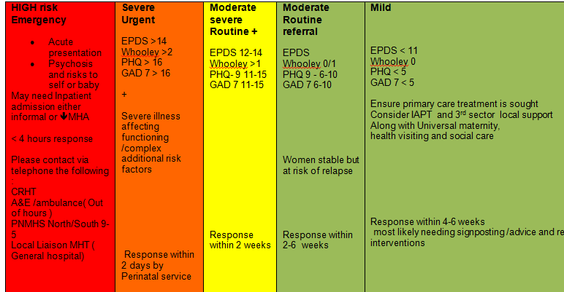
Area of referral/maternity contact details-If you wish to discuss your referral with the perinatal Mental team directly, please call 01245 315637 and ask to speak to the North or south duty worker.
If the patient is under midwifery remit, pregnancy and up to 28 days postnatal, please contact the perinatal midwife as below (please note that the perinatal MH team work closely with Midwifery but the perinatal midwives do not work under the perinatal team).
North Hub  Epunft.perinatalteam@nhs.net  Specialist MH Midwife (Mid Essex)  Amy Harrington  Mandy Ward  Tel: 01245 513251  Specialist MH Midwife (North West Essex)  Sarah Line - 01279 978246 ext 8246  Specialist MH Midwife (North East Essex)  Kerri Nicoll - 01206742124 | NE Hub – Colchester Hospital  NW Hub -Princess Alexandra hospital  Mid Hub – Chelmsford
South Hub  Perinatalteam@nhs.net  Specialist MH Midwife (South West Essex)  Vicky Stewart – Team Lead - 07824 802670  Dolly Lamkin – Midwife - 07500 983820  (Basildon, Thurrock, Brentwood)  Specialist MH Midwife (South East Essex)  Frances Jory ( Southend , Castlepoint, Rochford)  01702538170 | SE Hub - Southend Hospital  SW Hub - Basildon Hospital

