WHAT IS DAFNE?
DAFNE stands for: Dose Adjustment For Normal Eating.
It is a way of managing your diabetes by working how much insulin you need to take for what you want to eat.
DAFNE is a nationally delivered programme which is proven to reduce your HbA1c without increasing your risk of severe hypoglycaemia, increase quality of life and improve satisfaction with treatment.

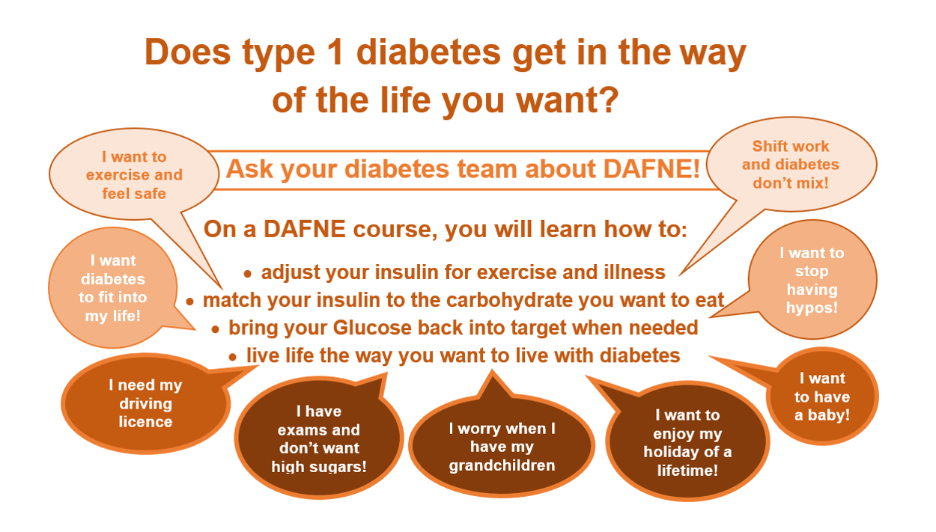
What's a DAFNE course like?
Remote DAFNE
The remote DAFNE course program is run over a 6 week period, with a pre assessment before and a 6-8 week follow up on completion of the course. There will be 4-6 Dafne participants on the Remote DAFNE course.
It includes a 3 hour group video call once a week on Microsoft teams, with 2-6 hours online learning in own time each week for 5 out of the 6 weeks. You will need a PC or tablet and access to the internet.
Please be aware that in order to complete the remote DAFNE course you will need to complete and attend Day 1, Day 2 and 1 further day of the 3 remaining days and complete all the online learning.
5 by 1 F2F DAFNE
The 5 by 1 course runs for 1 day over 5 weeks with a pre with a pre assessment before and a 6-8 week follow up on completion of the course. There will be 6-8 participants on the course. Two DAFNE educators will deliver the DAFNE course where group interaction, experiences and activities facilitate the learning.
Please be aware that in order to complete the 5 by1 DAFNE course you will need to attend week 1, week 2 and complete one further week of the 3 remaining weeks and attend the missed session (S) at another Dafne course ideally within 12 weeks.

Face to face 5 day course (1by5) Monday to Friday
The 5 by 1 course runs for 1 day over 5 days (Monday to Friday) with a pre assessment before and a 6-8 week follow up on completion of the course. There will be 6-8 participants on the course.
Two DAFNE educators will deliver the DAFNE course where group interaction, experiences and activities facilitate the learning.
Please be aware that in order to complete the 5 by1 DAFNE course you will need to attend Day 1, Day 2 and complete one further Day of the 3 remaining days and attend the missed session (S) at another Dafne course ideally within 12 weeks.

DAFNE Closed loop Essentials Course
Online course for people living with type 1 diabetes who are about to commence closed loop therapy, from either pen or pump therapy. It provides the essential key skills to keep the HCL pump user safe using closed loop.
It takes 4-6 hours of online learning to complete the course with no DAFNE educator input.
https://www.youtube.com/watch?v=-rTkygiOsMA

Please look on the Dafne website for more information and patient experiences of DAFNE.
Patient stories - DAFNE
Do you have type 1 diabetes? - DAFNE

Booking a place on a DAFNE course
If you are interested in booking a place on a DAFNE course please email the IDS Dafne team at epunft.diabetes.one@nhs.net or phone the appointment line: 01702 372081.
We can provide a DAFNE letter available for your employer to support your request to attend a Remote / face to face DAFNE course.

