What we do together matters.
Essex Partnership University NHS Foundation Trust (EPUT) was formed in 2017. It has since grown from strength to strength, providing many community health, mental health and learning disability services to support more than 3.2 million people living across Luton and Bedfordshire, Essex and Suffolk.
We are a large employer in the East of England with more than 7,200 staff working across more than 200 sites. We also provide services in people’s homes and community settings.
g
n
i
r
e
v
i
l
e
D

Our values

Achieving our vision

Meeting people where they are
e
g
s
n
i
d
n
a
t
s
r
e
d
n
U
l
a
u
e
d
r
i
a
v
i
c
d
s
n
s
i
e
h
l
c
m
a
a
e

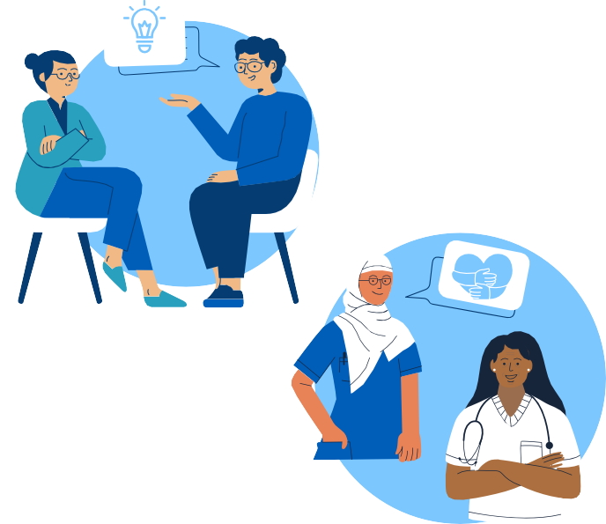


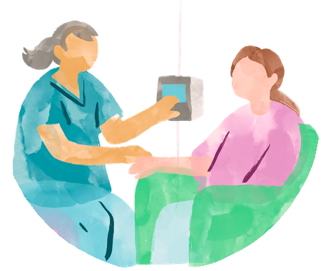




We Learn We Empower
t
i
g
i
D
n
o
i
t
a

We Care
n
i
l
a
v
o
n



As EPUT looks to the future in the context of the Government’s 10 year plan for health, as well as significant changes in the wider health and care system, it is critical that our strategic plan continues to reflect how we will achieve our ambition to be the leading health and wellbeing service in the provision of mental health and community care.
Our vision, values and strategic objectives remain the same, and our next phase in achieving them is focused on meeting people where they are and strengthening mental health and community care across our system. Our ambition is underpinned by three priorities: seamless access to care closer to home; personalised, inclusive mental health support for all; and the use of digital innovation to improve access, experience and efficiency.
Delivering these priorities requires strong partnership working across the NHS, local authorities and the voluntary sector. EPUT is playing a leading role in delivering joined-up care and working differently with partners to improve how services are planned and delivered. This includes transforming community mental health support through Community First, expanding West Essex Hospital at Home, and working with acute hospitals and primary care to support more people at home and in their communities, contributing to system sustainability and financial resilience.


We are integrating physical and mental health services, modernising our estate to support new models of care, and aligning our services with the NHS Long Term Plan. Our approach focuses on understanding the wider factors that shape someone’s health, not just their diagnosis. This includes delivering trauma-informed care through initiatives such as the South East Essex Trauma Alliance, improving support for neurodivergent people, and co-designing services with people who use them.

Digital transformation is central to this work. We are developing a single shared patient record through NOVA, supported by shared care records accessible across partner organisations.
Patients are being given greater control through tools such as Patients Know Best and virtual services, while staff benefit from improved access to information and more efficient systems. We are also using AI to support better outcomes, productivity and value for the health and care system.
By combining innovation with compassion, and partnership with accountability, EPUT’s next chapter will deliver measurable improvements in access, experience and outcomes, supporting healthier communities across Essex and beyond.

